Experience automation highlights firsthand
B&R User Meeting - March 12-13, 2013 in Salzburg
At the 2013 B&R User Meeting, which is taking place March 12-13 in Salzburg, participants will once again have the chance to experience the latest highlights in industrial automation firsthand. Ad-free product information straight from the various development departments, application reports from users and the possibility to speak with both customers using B&R technology as well as experts from various industries – these are the aspects that give the B&R User Meeting its special flair.
For anyone interested in automation and process control systems
During this two-day event, B&R will be offering an informative program for those interested in technical information related to machine and system manufacturing – from small machine controllers to complex process control systems. B&R speakers, B&R customers and other well-known industry experts will be on-hand to talk about current trends in industrial automation, such as: Optimizing the engineering workflow, increasing overall efficiency using simulation, the advantages of integrated safety technology, the latest communication standards for automation industries and potential benefits of condition and energy monitoring.
In response to overwhelming requests, discussions with industry experts will be offered in groups at the User Meeting 2013 in addition to the main program. This mix of panel discussions and workgroups will be complemented by several practical tasks.
Firsthand product information
The User Meeting is also a great chance for participants to speak with industry experts during breaks. You can also check out B&R's wide range of hardware and software tools live and in action.
Participants will once again be invited to tour B&R headquarters in Eggelsberg, which is set to include a few new surprises this year.

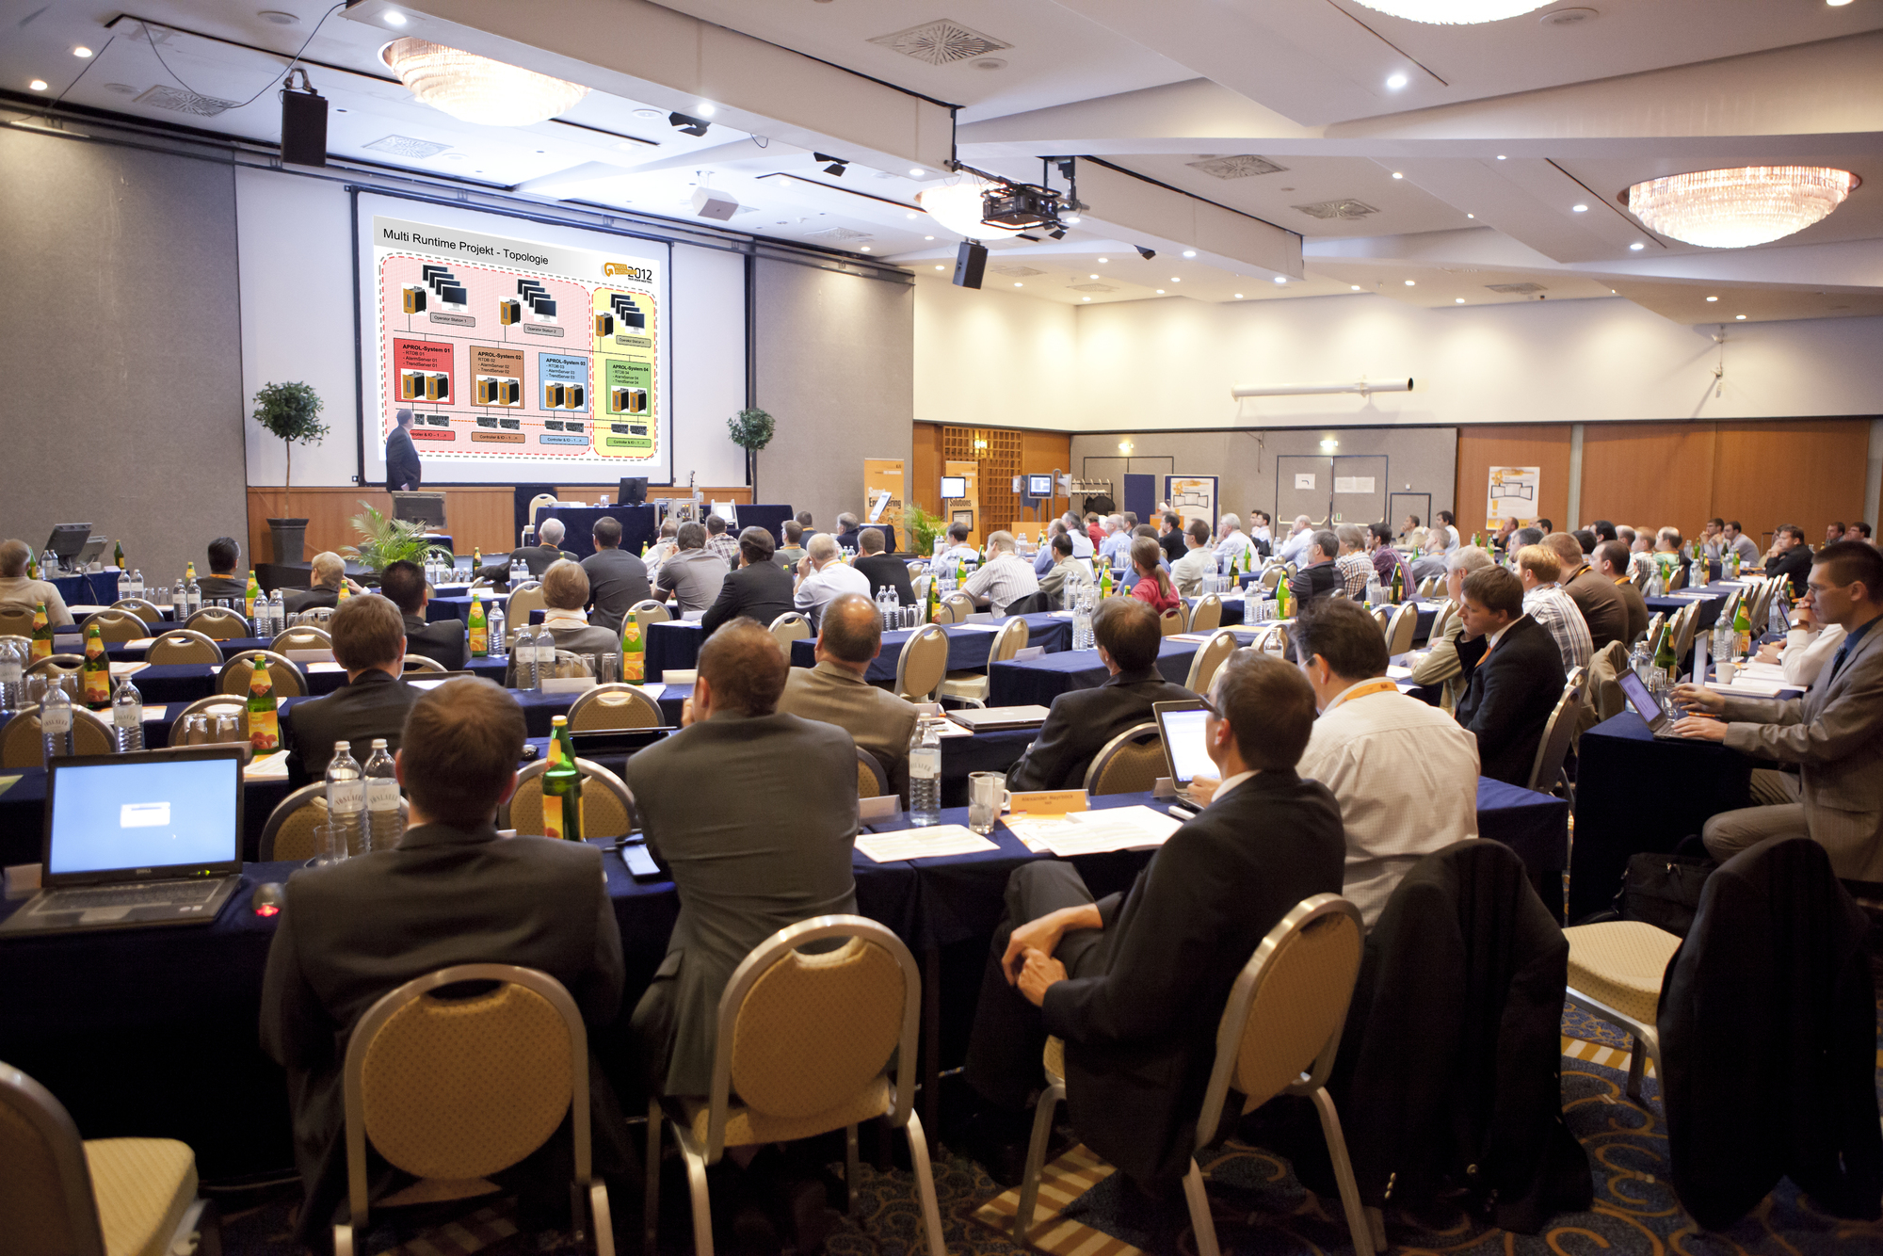
The B&R User Meeting offers an informative program for anyone interested in technical information related to machine and system manufacturing.

A propos de B&R
B&R est une société d'automatismes innovante dont le siège social est basé en Autriche et qui dispose d'agences partout dans le monde. Le 6 juillet 2017, B&R est devenue une business unit du groupe ABB. Comptant parmi les leaders de l’automatisation industrielle, B&R allie technologies avancées et ingénierie de haut niveau pour fournir à ses clients, dans la quasi-totalité des industries, des solutions complètes pour l’automatisation de machines et de lignes, le contrôle de mouvements, la visualisation et la sécurité intégrée. En s’appuyant sur des standards de communication IoT Industriel comme OPC UA, POWERLINK et openSAFETY, et sur le puissant environnement de développement logiciel Automation Studio, B&R façonne l'avenir de l'ingénierie des automatismes. Forte de son leadership technologique, la société puise sa capacité d'innovation dans sa volonté de simplifier les processus et d'aller au-delà des attentes des clients.
Pour plus d'informations : www.br-automation.com

