B&R User Meeting - March 12-13, 2013 in Salzburg
- Agenda - User Meeting 2013
- Workshops
- Gastreferenten
Experience automation highlights firsthand
At the 2013 B&R User Meeting, which is taking place March 12-13 in Salzburg, participants will once again have the chance to experience the latest highlights in industrial automation firsthand. Ad-free product information straight from the various development departments, application reports from users and the possibility to speak with both customers using B&R technology as well as experts from various industries – these are the aspects that give the B&R User Meeting its special flair.
For representatives from industrial automation and process control
During this two-day event, B&R will be offering an informative program for those interested in technical information related to machine and system manufacturing – from small machine controllers to complex process control systems. Specialists from B&R, industry experts and B&R customers will be on hand to discuss the following topics: Optimizing the engineering workflow, increasing overall efficiency using simulation, the advantages of integrated safety technology, the latest communication standards for automation industries and potential benefits of condition and energy monitoring.
In response to overwhelming requests, discussions with industry experts will be offered in groups at the User Meeting 2013 in addition to the main program. This mix of panel discussions and workgroups will be complemented by several practical tasks.
Firsthand product information
The User Meeting is also a great chance for participants to speak with industry experts during breaks. It's a perfect opportunity to check out B&R's wide range of hardware and software tools firsthand.
Participants will once again be invited to tour B&R headquarters in Eggelsberg, which is set to include a few new surprises this year.

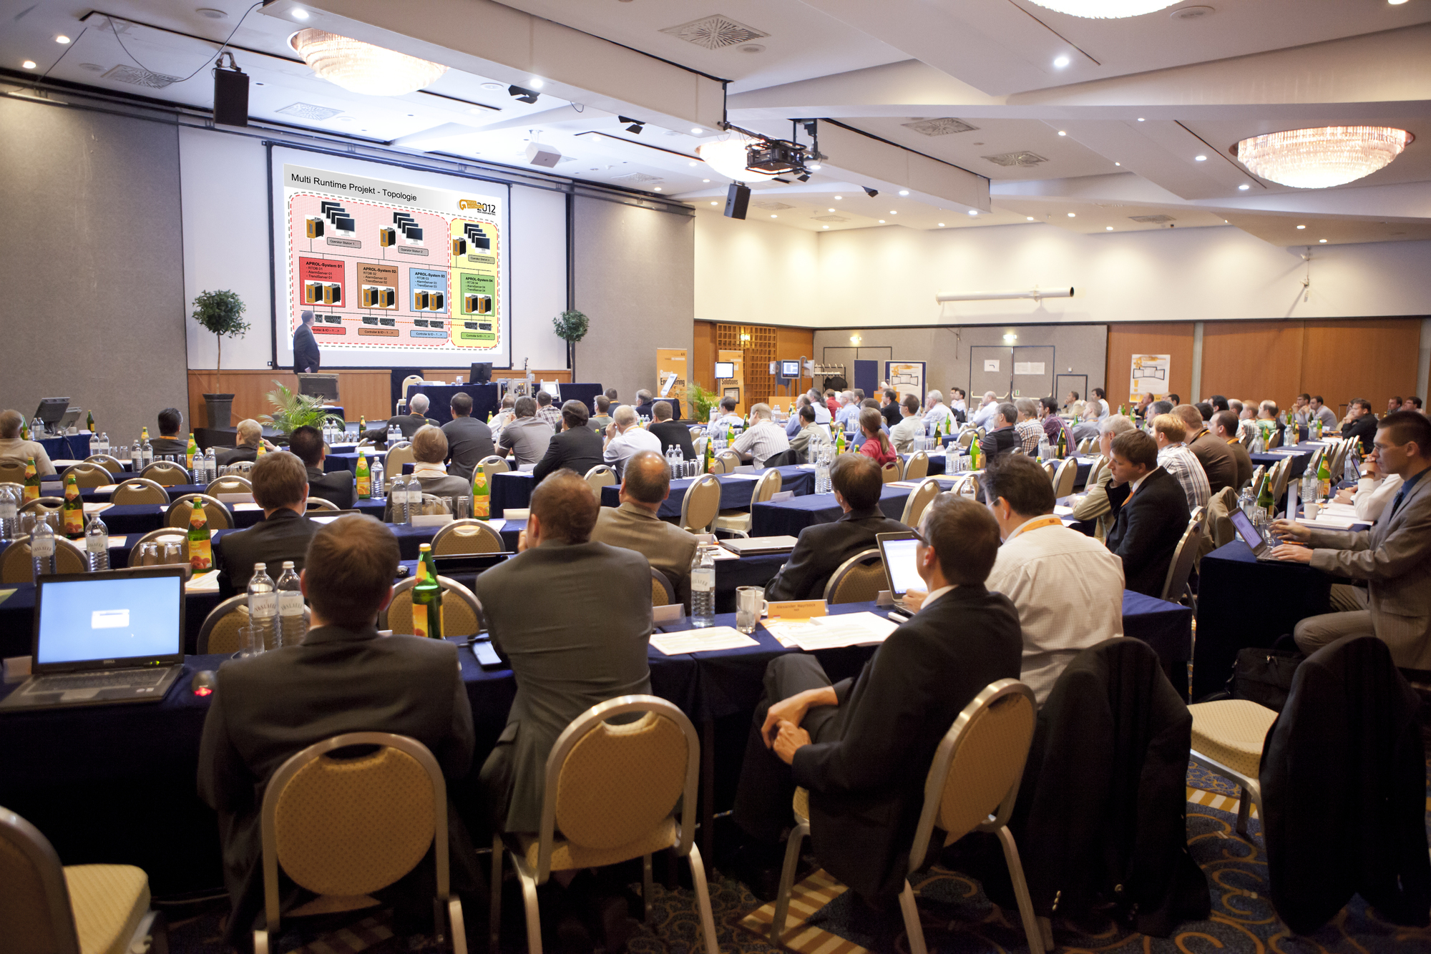
The B&R User Meeting offers an informative program for anyone interested in technical information related to machine and system manufacturing.

B&R Hakkında
ABB Grubunun bir bölümü olan B&R, merkezi Avusturya'da bulunan endüstriyel otomasyon alanında global bir liderdir. B&R, neredeyse her sektördeki müşterilere makine ve fabrika otomasyonu, hareket kontrolü, HMI ve entegre güvenlik teknolojisi için eksiksiz çözümler sunmak üzere en son teknolojiyi ileri mühendislikle birleştiriyor. OPC UA, POWERLINK ve openSAFETY gibi Endüstriyel IoT iletişim standartlarının yanı sıra Automation Studio yazılımıyla B&R, otomasyon mühendisliğinin geleceğini sürekli olarak yeniden tanımlıyor. B&R'ı endüstriyel otomasyonun ön saflarında tutan yenilikçi ruh, süreçleri basitleştirme ve müşteri beklentilerini aşma taahhüdünden kaynaklanmaktadır.
Daha fazla bilgi için www.br-automation.com adresini ziyaret edin.

