Experience automation highlights firsthand
B&R User Meeting - March 12-13, 2013 in Salzburg
At the 2013 B&R User Meeting, which is taking place March 12-13 in Salzburg, participants will once again have the chance to experience the latest highlights in industrial automation firsthand. Ad-free product information straight from the various development departments, application reports from users and the possibility to speak with both customers using B&R technology as well as experts from various industries – these are the aspects that give the B&R User Meeting its special flair.
For anyone interested in automation and process control systems
During this two-day event, B&R will be offering an informative program for those interested in technical information related to machine and system manufacturing – from small machine controllers to complex process control systems. B&R speakers, B&R customers and other well-known industry experts will be on-hand to talk about current trends in industrial automation, such as: Optimizing the engineering workflow, increasing overall efficiency using simulation, the advantages of integrated safety technology, the latest communication standards for automation industries and potential benefits of condition and energy monitoring.
In response to overwhelming requests, discussions with industry experts will be offered in groups at the User Meeting 2013 in addition to the main program. This mix of panel discussions and workgroups will be complemented by several practical tasks.
Firsthand product information
The User Meeting is also a great chance for participants to speak with industry experts during breaks. You can also check out B&R's wide range of hardware and software tools live and in action.
Participants will once again be invited to tour B&R headquarters in Eggelsberg, which is set to include a few new surprises this year.

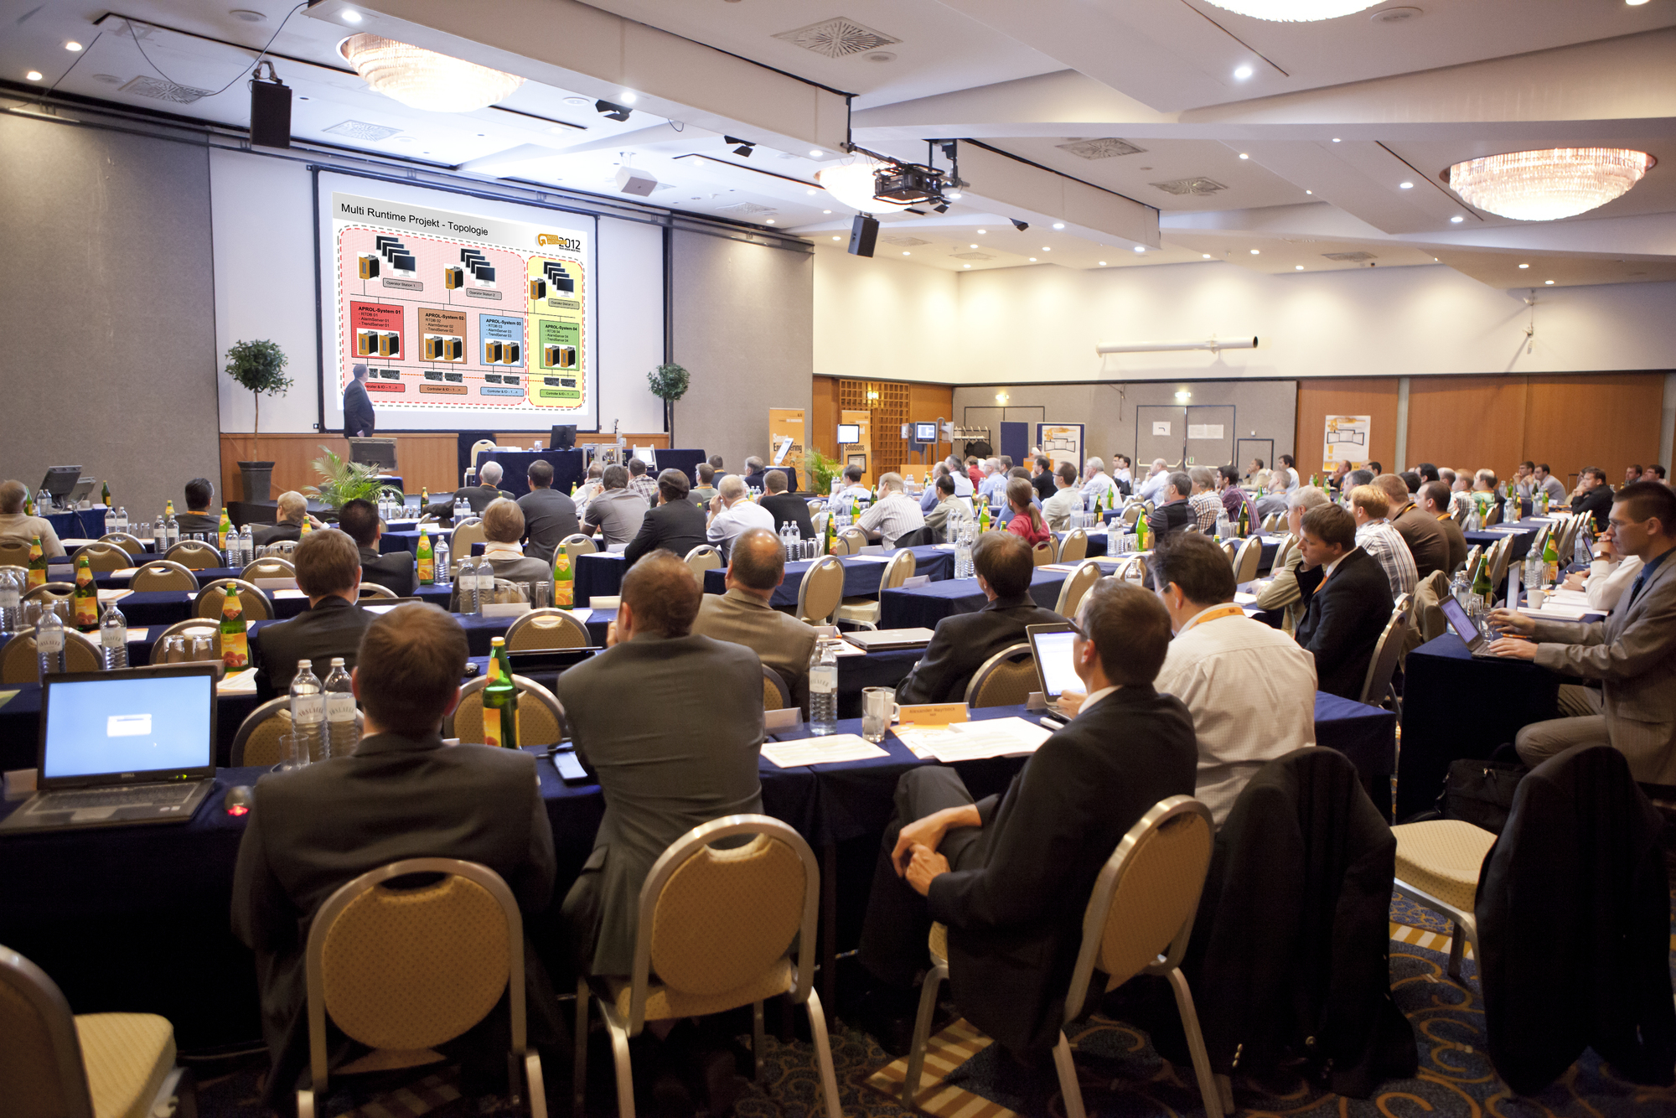
The B&R User Meeting offers an informative program for anyone interested in technical information related to machine and system manufacturing.

关于贝加莱
贝加莱是一家总部位于奥地利并在全球拥有分公司的创新型自动化企业。2017年7月，贝加莱成为ABB集团的机械自动化事业部。作为工业自动化领域的全球领导者，贝加莱将前沿技术与领先工程相结合，为几乎每个行业的客户提供面向机器与工厂自动化、运动控制、HMI和集成安全技术的完整解决方案。借助于OPC UA、POWERLINK、openSAFETY等工业物联网通信标准，以及强大的Automation Studio软件开发平台，贝加莱不断重新定义自动化工程的未来。受简化流程和超出客户预期的承诺驱动，贝加莱始终保持创新精神并处于工业自动化领域的前沿。
获取更多信息，请访问www.br-automation.com。

