Temperature range for B&R I/O modules and control systems considerably increased
X20 and X67 modules function reliably at temperatures ranging from -25 to +60°C
B&R has considerably increased the temperature range of their X20 and X67 control and I/O systems. This is made possible by the special industrial temperature electronic components installed in the modules. Both the X20 modules with IP20 protection and the X67 modules with IP67 protection function reliably at temperatures from -25 to +60°C, and these modules can be stored at even more extreme temperatures ranging from -40 to +85°C.
Because of the increased temperature range, the controllers and I/O modules are well suited for an even wider area of application. The fact that these B&R components operate reliably at such extreme temperatures provides further confirmation of their quality. Characterized by their robustness and stability, they provide proof of the extremely high quality of the industrial temperature electronic components that are being used.
In order to ensure reliable operation of the X20 CPUs, B&R uses special CompactFlash cards in the PLCs that can withstand these extreme temperatures.

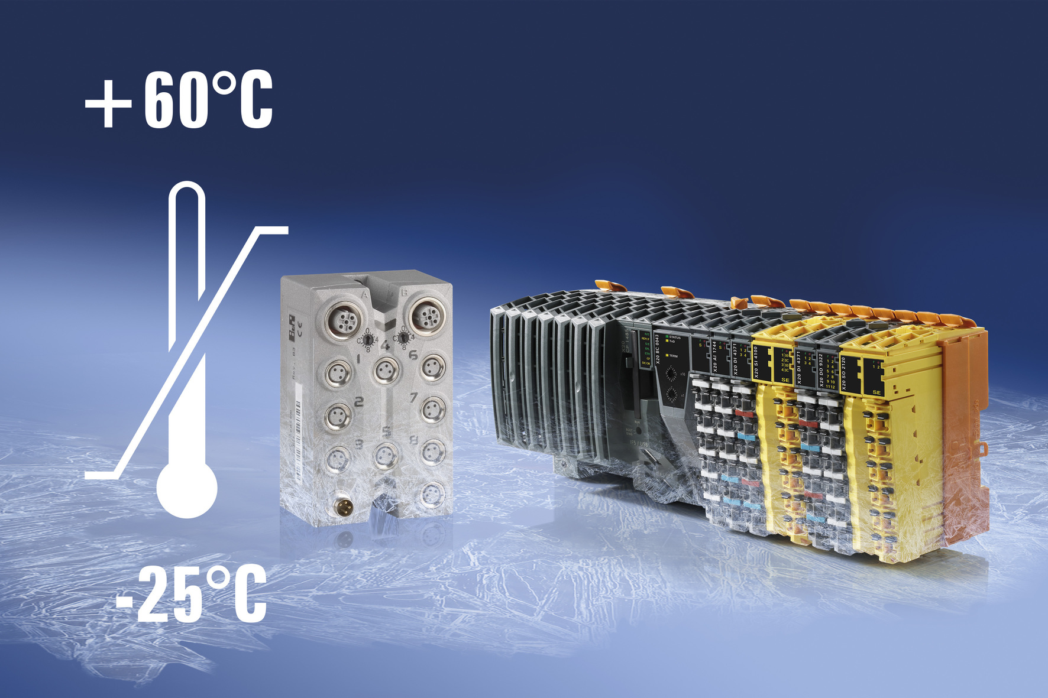
Able to withstand extreme temperatures: Both the X20 modules and the X67 modules from B&R function reliably at temperatures ranging from -25 to +60°C.

About B&R
B&R, a division of ABB Group, is a global leader in industrial automation headquartered in Austria. B&R combines state-of-the-art technology with advanced engineering to provide customers in virtually every industry with complete solutions for machine and factory automation, motion control, HMI and integrated safety technology. With Industrial IoT communication standards including OPC UA, POWERLINK and openSAFETY as well as its Automation Studio software, B&R is constantly redefining the future of automation engineering. The innovative spirit that keeps B&R at the forefront of industrial automation is driven by a commitment to simplifying processes and exceeding customer expectations.
For more information, visit www.br-automation.com.

