Temperature range for B&R I/O modules and control systems considerably increased
X20 and X67 modules function reliably at temperatures ranging from -25 to +60°C
B&R has considerably increased the temperature range of their X20 and X67 control and I/O systems. This is made possible by the special industrial temperature electronic components installed in the modules. Both the X20 modules with IP20 protection and the X67 modules with IP67 protection function reliably at temperatures from -25 to +60°C, and these modules can be stored at even more extreme temperatures ranging from -40 to +85°C.
Because of the increased temperature range, the controllers and I/O modules are well suited for an even wider area of application. The fact that these B&R components operate reliably at such extreme temperatures provides further confirmation of their quality. Characterized by their robustness and stability, they provide proof of the extremely high quality of the industrial temperature electronic components that are being used.
In order to ensure reliable operation of the X20 CPUs, B&R uses special CompactFlash cards in the PLCs that can withstand these extreme temperatures.

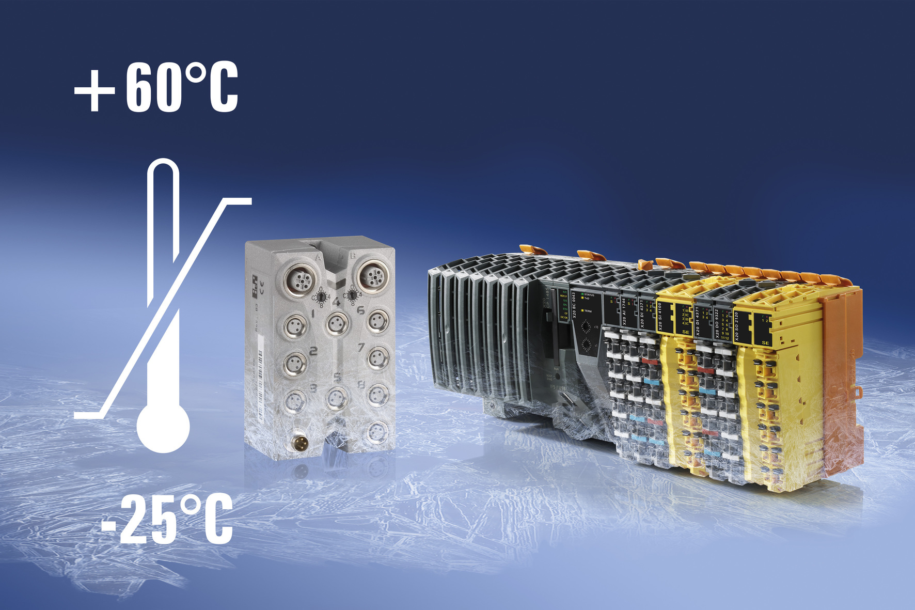
Able to withstand extreme temperatures: Both the X20 modules and the X67 modules from B&R function reliably at temperatures ranging from -25 to +60°C.

关于贝加莱
贝加莱是一家总部位于奥地利并在全球拥有分公司的创新型自动化企业。2017年7月，贝加莱成为ABB集团的机械自动化事业部。作为工业自动化领域的全球领导者，贝加莱将前沿技术与领先工程相结合，为几乎每个行业的客户提供面向机器与工厂自动化、运动控制、HMI和集成安全技术的完整解决方案。借助于OPC UA、POWERLINK、openSAFETY等工业物联网通信标准，以及强大的Automation Studio软件开发平台，贝加莱不断重新定义自动化工程的未来。受简化流程和超出客户预期的承诺驱动，贝加莱始终保持创新精神并处于工业自动化领域的前沿。
获取更多信息，请访问www.br-automation.com。

