B&R provides support for children with cancer (Kinder-Krebs-Hilfe)
This organization provides help and support for children with cancer and their families
About 300 children in Austria are diagnosed with cancer every year. This illness changes the lives of children and their families abruptly and without warning. To help children with cancer and their families by providing advice and practical services, a group of affected parents established the Upper Austrian Children's Cancer Association in May of 1988. One of the founding members is the current president of the fund, Agnes Stark, whose son was diagnosed with cancer at the age of three. She knows from her own experience how important support is such situations: "The people who need it most are often the ones who don’t ask for it. That's why we actively reach out to the families."
The Children's Cancer Association assists in emotional and social matters, provides information about legal funding and organizes financial assistance for affected families. "It is essential to ensure that families do not fall through the cracks," says Stark. Among other things, the fund subsidizes medicines or therapy abroad, and allows parents and siblings to be near the sick family member during this difficult time.
"We are constantly striving to improve our services for affected families," said chairwoman Stark. "We do, however, continue to rely on donations." B&R has shown their support for the work done by this organization by donating €3000. "Members of the children's cancer association are at the hospital every day to take care of the patients and their relatives," says B&R personnel manager Nicole Rainer. "This is the type of support we want to promote with our donation."

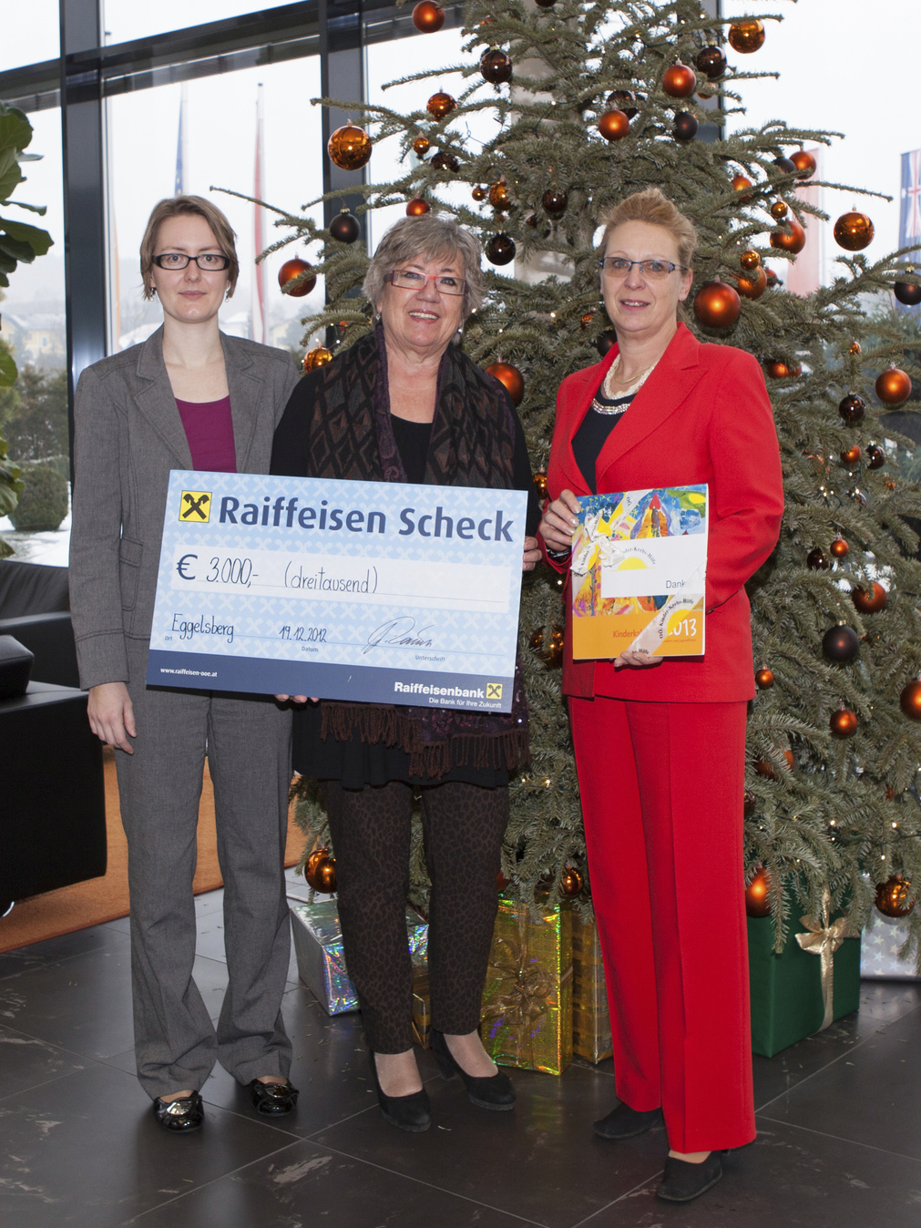
On behalf of the Upper Austrian Children's Cancer Association, chairwoman Agnes Stark (center) receives a check from B&R, handed to her by Gaby Nagl-Güthler (right) from Human Capital and Nicole Wittmann from Corporate Communications.

About B&R
B&R, a division of ABB Group, is a global leader in industrial automation headquartered in Austria. B&R combines state-of-the-art technology with advanced engineering to provide customers in virtually every industry with complete solutions for machine and factory automation, motion control, HMI and integrated safety technology. With Industrial IoT communication standards including OPC UA, POWERLINK and openSAFETY as well as its Automation Studio software, B&R is constantly redefining the future of automation engineering. The innovative spirit that keeps B&R at the forefront of industrial automation is driven by a commitment to simplifying processes and exceeding customer expectations.
For more information, visit www.br-automation.com.

