B&R provides support for children with cancer (Kinder-Krebs-Hilfe)
This organization provides help and support for children with cancer and their families
About 300 children in Austria are diagnosed with cancer every year. This illness changes the lives of children and their families abruptly and without warning. To help children with cancer and their families by providing advice and practical services, a group of affected parents established the Upper Austrian Children's Cancer Association in May of 1988. One of the founding members was chairwoman Agnes Stark, whose son was diagnosed with cancer when he was three years old. From her own experience, she knows how important support is in situations like this: "Those who are most in need of help often do not ask for it. That's why we actively reach out to the families."
The Children's Cancer Association assists in emotional and social matters, provides information about legal funding and organizes financial assistance for affected families. "It is essential to ensure that families do not fall through the cracks," says Stark. For this reason, the association provides things like funding for medicine as well as therapies abroad and makes it possible for parents and siblings to be close to the affected family member during this difficult time.
"We are constantly striving to improve our services for affected families," said chairwoman Stark. "We do, however, continue to rely on donations." B&R has shown their support for the work done by this organization by donating 3000 euros. "Members of the children's cancer association are at the hospital every day to take care of the patients and their relatives," says B&R personnel manager Nicole Rainer. "This is the type of support we want to promote with our donation."

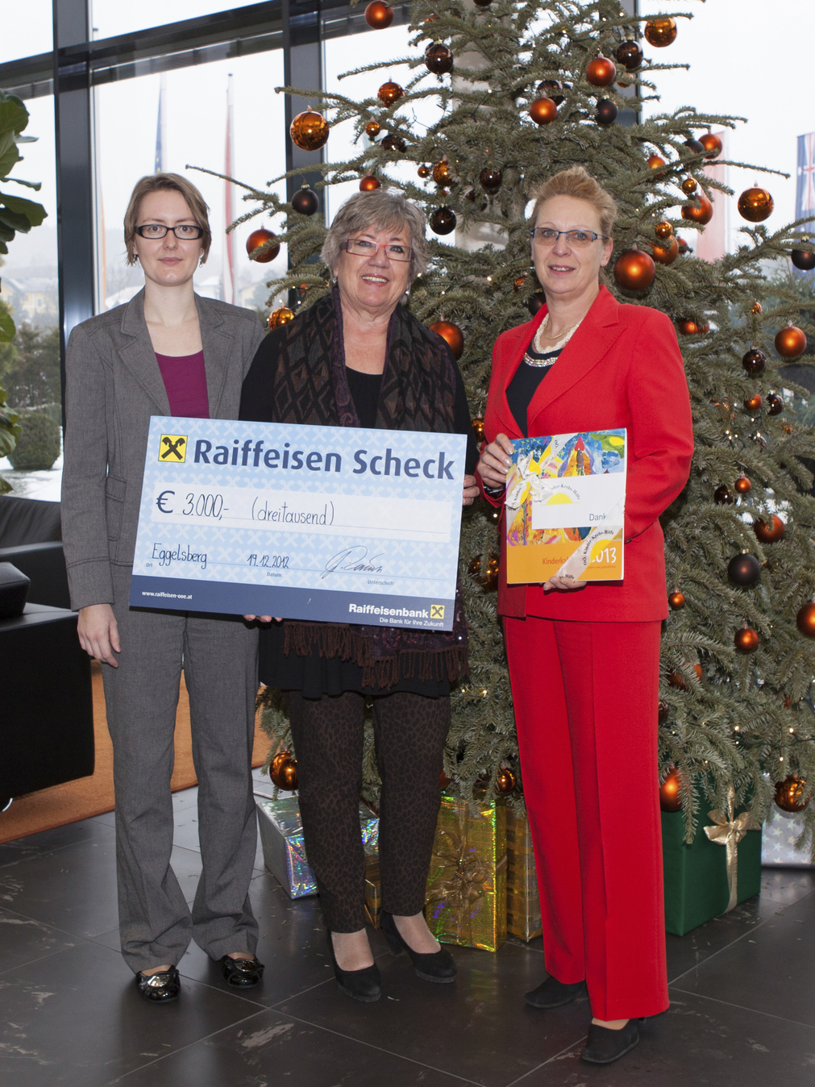
On behalf of the Upper Austrian Children's Cancer Association, chairwoman Agnes Stark (center) receives a check from B&R, handed to her by Gaby Nagl-Güthler (right) from Human Capital and Nicole Wittmann from Corporate Communications.

Acerca de B&R
B&R, empresa perteneciente al Grupo ABB y con sede en Austria, es líder mundial en automatización industrial. B&R combina tecnología de vanguardia con ingeniería avanzada para proporcionar a usuarios de todos los sectores soluciones completas para la automatización de máquinas y fábricas, Motion Control, HMI y tecnología de seguridad integrada. El catálogo de productos se completa con estándares de comunicación de IoT industrial que incluyen OPC UA, POWERLINK y openSAFETY. Gracias a su única herramienta de software Automation Studio, B&R redefine constantemente el futuro de la ingeniería de automatización. El espíritu innovador que mantiene a B&R a la vanguardia de la automatización industrial está impulsado por el compromiso de simplificar los procesos y superar las expectativas de los clientes.Para más información, visite www.br-automation.com.
Para más información, visite www.br-automation.com.

