B&R provides support for children with cancer (Kinder-Krebs-Hilfe)
This organization provides help and support for children with cancer and their families
About 300 children in Austria are diagnosed with cancer every year. This illness changes the lives of children and their families abruptly and without warning. To help children with cancer and their families by providing advice and practical services, a group of affected parents established the Upper Austrian Children's Cancer Association in May of 1988. One of the founding members is the current president of the fund, Agnes Stark, whose son was diagnosed with cancer at the age of three. She knows from her own experience how important support is such situations: "The people who need it most are often the ones who don’t ask for it. That's why we actively reach out to the families."
The Children's Cancer Association assists in emotional and social matters, provides information about legal funding and organizes financial assistance for affected families. "It is essential to ensure that families do not fall through the cracks," says Stark. Among other things, the fund subsidizes medicines or therapy abroad, and allows parents and siblings to be near the sick family member during this difficult time.
"We are constantly striving to improve our services for affected families," said chairwoman Stark. "We do, however, continue to rely on donations." B&R has shown their support for the work done by this organization by donating €3000. "Members of the children's cancer association are at the hospital every day to take care of the patients and their relatives," says B&R personnel manager Nicole Rainer. "This is the type of support we want to promote with our donation."

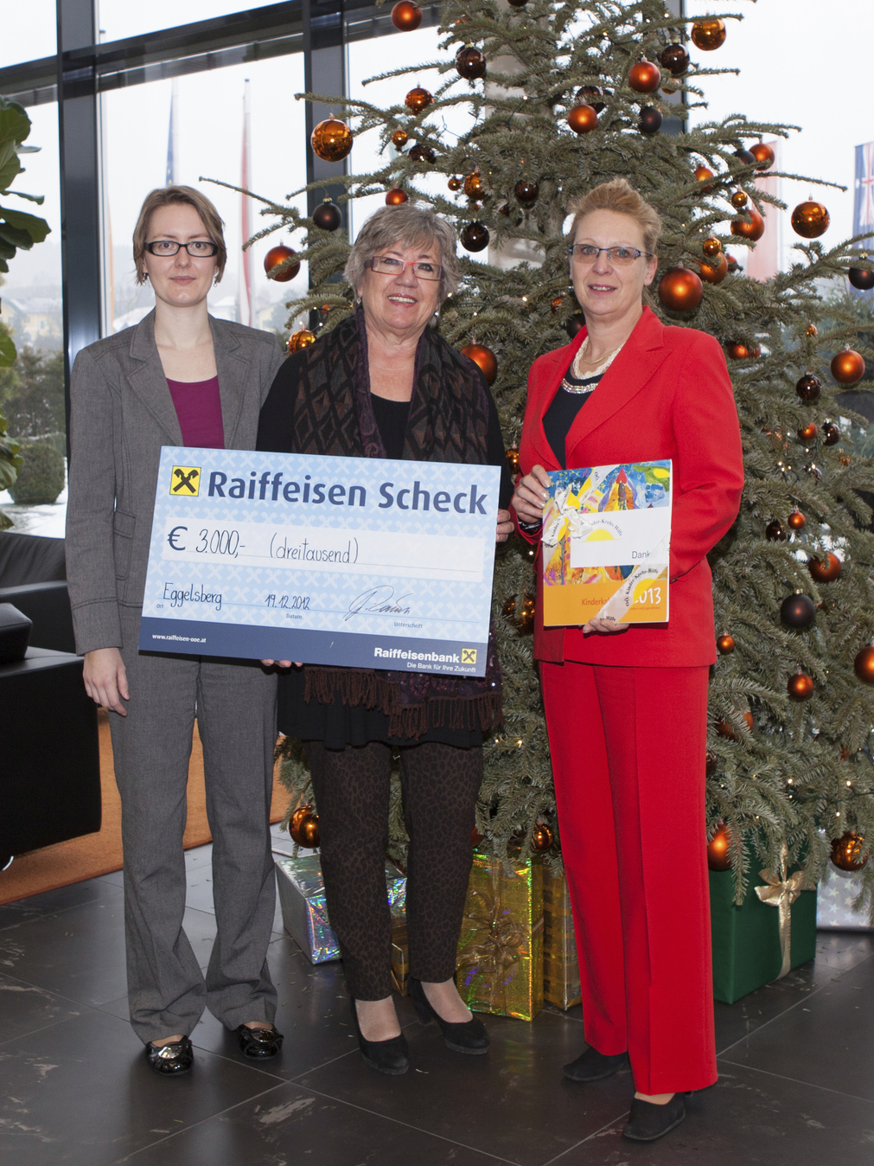
On behalf of the Upper Austrian Children's Cancer Association, chairwoman Agnes Stark (center) receives a check from B&R, handed to her by Gaby Nagl-Güthler (right) from Human Capital and Nicole Wittmann from Corporate Communications.

B&R Hakkında
ABB Grubunun bir bölümü olan B&R, merkezi Avusturya'da bulunan endüstriyel otomasyon alanında global bir liderdir. B&R, neredeyse her sektördeki müşterilere makine ve fabrika otomasyonu, hareket kontrolü, HMI ve entegre güvenlik teknolojisi için eksiksiz çözümler sunmak üzere en son teknolojiyi ileri mühendislikle birleştiriyor. OPC UA, POWERLINK ve openSAFETY gibi Endüstriyel IoT iletişim standartlarının yanı sıra Automation Studio yazılımıyla B&R, otomasyon mühendisliğinin geleceğini sürekli olarak yeniden tanımlıyor. B&R'ı endüstriyel otomasyonun ön saflarında tutan yenilikçi ruh, süreçleri basitleştirme ve müşteri beklentilerini aşma taahhüdünden kaynaklanmaktadır.
Daha fazla bilgi için www.br-automation.com adresini ziyaret edin.

