B&R provides support for children with cancer (Kinder-Krebs-Hilfe)
This organization provides help and support for children with cancer and their families
About 300 children in Austria are diagnosed with cancer every year. This illness changes the lives of children and their families abruptly and without warning. To help children with cancer and their families by providing advice and practical services, a group of affected parents established the Upper Austrian Children's Cancer Association in May of 1988. One of the founding members was chairwoman Agnes Stark, whose son was diagnosed with cancer when he was three years old. From her own experience, she knows how important support is in situations like this: "Those who are most in need of help often do not ask for it. That's why we actively reach out to the families."
The Children's Cancer Association assists in emotional and social matters, provides information about legal funding and organizes financial assistance for affected families. "It is essential to ensure that families do not fall through the cracks," says Stark. For this reason, the association provides things like funding for medicine as well as therapies abroad and makes it possible for parents and siblings to be close to the affected family member during this difficult time.
"We are constantly striving to improve our services for affected families," said chairwoman Stark. "We do, however, continue to rely on donations." B&R has shown their support for the work done by this organization by donating 3000 euros. "Members of the children's cancer association are at the hospital every day to take care of the patients and their relatives," says B&R personnel manager Nicole Rainer. "This is the type of support we want to promote with our donation."

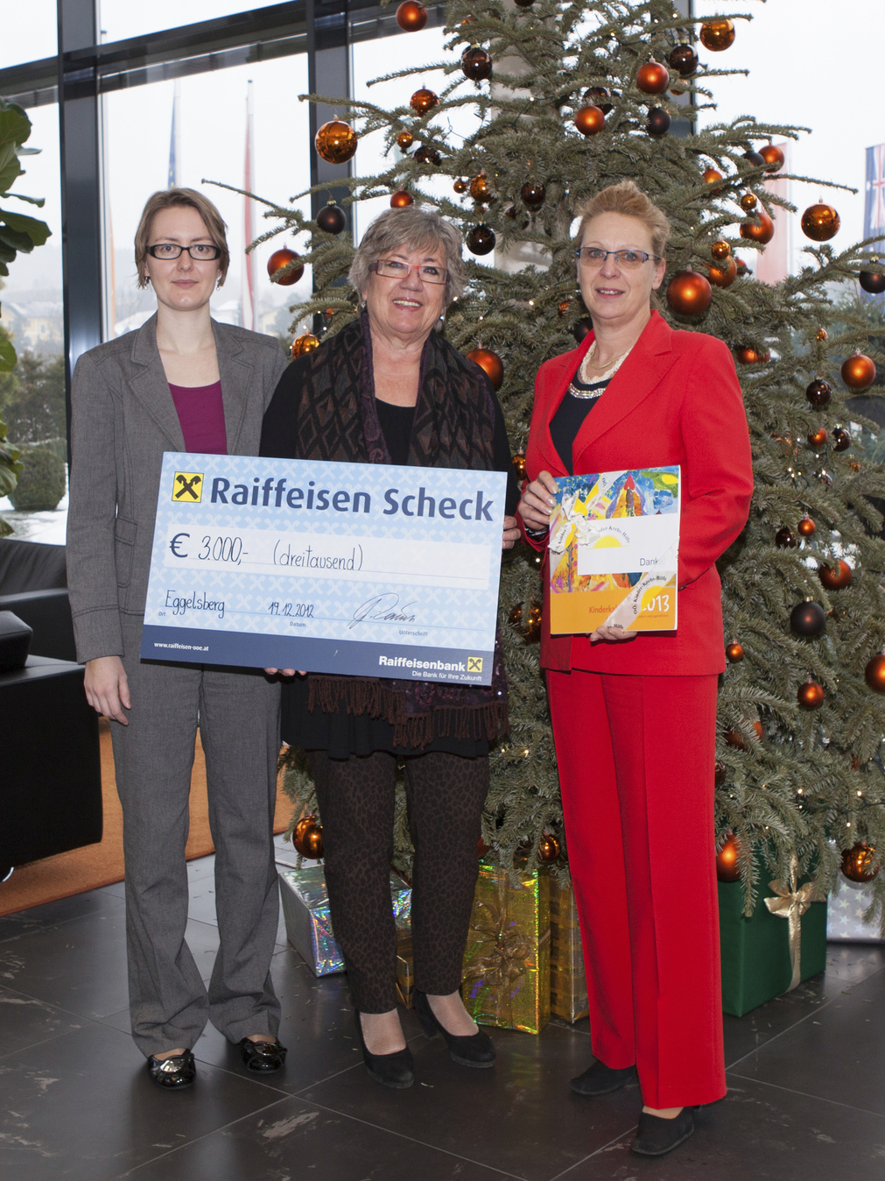
On behalf of the Upper Austrian Children's Cancer Association, chairwoman Agnes Stark (center) receives a check from B&R, handed to her by Gaby Nagl-Güthler (right) from Human Capital and Nicole Wittmann from Corporate Communications.

关于贝加莱
贝加莱是一家总部位于奥地利并在全球拥有分公司的创新型自动化企业。2017年7月，贝加莱成为ABB集团的机械自动化事业部。作为工业自动化领域的全球领导者，贝加莱将前沿技术与领先工程相结合，为几乎每个行业的客户提供面向机器与工厂自动化、运动控制、HMI和集成安全技术的完整解决方案。借助于OPC UA、POWERLINK、openSAFETY等工业物联网通信标准，以及强大的Automation Studio软件开发平台，贝加莱不断重新定义自动化工程的未来。受简化流程和超出客户预期的承诺驱动，贝加莱始终保持创新精神并处于工业自动化领域的前沿。
获取更多信息，请访问www.br-automation.com。

