B&R China User Meeting in Shanghai was a huge success
B&R demonstrates flexibility and innovative prowess
There were over one hundred visitors at the B&R China User Meeting in Shanghai at the end of last year. Two hot topics dominated the event – energy efficiency and intelligent automation. "More than ever, the field of industrial automation is called upon to tackle challenges such as improving energy efficiency in production facilities, reducing the time and cost spent on maintaining equipment, and providing a uniform development platform for producers," says Dr. Xiao Weirong, managing director of B&R China. "B&R solutions have the flexibility it takes to master these challenges with versatile hardware and software that can be tailored to our customers' wishes."
Monitor your plant from a smartphone or tablet
Chen Zhiping, Zhou Jing and Fan Huifang, all department managers at B&R China, held lectures on various topics. They spoke about the development of web-based system applications, about project management for electrical systems and about B&R's System Diagnostics Manager (SDM). With SDM, users benefit from quick access to detailed information about their hardware and software – at any time and from anywhere in the world. The functionality of the diagnostics tool was demonstrated by Chen Weikang from B&R's partner company, Datong Information Company, with assistance from the iSee app. This app supports remote plant maintenance and monitoring, appointment scheduling and disturbance and alarm messaging via smartphones and tablets.
B&R solutions welcomed by Chinese users
User Meeting participants also got a look at the latest products and solutions from B&R. Among the highlights was the philosophy of Smart Engineering, demonstrated by the new Automation Studio 4, which helps cut development costs and accelerate time-to-market in spite of ever increasing product complexity. The new energy data management solution, APROL EnMon, was also met with great interest. This solution helps users implement ISO 50001, and by improving energy efficiency it helps them lower costs and strengthen their competitive edge. Yet another highlight was the latest box PC from B&R, the Automation PC 910. The latest 3rd generation Intel® Core™ i-series processor technology provides the highest performance currently available on any industrial PC.

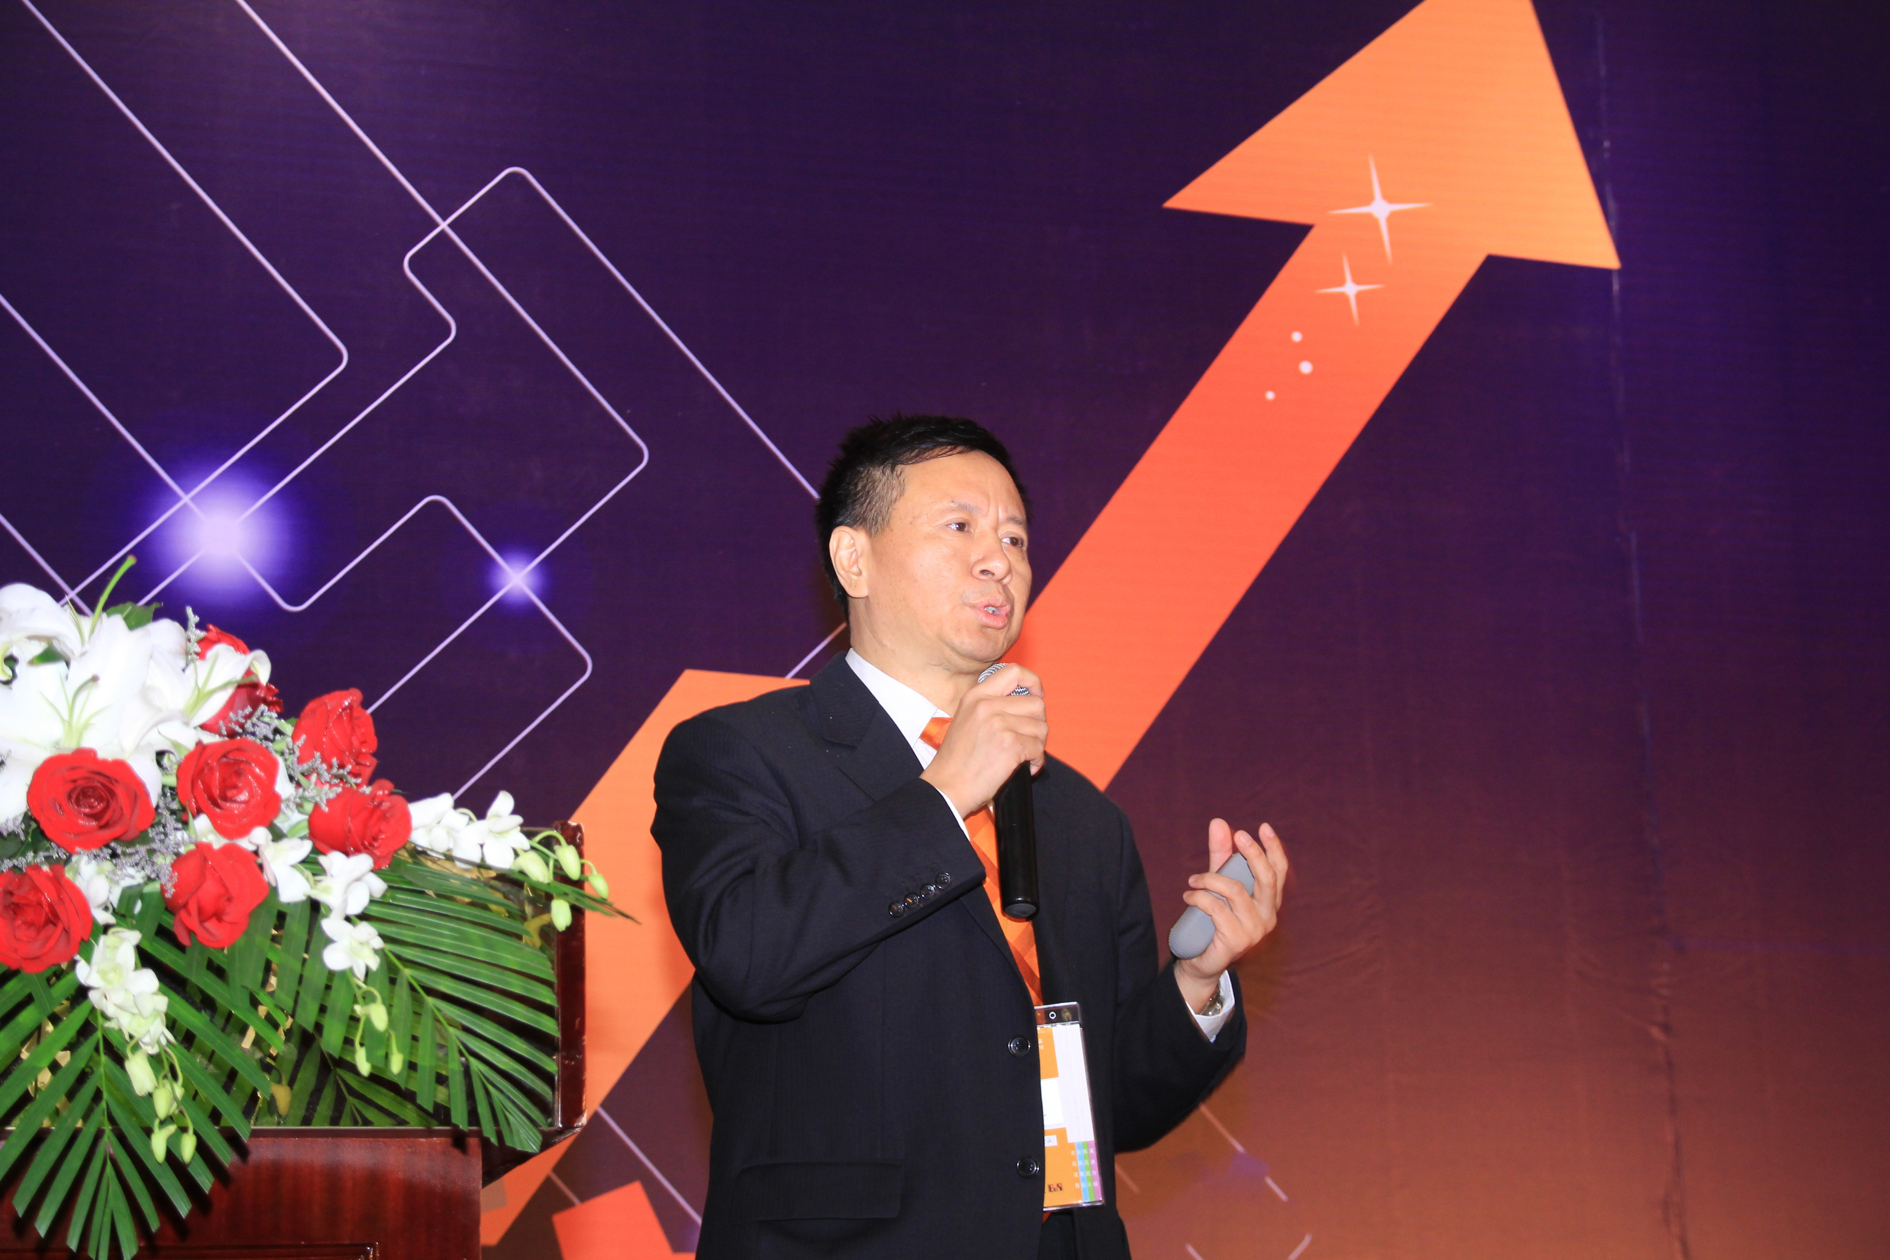
Dr. Xiao Weirong, Managing Director of B&R China, stressed the importance of energy efficiency and intelligent automation for manufacturing companies at the User Meeting in Shanghai.
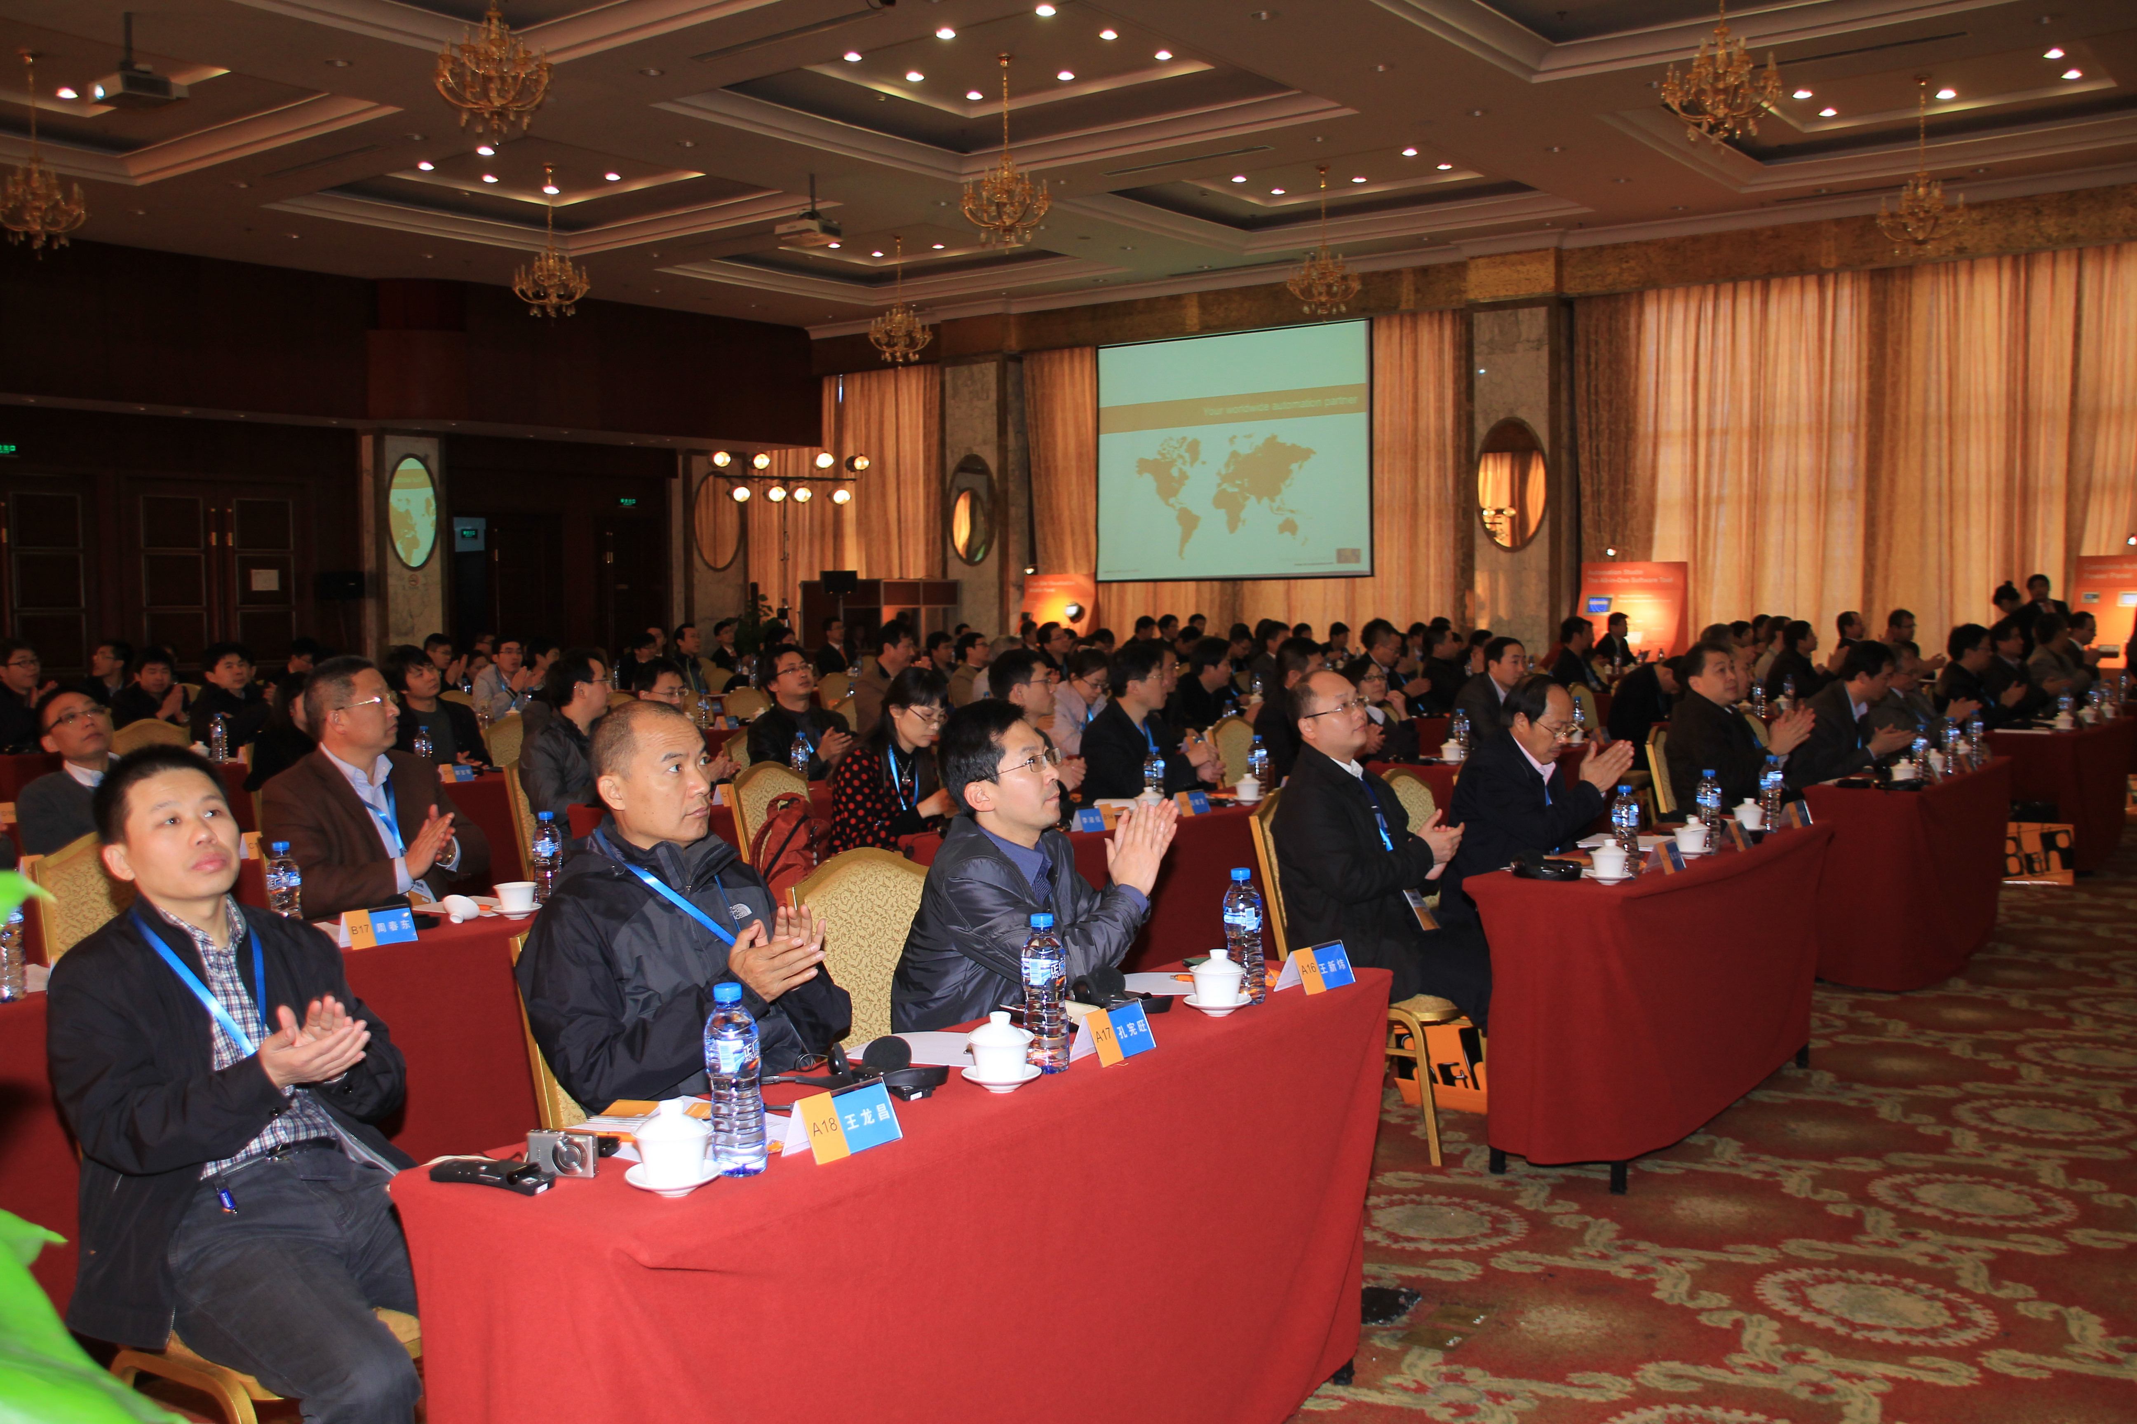
More than one hundred participants took advantage of the B&R User Meeting in Shanghai as an opportunity to get informed about current trends in automation and the latest innovations from B&R.

A propos de B&R
B&R est une société d'automatismes innovante dont le siège social est basé en Autriche et qui dispose d'agences partout dans le monde. Le 6 juillet 2017, B&R est devenue une business unit du groupe ABB. Comptant parmi les leaders de l’automatisation industrielle, B&R allie technologies avancées et ingénierie de haut niveau pour fournir à ses clients, dans la quasi-totalité des industries, des solutions complètes pour l’automatisation de machines et de lignes, le contrôle de mouvements, la visualisation et la sécurité intégrée. En s’appuyant sur des standards de communication IoT Industriel comme OPC UA, POWERLINK et openSAFETY, et sur le puissant environnement de développement logiciel Automation Studio, B&R façonne l'avenir de l'ingénierie des automatismes. Forte de son leadership technologique, la société puise sa capacité d'innovation dans sa volonté de simplifier les processus et d'aller au-delà des attentes des clients.
Pour plus d'informations : www.br-automation.com

