B&R China User Meeting in Shanghai was a huge success
B&R demonstrates flexibility and innovative prowess
More than a hundred guests attended the B&R China User Meeting in Shanghai at the end of last year. Two key topics dominated the event – energy efficiency and intelligent automation. "Industrial automation is more urgently needed than ever, for example to increase energy efficiency in production, to reduce maintenance on installations and to provide a uniform development platform for manufacturing companies", said Dr. Xiao Weirong, CEO of B&R China. "B&R solutions are flexible enough to meet these requirements and make it possible to modify software and system design to customer wishes."
Monitor your plant from a smartphone or tablet
Chen Zhiping, Zhou Jing and Fan Huifang, all department managers at B&R China, spoke about various subjects. They talked about the development of web-based system applications, about project management for electrical systems and about the System Diagnostics Manager (SDM). The benefit to users from SDM is that hardware and software information can be called up at any time, from anywhere in the world. Chen Weikang from our partner company Datong Information Company demonstrated the diagnostic tool using the iSee app. This app allows remote maintenance and monitoring of installations, scheduling, as well as error and alarm messages via smartphone or iPad.
B&R solutions impress Chinese users
The latest products and solutions from B&R were also presented at the User Meeting. Highlights included the Smart Engineering philosophy with Automation Studio 4, which helps ensure low development costs and short launch times despite increasingly complex products. The solution for energy data management, APROL EnMon, also generated great interest. This solution helps users implement ISO 50001 and improve energy efficiency to make financial savings and ensure competitiveness. Another highlight was the latest box PC from B&R, the Automation PC 910. The latest third-generation Intel® Core™ i technology is at the heart of this powerful PC, which provides the most performance currently available for industrial PCs.

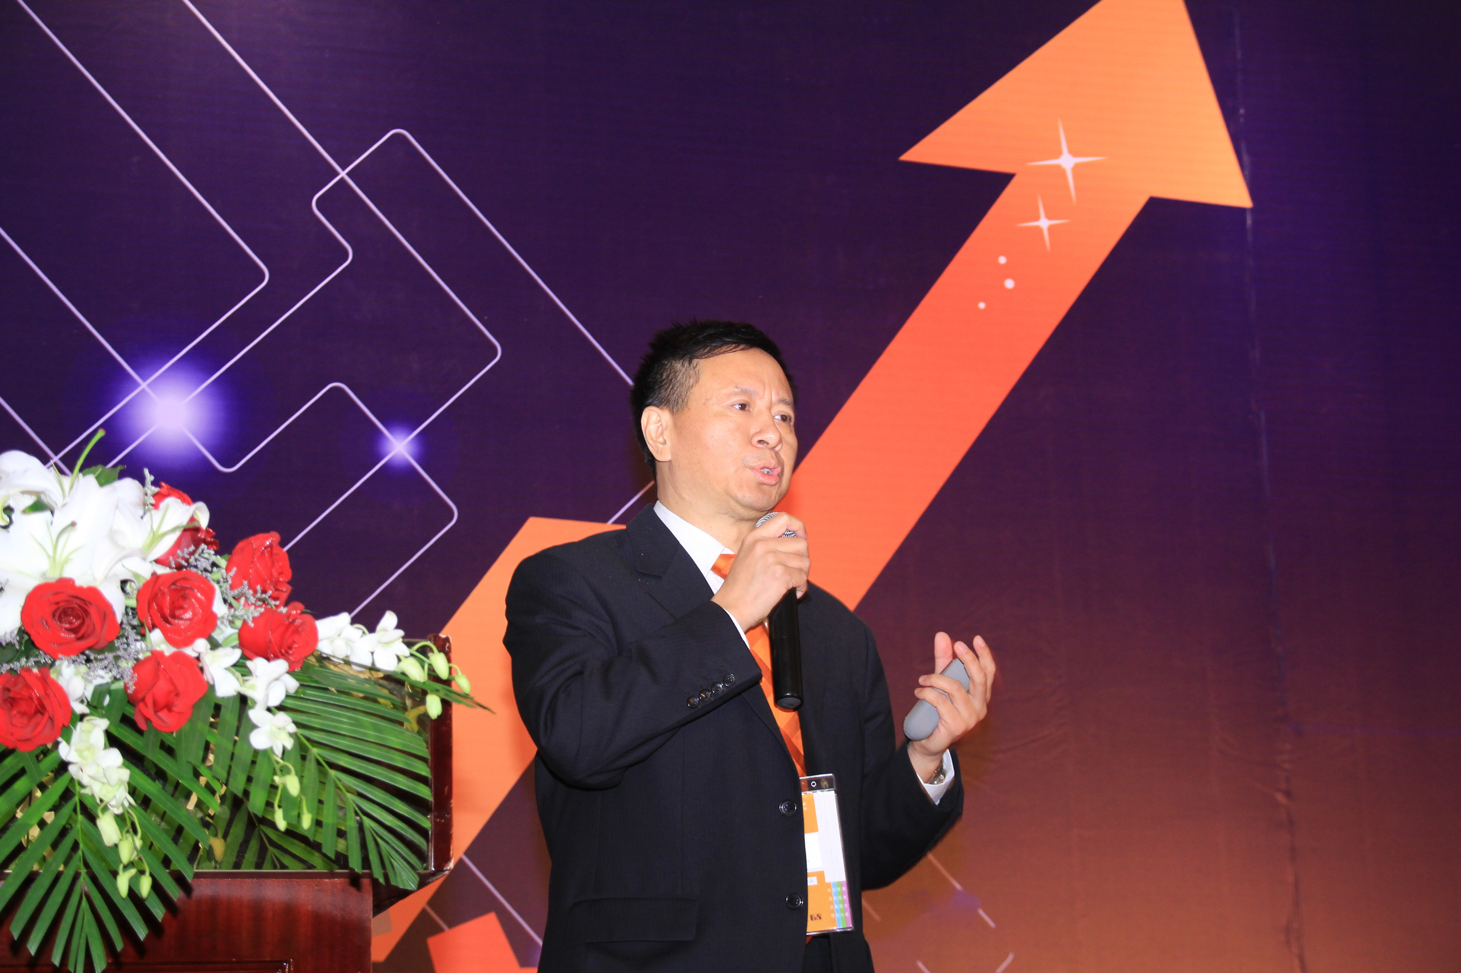
Dr. Xiao Weirong, Managing Director of B&R China, stressed the importance of energy efficiency and intelligent automation for manufacturing companies at the User Meeting in Shanghai.

B&R Hakkında
ABB Grubunun bir bölümü olan B&R, merkezi Avusturya'da bulunan endüstriyel otomasyon alanında global bir liderdir. B&R, neredeyse her sektördeki müşterilere makine ve fabrika otomasyonu, hareket kontrolü, HMI ve entegre güvenlik teknolojisi için eksiksiz çözümler sunmak üzere en son teknolojiyi ileri mühendislikle birleştiriyor. OPC UA, POWERLINK ve openSAFETY gibi Endüstriyel IoT iletişim standartlarının yanı sıra Automation Studio yazılımıyla B&R, otomasyon mühendisliğinin geleceğini sürekli olarak yeniden tanımlıyor. B&R'ı endüstriyel otomasyonun ön saflarında tutan yenilikçi ruh, süreçleri basitleştirme ve müşteri beklentilerini aşma taahhüdünden kaynaklanmaktadır.
Daha fazla bilgi için www.br-automation.com adresini ziyaret edin.

