B&R China User Meeting in Shanghai was a huge success
B&R demonstrates flexibility and innovative prowess
There were over one hundred visitors at the B&R China User Meeting in Shanghai at the end of last year. Two hot topics dominated the event – energy efficiency and intelligent automation. "More than ever, the field of industrial automation is called upon to tackle challenges such as improving energy efficiency in production facilities, reducing the time and cost spent on maintaining equipment, and providing a uniform development platform for producers," says Dr. Xiao Weirong, managing director of B&R China. "B&R solutions have the flexibility it takes to master these challenges with versatile hardware and software that can be tailored to our customers' wishes."
Monitor your plant from a smartphone or tablet
Chen Zhiping, Zhou Jing and Fan Huifang, all department managers at B&R China, held lectures on various topics. They spoke about the development of web-based system applications, about project management for electrical systems and about B&R's System Diagnostics Manager (SDM). With SDM, users benefit from quick access to detailed information about their hardware and software – at any time and from anywhere in the world. The functionality of the diagnostics tool was demonstrated by Chen Weikang from B&R's partner company, Datong Information Company, with assistance from the iSee app. This app supports remote plant maintenance and monitoring, appointment scheduling and disturbance and alarm messaging via smartphones and tablets.
B&R solutions welcomed by Chinese users
User Meeting participants also got a look at the latest products and solutions from B&R. Among the highlights was the philosophy of Smart Engineering, demonstrated by the new Automation Studio 4, which helps cut development costs and accelerate time-to-market in spite of ever increasing product complexity. The new energy data management solution, APROL EnMon, was also met with great interest. This solution helps users implement ISO 50001, and by improving energy efficiency it helps them lower costs and strengthen their competitive edge. Yet another highlight was the latest box PC from B&R, the Automation PC 910. The latest 3rd generation Intel® Core™ i-series processor technology provides the highest performance currently available on any industrial PC.

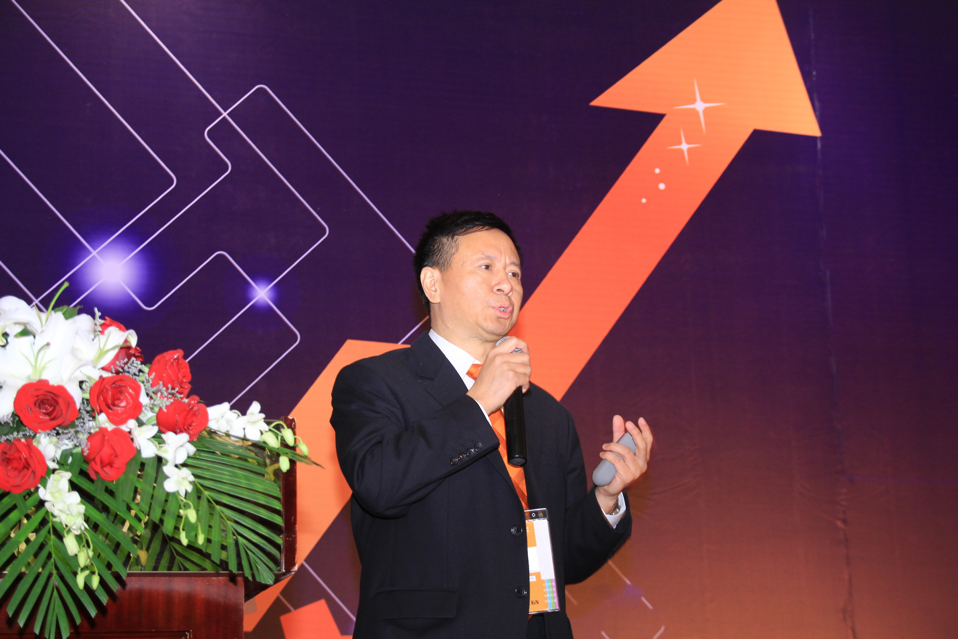
Dr. Xiao Weirong, Managing Director of B&R China, stressed the importance of energy efficiency and intelligent automation for manufacturing companies at the User Meeting in Shanghai.
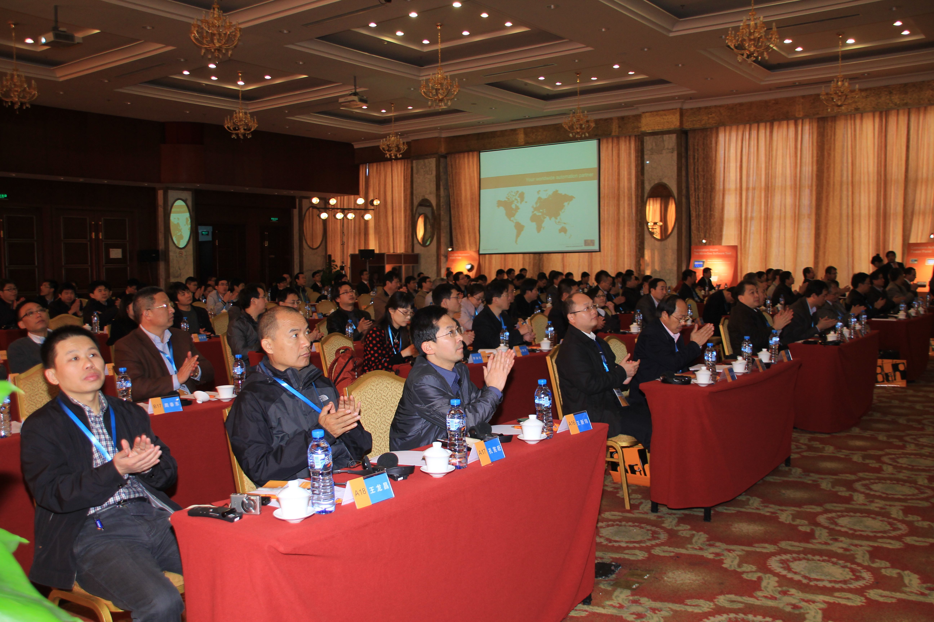
More than one hundred participants took advantage of the B&R User Meeting in Shanghai as an opportunity to get informed about current trends in automation and the latest innovations from B&R.

关于贝加莱
贝加莱是一家总部位于奥地利并在全球拥有分公司的创新型自动化企业。2017年7月，贝加莱成为ABB集团的机械自动化事业部。作为工业自动化领域的全球领导者，贝加莱将前沿技术与领先工程相结合，为几乎每个行业的客户提供面向机器与工厂自动化、运动控制、HMI和集成安全技术的完整解决方案。借助于OPC UA、POWERLINK、openSAFETY等工业物联网通信标准，以及强大的Automation Studio软件开发平台，贝加莱不断重新定义自动化工程的未来。受简化流程和超出客户预期的承诺驱动，贝加莱始终保持创新精神并处于工业自动化领域的前沿。
获取更多信息，请访问www.br-automation.com。

