B&R at the 2013 Hannover Messe
Innovative automation for integrated industrial applications
The eleven international trade fairs covering all areas of technology that are being held at the Hanover Trade Show (April 8-12, 2013) are a powerful stimulus for investments in automation and technology. B&R will be presenting all of their products and services at this industrial automation trade show (Hall 9, Booth D28). One of the main focal points will be the company's latest developments. These open up new possibilities for machine and system manufacturers to increase their competitiveness, and reflect the leitmotif guiding this year's Hanover Trade Show: "Integrated Industry", which highlights the growing interdependence between all areas of industry.
Drastically reduced development costs
B&R's dedication to providing solutions that fully integrate all aspects of development has taken on new dimensions with the new generation of its engineering environment, Automation Studio 4. It takes the B&R's smart engineering philosophy and applies it in a practical manner by increasing development efficiency and – in spite of continually increasing machine and system complexity – helping to meet demands for low development costs and short time to market.
The third generation has arrived
At Hanover, B&R will be presenting far-reaching innovations in every area of industrial automation. One example is the Automation PC 910 Box PC, a new family of high-powered industrial PCs that uses the latest Intel® Core™ i-series technology to provide end users with unparalleled flexibility and substantial cost benefits.
Efficient redundancy solution
B&R's failsafe systems are extraordinarily efficient – and therefore also attractive for smaller applications in traditional machine automation – including PLC redundancy for the B&R X20 system integrated in the Automation Studio 4 software environment. The communication protocol for this solution is the high-performance POWERLINK real-time fieldbus. POWERLINK provides extremely short response times for applications with unprecedented speed and performance.
Optimized energy management
As a solution for energy data management, APROL EnMon helps users improve their energy efficiency. This ready-to-use solution, which runs on B&R's Automation PC 910, is a simple way to implement the requirements specified in ISO 50001. The solution helps considerably reduce energy consumption, with the resulting financial savings strengthening users' competitive edge.
ACOPOSmotorsaves space in the control cabinet
B&R has also been busy further developing its ACOPOSmulti drive system. The motor-mounted servo drive, ACOPOSmotor, melds with the motor to form a configurable and easy-to-connect mechatronic servo drive unit with integrated safe motion functions and delivers power right where it is needed on the machine – over the only open safety protocol, openSAFETY. This saves valuable space in the control cabinet and advances the development of decentralized machine architectures.
Virtual safety controller – SafeLOGIC-X
For safe automation applications, B&R presents a software-based safety controller whose safety functionality is distributed across safe I/O modules, a standard controller and the HMI application. This solution, called SafeLOGIC-X, allows even smaller, cost-sensitive safety applications to enjoy the benefits of an integrated safety solution with full-fledged support for all safe motion functions. SafeLOGIC-X uses the openSAFETY communication protocol, the first open – and only 100% bus-independent – safety standard for all Industrial Ethernet solutions.
Modular concept for mobile automation
The ultimate demonstration of "Integrated Industry" can be found in B&R's line of mobile automation solutions. These operation and monitoring devices, remote PLCs and distributed I/O units designed for outdoor applications and special-purpose vehicles are just as modular as B&R's products for production halls and large-scale plants. Since they are also fully compatible with these traditional automation systems, the mobile machines can also be seamlessly integrated in an overall system.

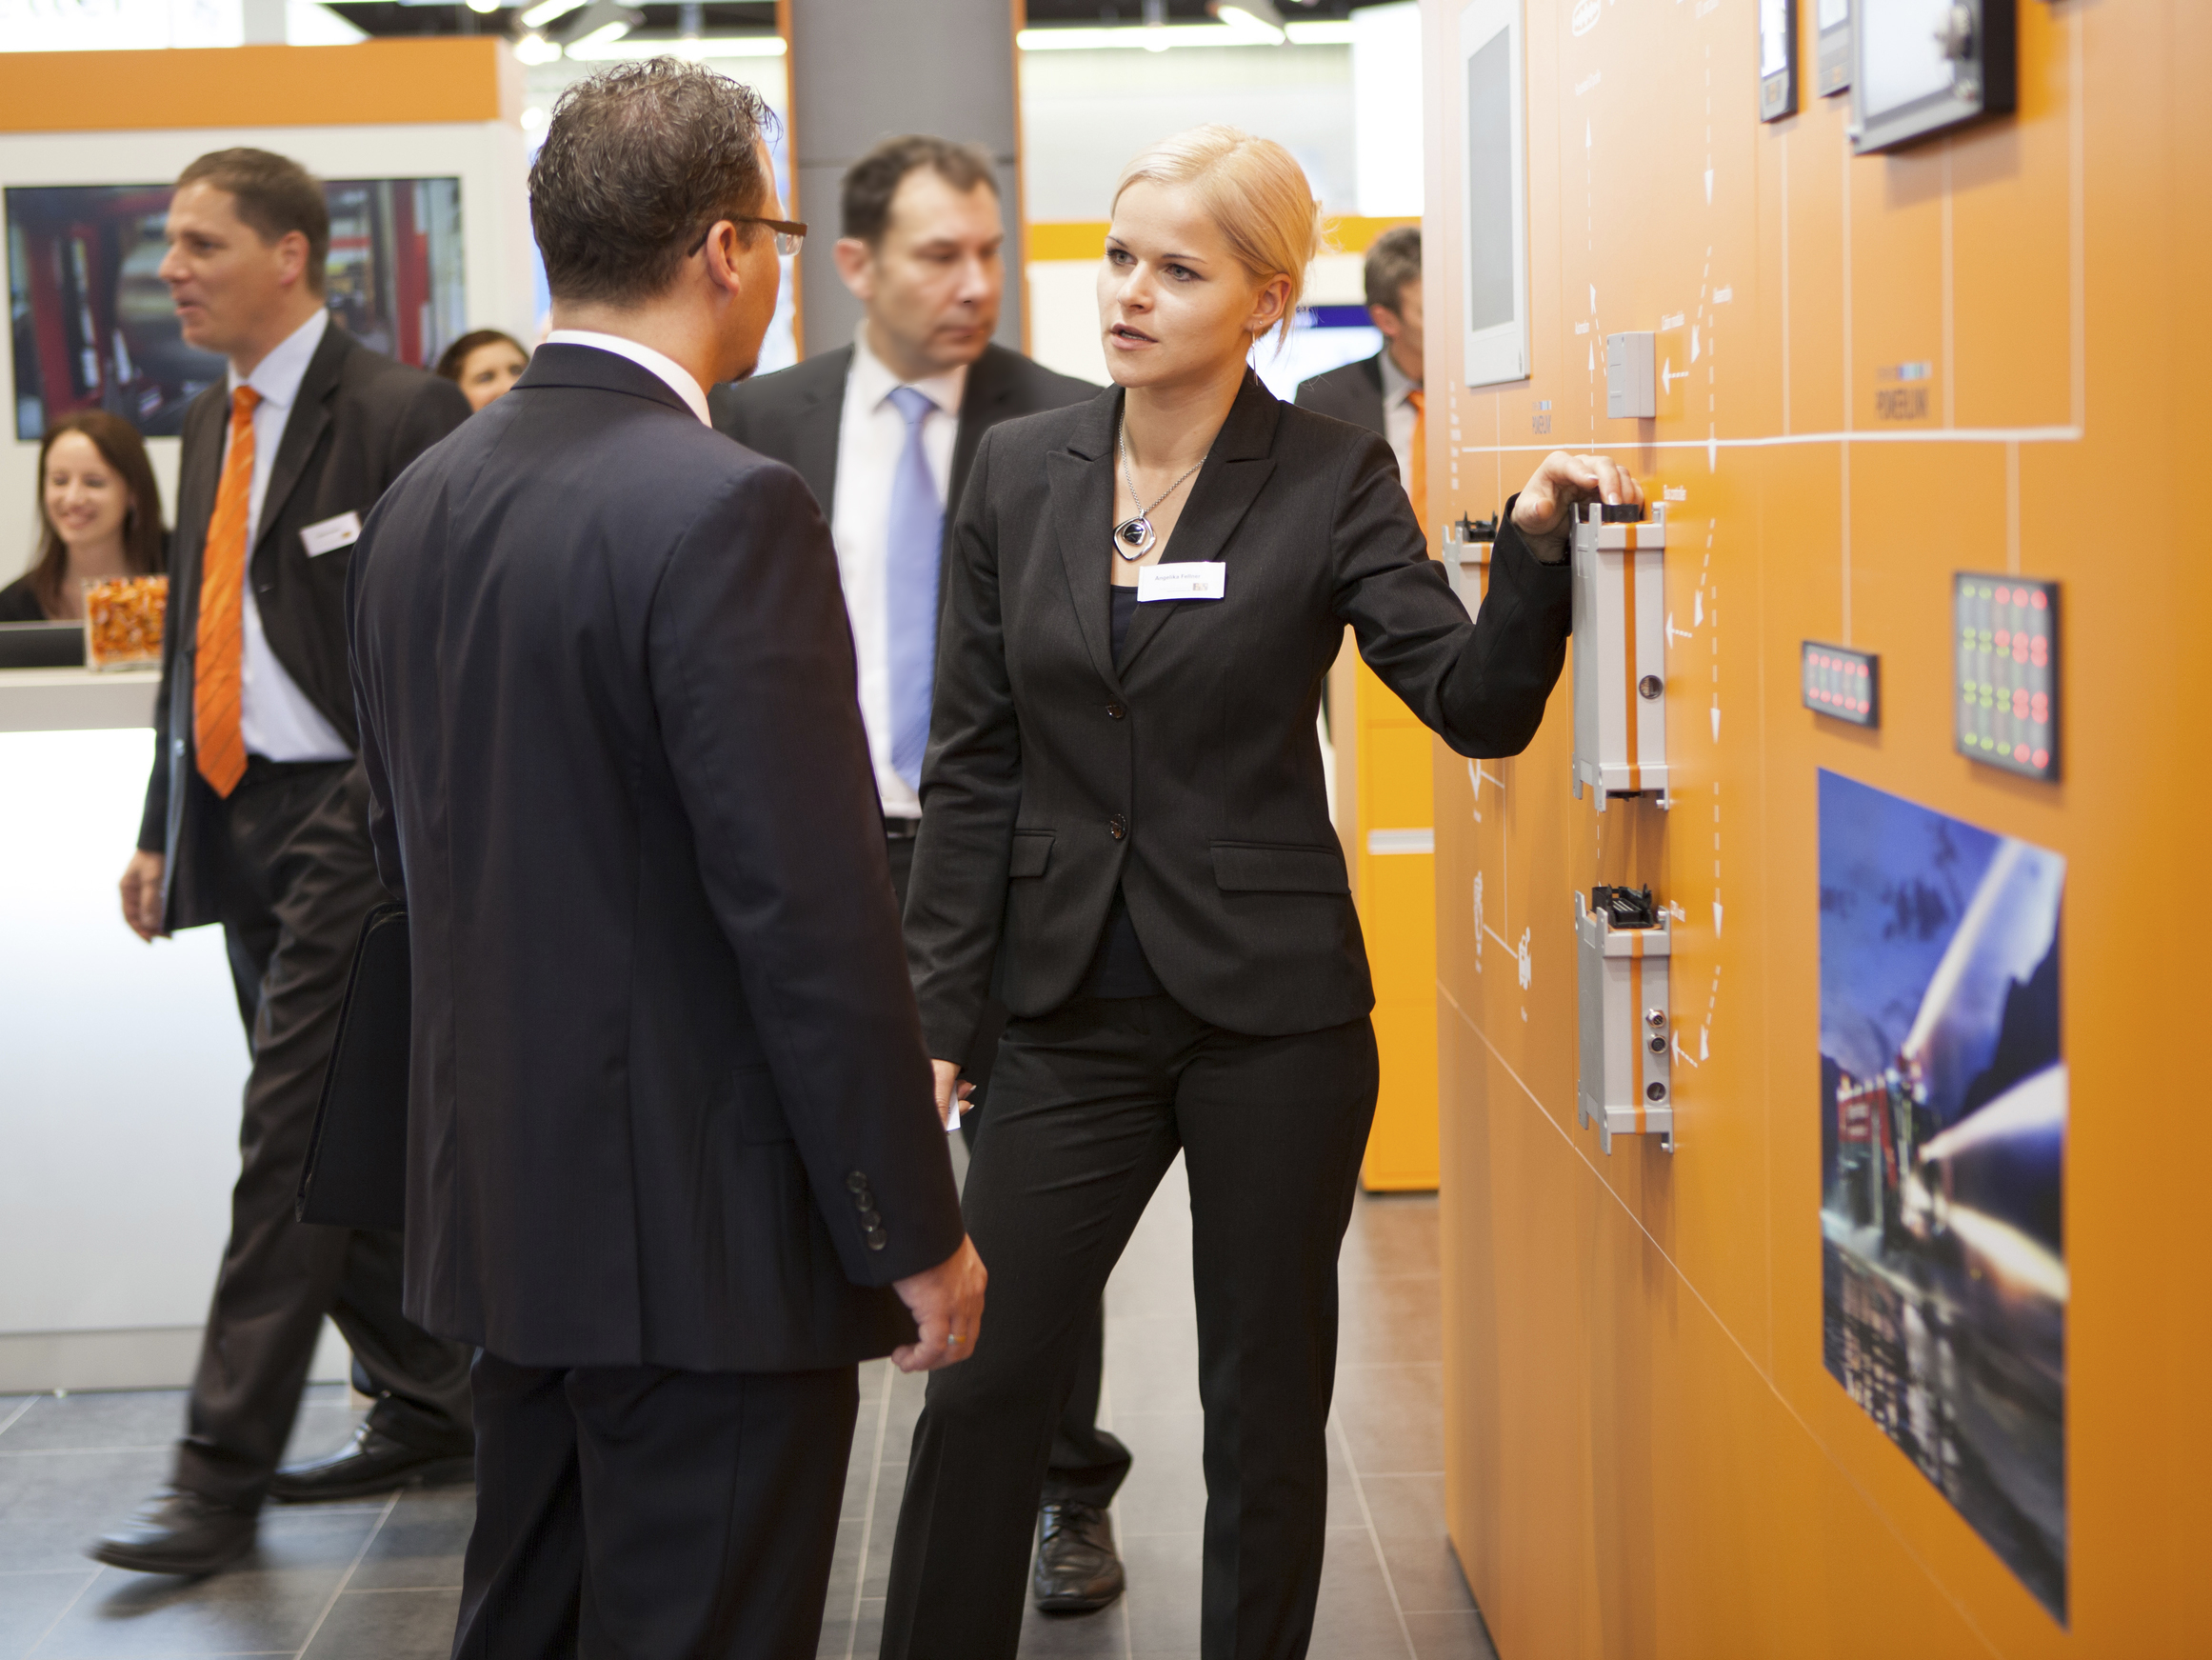
At the 2013 Hanover Trade Show (Hall 9, Booth D28), B&R will be presenting innovative automation solutions for various applications including mobile machinery.
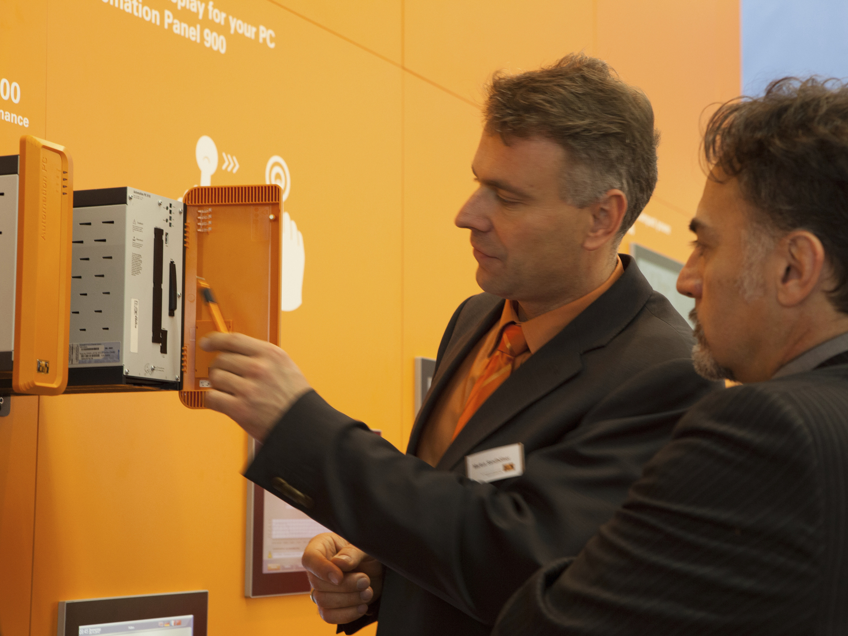
Also being presented at the Hanover Trade Show: B&R's new Automation PC 910 Box PC – the most powerful industrial PC on the market.

B&R Hakkında
ABB Grubunun bir bölümü olan B&R, merkezi Avusturya'da bulunan endüstriyel otomasyon alanında global bir liderdir. B&R, neredeyse her sektördeki müşterilere makine ve fabrika otomasyonu, hareket kontrolü, HMI ve entegre güvenlik teknolojisi için eksiksiz çözümler sunmak üzere en son teknolojiyi ileri mühendislikle birleştiriyor. OPC UA, POWERLINK ve openSAFETY gibi Endüstriyel IoT iletişim standartlarının yanı sıra Automation Studio yazılımıyla B&R, otomasyon mühendisliğinin geleceğini sürekli olarak yeniden tanımlıyor. B&R'ı endüstriyel otomasyonun ön saflarında tutan yenilikçi ruh, süreçleri basitleştirme ve müşteri beklentilerini aşma taahhüdünden kaynaklanmaktadır.
Daha fazla bilgi için www.br-automation.com adresini ziyaret edin.

