B&R at the 2013 Hanover Trade Show
Innovative automation for integrated industrial applications
The eleven international trade fairs covering all areas of technology that are being held at the Hanover Trade Show (April 8-12, 2013) are a powerful stimulus for investments in automation and technology. B&R will be presenting all of their products and services at this industrial automation trade show (Hall 9, Booth D28). One of the main focal points will be the company's latest developments. These open up new possibilities for machine and system manufacturers to increase their competitiveness, and reflect the leitmotif guiding this year's Hanover Trade Show: "Integrated Industry", which highlights the growing interdependence between all areas of industry.
Significantly reducing development costs
B&R's dedication to providing solutions that fully integrate all aspects of development has taken on new dimensions with the new generation of its engineering environment, Automation Studio 4. It takes the B&R's smart engineering philosophy and applies it in a practical manner by increasing development efficiency and – in spite of continually increasing machine and system complexity – helping to meet demands for low development costs and short time to market.
第三代已经来临
At Hanover, B&R will be presenting far-reaching innovations in every area of industrial automation. With the Automation PC 910, B&R introduces a new family of powerful industrial box PCs that promise users extreme levels of freedom and cost-efficiency with the latest generation of Intel® Core™ i-series processing technology.
Efficient redundancy solution
B&R's failsafe systems are extraordinarily efficient – and therefore also attractive for smaller applications in traditional machine automation – including PLC redundancy for the B&R X20 System integrated in the Automation Studio 4 software environment. The communication protocol for this solution is the high-performance POWERLINK real-time fieldbus. POWERLINK provides extremely short response times for applications with unprecedented speed and performance.
Optimized energy management
As a solution for energy data management, APROL EnMon helps users improve their energy efficiency. This out-of-the-box solution that runs on B&R'S Automation PC 910 is a simple way to implement the requirements specified in ISO 50001. APROL EnMon helps considerably reduce energy consumption, and the resulting financial savings strengthens users' competitive edge.
ACOPOSmotor saves space in the control cabinet
B&R has also been busy further developing its ACOPOSmulti drive system. The motor-mounted servo drive, ACOPOSmotor, melds with the motor to form a configurable and easy-to-connect mechatronic servo drive unit with integrated safe motion functions and delivers power right where it is needed on the machine – over the only open safety protocol, openSAFETY. This saves valuable space in the control cabinet and advances the development of decentralized machine architectures.
Virtual safe controller – SafeLOGIC-X
For safe automation applications, B&R presents a software-based safety controller whose safety functionality is distributed across safe I/O modules, a standard controller and the HMI application. This solution, called SafeLOGIC-X, allows even smaller, cost-sensitive safety applications to enjoy the benefits of an integrated safety solution with full-fledged support for all safe motion functions. SafeLOGIC-X uses the openSAFETY communication protocol, the first open – and only 100% bus-independent – safety standard for all Industrial Ethernet solutions.
Modular concept for mobile automation
The ultimate demonstration of "Integrated Industry" can be found in B&R's line of mobile automation solutions. These operation and monitoring devices, remote PLCs and distributed I/O units designed for outdoor applications and special-purpose vehicles are just as modular as B&R's products for production halls and large-scale plants. Since they are also fully compatible with these traditional automation systems, the mobile machines can also be seamlessly integrated in an overall system.

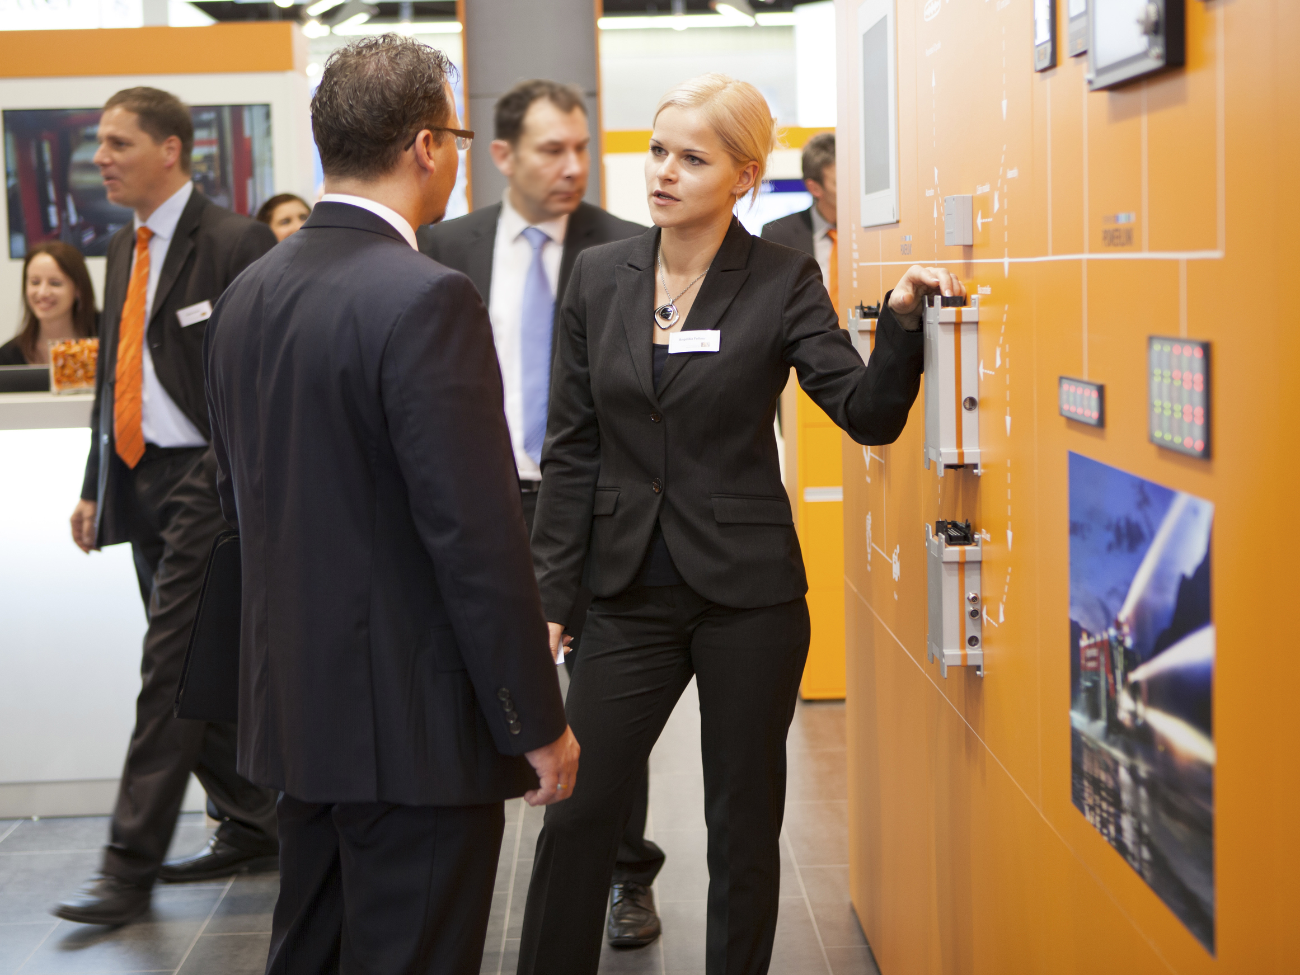
在2013年汉诺威展会（9号馆，展位号D28）上，贝加莱将针对包括移动机械在内的各种应用展示创新的自动化解决方案。
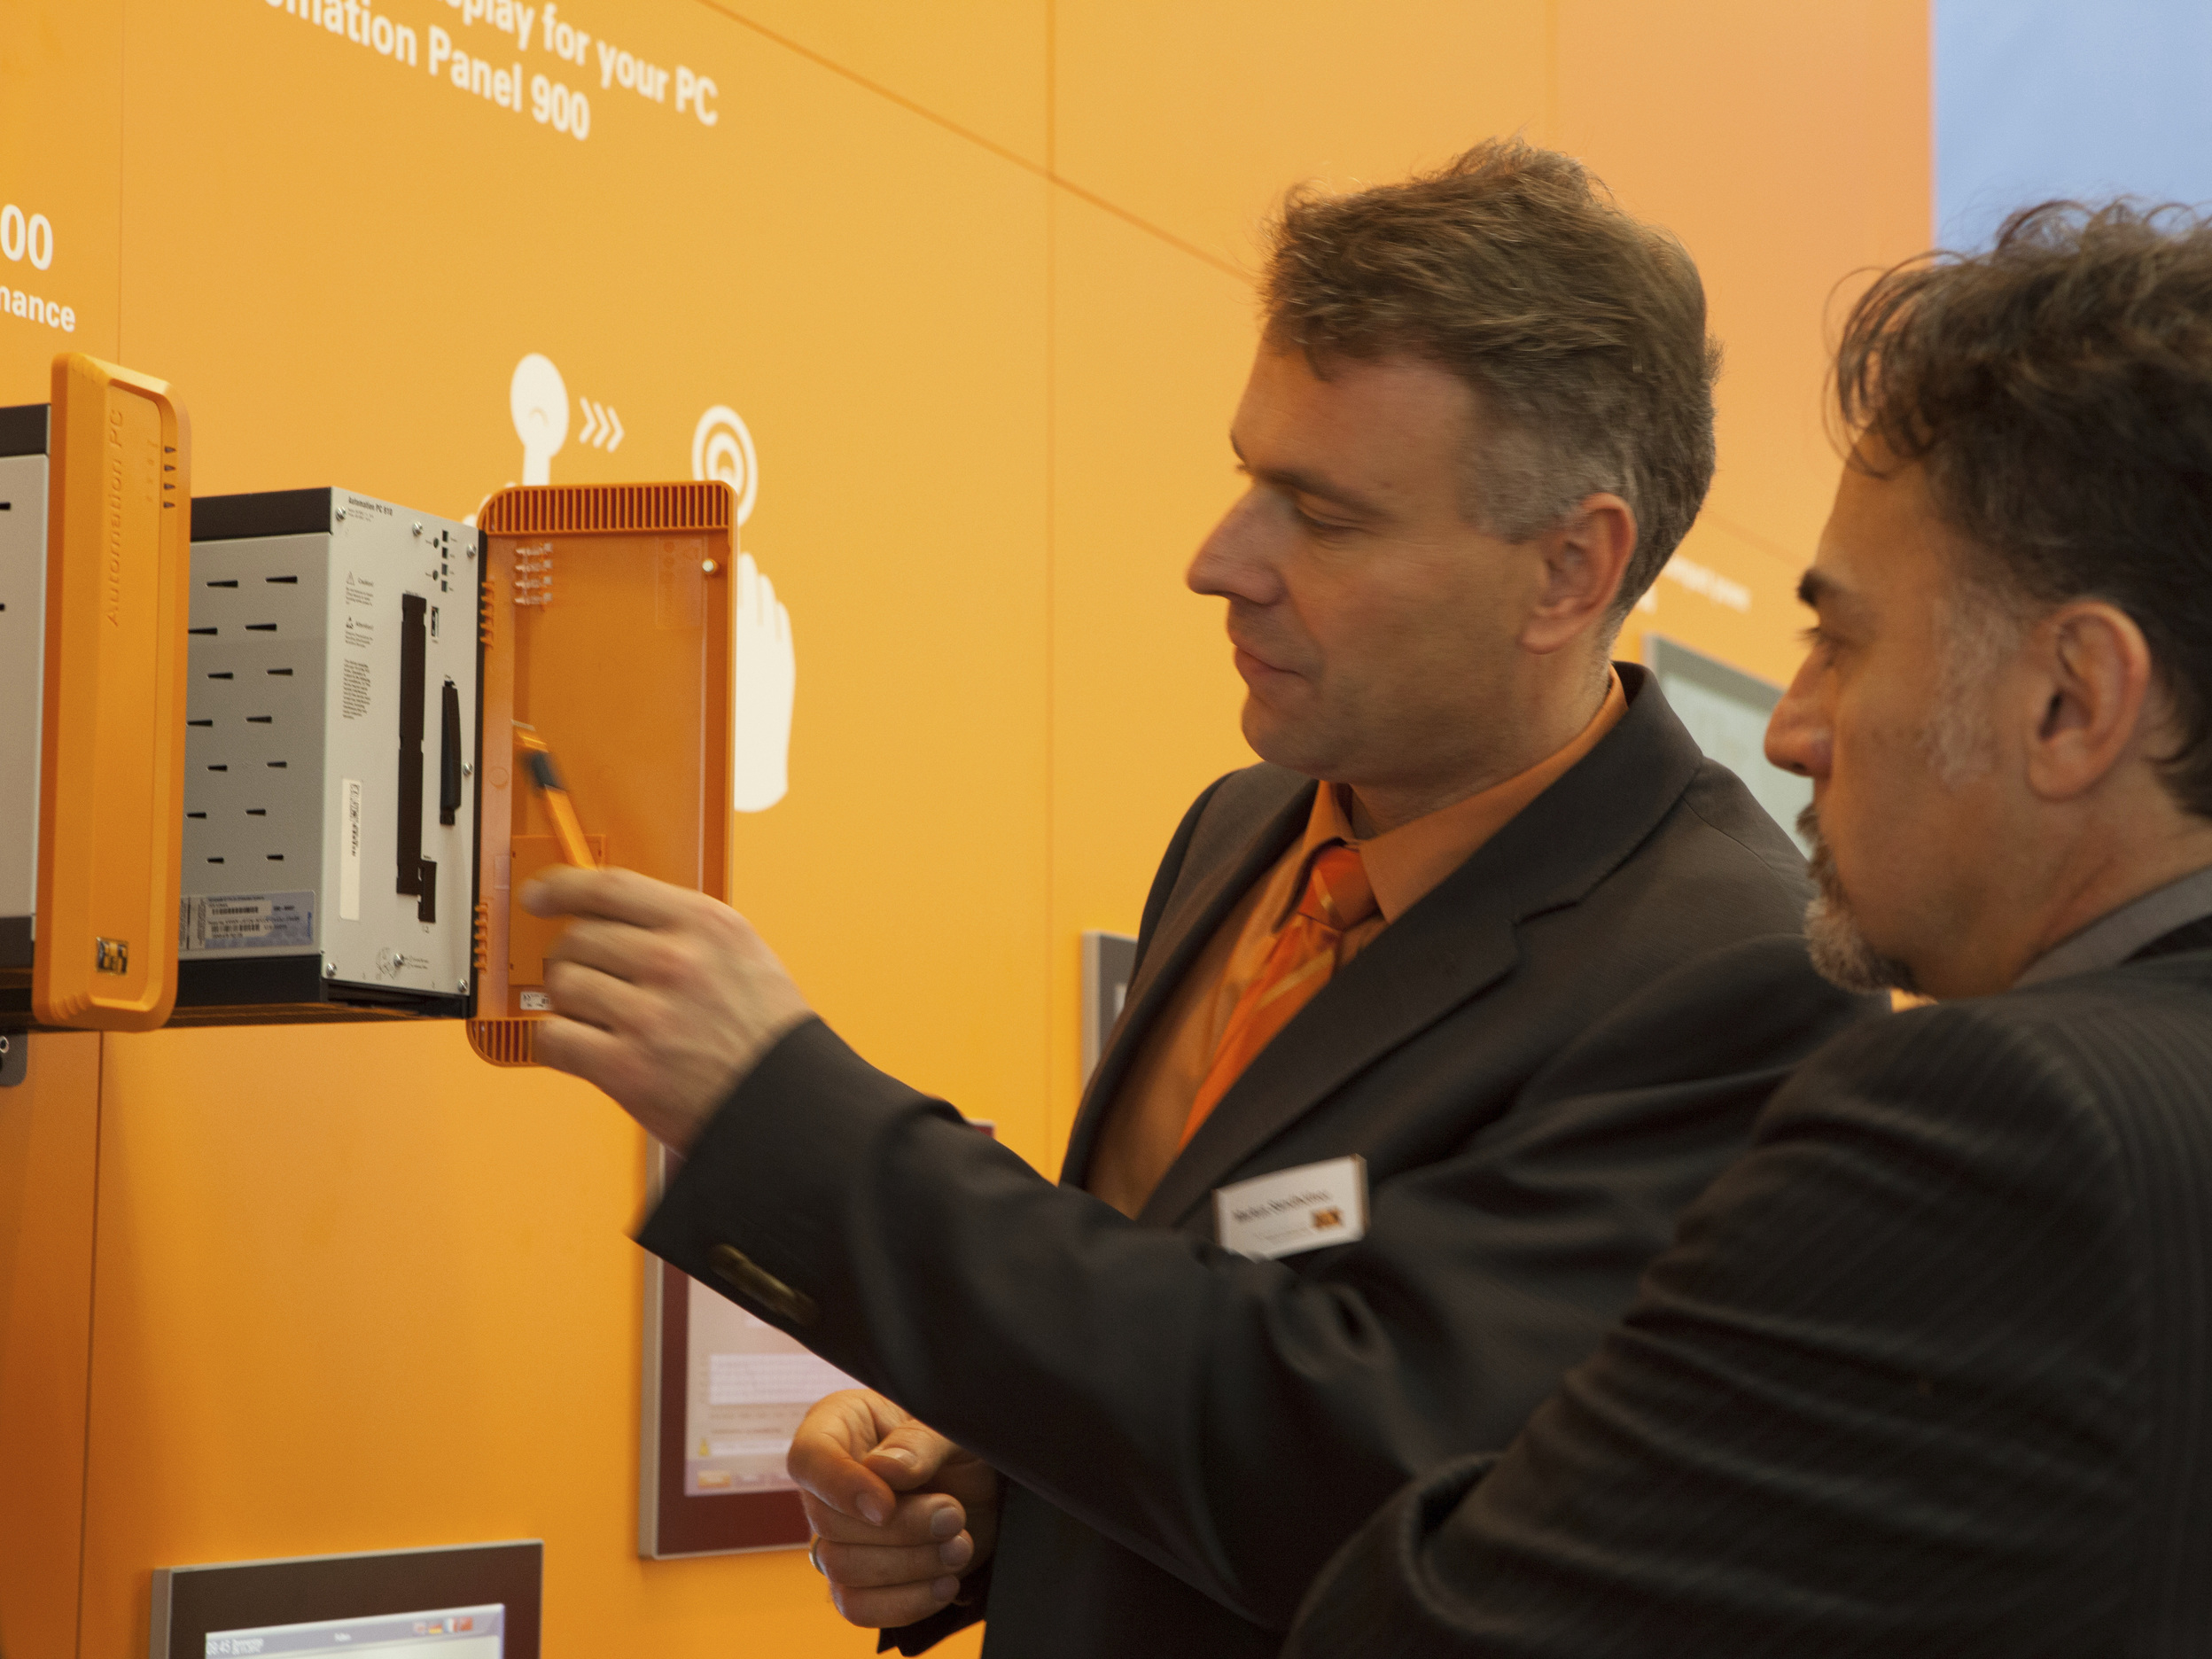
Also being presented at the Hanover Trade Show: B&R's new Automation PC 910 Box PC – the most powerful industrial PC on the market.

关于贝加莱
贝加莱是一家总部位于奥地利并在全球拥有分公司的创新型自动化企业。2017年7月，贝加莱成为ABB集团的机械自动化事业部。作为工业自动化领域的全球领导者，贝加莱将前沿技术与领先工程相结合，为几乎每个行业的客户提供面向机器与工厂自动化、运动控制、HMI和集成安全技术的完整解决方案。借助于OPC UA、POWERLINK、openSAFETY等工业物联网通信标准，以及强大的Automation Studio软件开发平台，贝加莱不断重新定义自动化工程的未来。受简化流程和超出客户预期的承诺驱动，贝加莱始终保持创新精神并处于工业自动化领域的前沿。
获取更多信息，请访问www.br-automation.com。

