International Packaging Conclave 2012
Nestlé and B&R promote open technology standards for packaging lines
The 2012 International Packaging Conclave in Greater Noida, India, recorded a resounding success, bringing together 110 participants – including top managers from some of the most prominent end-user companies in the food & beverage and pharmaceutical industries. Focusing on its theme of “Integration and collaboration across the packaging value chain”, the conclave provided an interactive platform for panel discussions and case studies. Together, speakers and participants addressed the potential for improved productivity, sustainability, OEE and ROI in the packaging industry.
Consistency & transparency for greater efficiency – PackML
During the central panel discussion on the role of open technology in the future of packaging line automation, Dr. Bryan Griffen, Electrical & Automation Engineering Manager at Nestlé and chairman of the OMAC Packaging Workgroup (OPW), spoke about the key benefits that embracing a technology standard like PackML could bring to end users, OEMs and system integrators.
Griffen recalled Nestlé’s realization that dictating a single automation supplier for an entire packaging line is neither practical nor feasible, and that the best results are obtained when machine builders use the technology that best suits their needs. “At the same time,” said Griffen, “we still need to be able to integrate these machines to create a functional packaging line.” OMAC guidelines like the PackML standard establish functional specifications and preferred suppliers rather than proprietary brand specifications. This gives machine builders the freedom to select whatever technology best meets their requirements, while allowing end users to easily and fully integrate the machines on the line. “By going with international standards like PackML, you can get consistent information and a common look and feel over installed lines as well as new installations, even using disparate automation technologies,” concluded Griffen, inviting his fellow Packaging Conclave attendees to become corporate members of OMAC and join him on the OMAC Packaging Workgroup.
Ending the “fieldbus wars” with openSAFETY
Maurizio Tarozzi, Global Technology Manager for Packaging Solutions at B&R, explained how openSAFETY, the first open and the only bus-independent safety standard for all Industrial Ethernet solutions, can take packaging line integration and effectiveness a step further. Presenting a case study featuring a complete beverage line for filling water into plastic bottles, Tarozzi illustrated how openSAFETY is able to transfer safety data such as E-stop button activation, light curtain violations, etc. between disparate PLC technologies used throughout a single packaging line.
“Safety networks can provide a new level of integrated safety and diagnostics,” pointed out Griffen in the Q&A session that followed. However, with industrial bus organizations each proposing their own safety network, Griffen sees openSAFETY – an IEC-compliant protocol that can run on the application layer of any major network – as a potential solution to what have been dubbed the “fieldbus wars”.

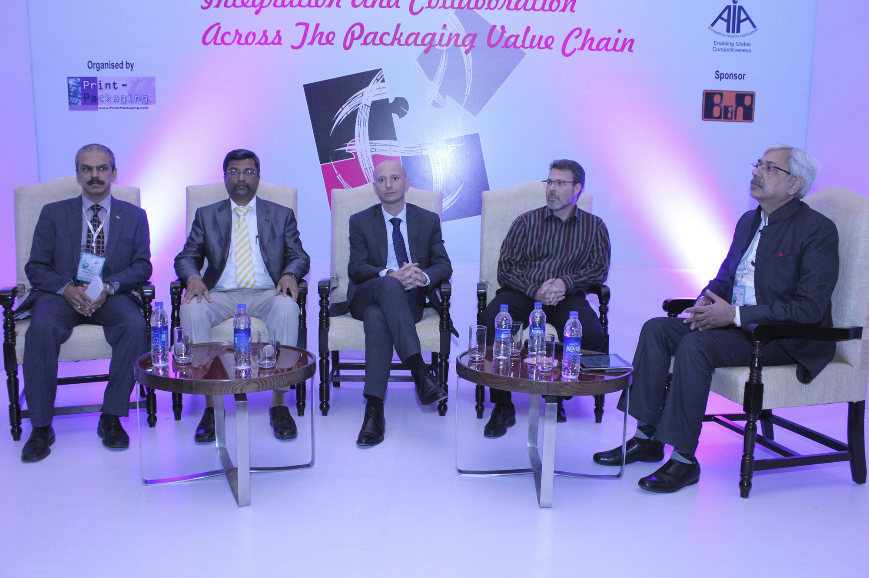
Panel discussion about open technology standards (from left to right): Mahabaleshwara B.L., Nestle India, Satish Ansingkar, B&R, Maurizio Tarozzi, B&R, Bryan Griffen, Nestle/Chairman OMAC Packaging Workgroup (OPW) and moderator Anup Wadhwa.

B&R Hakkında
ABB Grubunun bir bölümü olan B&R, merkezi Avusturya'da bulunan endüstriyel otomasyon alanında global bir liderdir. B&R, neredeyse her sektördeki müşterilere makine ve fabrika otomasyonu, hareket kontrolü, HMI ve entegre güvenlik teknolojisi için eksiksiz çözümler sunmak üzere en son teknolojiyi ileri mühendislikle birleştiriyor. OPC UA, POWERLINK ve openSAFETY gibi Endüstriyel IoT iletişim standartlarının yanı sıra Automation Studio yazılımıyla B&R, otomasyon mühendisliğinin geleceğini sürekli olarak yeniden tanımlıyor. B&R'ı endüstriyel otomasyonun ön saflarında tutan yenilikçi ruh, süreçleri basitleştirme ve müşteri beklentilerini aşma taahhüdünden kaynaklanmaktadır.
Daha fazla bilgi için www.br-automation.com adresini ziyaret edin.

