International Packaging Conclave 2012
Nestlé and B&R promote open technology standards for packaging lines
The 2012 International Packaging Conclave in Greater Noida, India, recorded a resounding success, bringing together 110 participants – including top managers from some of the most prominent end-user companies in the food & beverage and pharmaceutical industries. Focusing on its theme of “Integration and collaboration across the packaging value chain”, the conclave provided an interactive platform for panel discussions and case studies. Together, speakers and participants addressed the potential for improved productivity, sustainability, OEE and ROI in the packaging industry.
Consistency & transparency for greater efficiency – PackML
During the central panel discussion on the role of open technology in the future of packaging line automation, Dr. Bryan Griffen, Electrical & Automation Engineering Manager at Nestlé and chairman of the OMAC Packaging Workgroup (OPW), spoke about the key benefits that embracing a technology standard like PackML could bring to end users, OEMs and system integrators.
Griffen recalled Nestlé’s realization that dictating a single automation supplier for an entire packaging line is neither practical nor feasible, and that the best results are obtained when machine builders use the technology that best suits their needs. “At the same time,” said Griffen, “we still need to be able to integrate these machines to create a functional packaging line.” OMAC guidelines like the PackML standard establish functional specifications and preferred suppliers rather than proprietary brand specifications. This gives machine builders the freedom to select whatever technology best meets their requirements, while allowing end users to easily and fully integrate the machines on the line. “By going with international standards like PackML, you can get consistent information and a common look and feel over installed lines as well as new installations, even using disparate automation technologies,” concluded Griffen, inviting his fellow Packaging Conclave attendees to become corporate members of OMAC and join him on the OMAC Packaging Workgroup.
Ending the “fieldbus wars” with openSAFETY
Maurizio Tarozzi, Global Technology Manager for Packaging Solutions at B&R, explained how openSAFETY, the first open and the only bus-independent safety standard for all Industrial Ethernet solutions, can take packaging line integration and effectiveness a step further. Presenting a case study featuring a complete beverage line for filling water into plastic bottles, Tarozzi illustrated how openSAFETY is able to transfer safety data such as E-stop button activation, light curtain violations, etc. between disparate PLC technologies used throughout a single packaging line.
“Safety networks can provide a new level of integrated safety and diagnostics,” pointed out Griffen in the Q&A session that followed. However, with industrial bus organizations each proposing their own safety network, Griffen sees openSAFETY – an IEC-compliant protocol that can run on the application layer of any major network – as a potential solution to what have been dubbed the “fieldbus wars”.

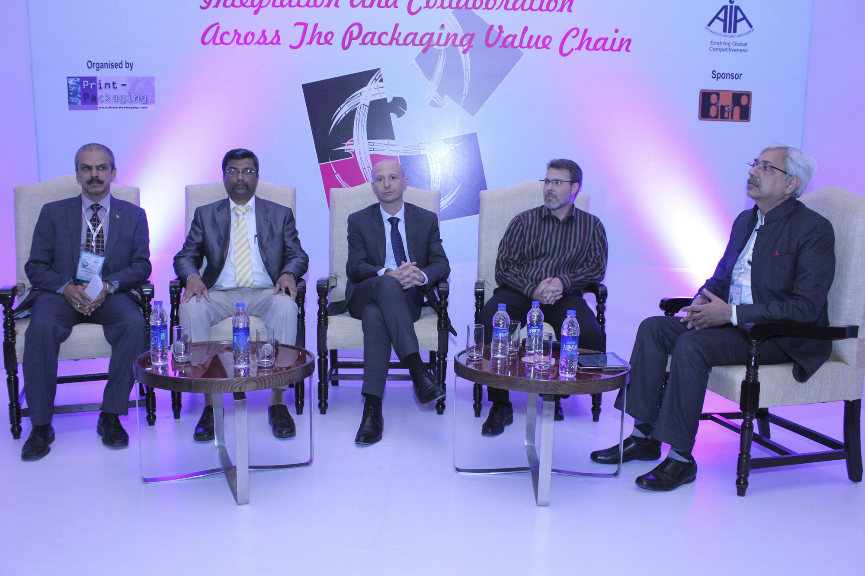
Panel discussion about open technology standards (from left to right): Mahabaleshwara B.L., Nestle India, Satish Ansingkar, B&R, Maurizio Tarozzi, B&R, Bryan Griffen, Nestle/Chairman OMAC Packaging Workgroup (OPW) and moderator Anup Wadhwa.

关于贝加莱
贝加莱是一家总部位于奥地利并在全球拥有分公司的创新型自动化企业。2017年7月，贝加莱成为ABB集团的机械自动化事业部。作为工业自动化领域的全球领导者，贝加莱将前沿技术与领先工程相结合，为几乎每个行业的客户提供面向机器与工厂自动化、运动控制、HMI和集成安全技术的完整解决方案。借助于OPC UA、POWERLINK、openSAFETY等工业物联网通信标准，以及强大的Automation Studio软件开发平台，贝加莱不断重新定义自动化工程的未来。受简化流程和超出客户预期的承诺驱动，贝加莱始终保持创新精神并处于工业自动化领域的前沿。
获取更多信息，请访问www.br-automation.com。

