B&R at bauma 2013 in Munich
Modular automation system for the construction machinery industry
At bauma 2013 from April 15-21, B&R will be presenting its full range of mobile automation solutions in Hall D / Booth D1.216. The highlight of B&R's bauma appearance will be two of the technology leader's latest developments.
With its new MA170 control and I/O system, B&R is mixing things up in the field of construction machinery automation. What's so revolutionary about these systems is their modular design, an approach B&R has perfected in the area of industrial automation and is now bringing to the world of mobile machinery. The mobile automation product range is rounded off by an automation panel, which serves as a central element to provide integrated control, operation and visualization of vehicles and mobile equipment.
The B&R Automation Studio engineering environment streamlines development of complete solutions that are efficiently scalable and easy to maintain. This fully integrated, high-performance tool helps engineers master every aspect of an automation project, with loads of convenient features such as an extensive collection of preprogrammed software libraries.
A new dimension in data communication
B&R's mobile devices are equipped with CAN bus, as is obligatory for vehicles, as well as the option of using POWERLINK, the open and fast real-time standard. As an Ethernet-based protocol, POWERLINK is built for high bandwidth communication, with plenty of capacity to handle demanding applications involving sensors and image processing without requiring any auxiliary hardware or software.

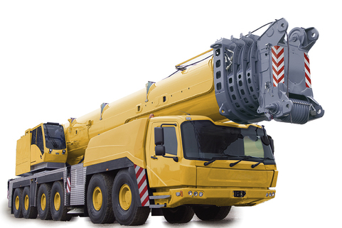
At bauma 2013, B&R will be presenting its full range of mobile automation solutions in Hall D / Booth D1.216, featuring groundbreaking innovations in modular automation for construction machinery.

About B&R
B&R, a division of ABB Group, is a global leader in industrial automation headquartered in Austria. B&R combines state-of-the-art technology with advanced engineering to provide customers in virtually every industry with complete solutions for machine and factory automation, motion control, HMI and integrated safety technology. With Industrial IoT communication standards including OPC UA, POWERLINK and openSAFETY as well as its Automation Studio software, B&R is constantly redefining the future of automation engineering. The innovative spirit that keeps B&R at the forefront of industrial automation is driven by a commitment to simplifying processes and exceeding customer expectations.
For more information, visit www.br-automation.com.

