B&R en la Feria Drinktec 2013 de Múnich
Modular automation system for the construction machinery industry
At bauma 2013 from April 15-21, B&R will be presenting its full range of mobile automation solutions in Hall D / Booth D1.216. The highlight of B&R's bauma appearance will be two of the technology leader's latest developments.
With its new MA170 control and I/O systems, B&R is mixing things up in the field of construction machinery automation. What's so revolutionary about these systems is their modular design, an approach B&R has perfected in the area of industrial automation and is now bringing to the world of mobile machinery. The mobile automation product range is rounded off by an automation panel, which serves as a central element to provide integrated control, operation and visualization of vehicles and mobile equipment.
The B&R Automation Studio engineering environment streamlines development of complete solutions that are efficiently scalable and easy to maintain. This fully-integrated, high-performance tool helps engineers master every aspect of an automation project, with loads of convenient features such as an extensive collection of preprogrammed software libraries.
Una nueva dimensión en la comunicación de datos
B&R's mobile devices are equipped with CAN bus, as is obligatory for vehicles, as well as the option of using POWERLINK, the open and fast real-time standard. As an Ethernet-based protocol, POWERLINK is built for high bandwidth communication, with plenty of capacity to handle demanding applications involving sensors and image processing without requiring any auxiliary hardware or software.

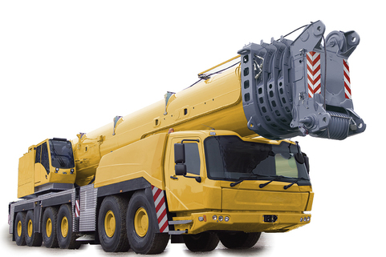
At bauma 2013, B&R will be presenting its full range of mobile automation solutions in Hall D / Booth D1.216, featuring groundbreaking innovations in modular automation for construction machinery.

Acerca de B&R
B&R, empresa perteneciente al Grupo ABB y con sede en Austria, es líder mundial en automatización industrial. B&R combina tecnología de vanguardia con ingeniería avanzada para proporcionar a usuarios de todos los sectores soluciones completas para la automatización de máquinas y fábricas, Motion Control, HMI y tecnología de seguridad integrada. El catálogo de productos se completa con estándares de comunicación de IoT industrial que incluyen OPC UA, POWERLINK y openSAFETY. Gracias a su única herramienta de software Automation Studio, B&R redefine constantemente el futuro de la ingeniería de automatización. El espíritu innovador que mantiene a B&R a la vanguardia de la automatización industrial está impulsado por el compromiso de simplificar los procesos y superar las expectativas de los clientes.Para más información, visite www.br-automation.com.
Para más información, visite www.br-automation.com.

