B&R at bauma 2013 in Munich
Modular automation system for the construction machinery industry
At bauma 2013 from April 15-21, B&R will be presenting its full range of mobile automation solutions in Hall D / Booth D1.216. The highlight of B&R's bauma appearance will be two of the technology leader's latest developments.
With its new MA170 control and I/O systems, B&R is mixing things up in the field of construction machinery automation. What's so revolutionary about these systems is their modular design, an approach B&R has perfected in the area of industrial automation and is now bringing to the world of mobile machinery. The mobile automation product range is rounded off by an automation panel, which serves as a central element to provide integrated control, operation and visualization of vehicles and mobile equipment.
The B&R Automation Studio engineering environment streamlines development of complete solutions that are efficiently scalable and easy to maintain. This fully-integrated, high-performance tool helps engineers master every aspect of an automation project, with loads of convenient features such as an extensive collection of preprogrammed software libraries.
A new dimension in data communication
B&R's mobile devices are equipped with CAN bus, as is obligatory for vehicles, as well as the option of using POWERLINK, the open and fast real-time standard. As an Ethernet-based protocol, POWERLINK is built for high bandwidth communication, with plenty of capacity to handle demanding applications involving sensors and image processing without requiring any auxiliary hardware or software.

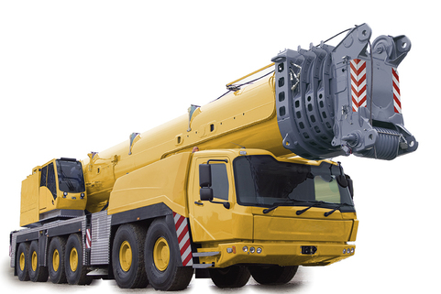
At bauma 2013, B&R will be presenting its full range of mobile automation solutions in Hall D / Booth D1.216, featuring groundbreaking innovations in modular automation for construction machinery.

关于贝加莱
贝加莱是一家总部位于奥地利并在全球拥有分公司的创新型自动化企业。2017年7月，贝加莱成为ABB集团的机械自动化事业部。作为工业自动化领域的全球领导者，贝加莱将前沿技术与领先工程相结合，为几乎每个行业的客户提供面向机器与工厂自动化、运动控制、HMI和集成安全技术的完整解决方案。借助于OPC UA、POWERLINK、openSAFETY等工业物联网通信标准，以及强大的Automation Studio软件开发平台，贝加莱不断重新定义自动化工程的未来。受简化流程和超出客户预期的承诺驱动，贝加莱始终保持创新精神并处于工业自动化领域的前沿。
获取更多信息，请访问www.br-automation.com。

