B&R at Ligna 2013 in Hanover
Increased efficiency and safety for the woodworking industry
This year's Ligna 2013 trade fair starts on May 6th and will run until May 10th. At this premier international timber and woodworking industry event, B&R (Hall 25, Booth D34) will be demonstrating innovative automation solutions that increase both efficiency and safety, thus offering the perfect opportunity for woodworking machine and system manufacturers to increase their competitiveness on the market.
B&R offers complete solutions for the entire range of applications
Ligna covers all areas related to the harvesting and processing of the renewable raw material wood. This includes forestry and saw mill equipment, solid wood processing, wood-based bioenergy, lumber, furniture manufacturing and carpentry. In keeping with this, B&R will be demonstrating their expertise in a wide range of applications at this event, including the areas of mobile machines, systems for biomass heating and machines used to manufacture boards, flooring, construction lumber and furniture.
A common thread throughout the products and solutions being presented in these diverse areas is the extraordinarily high degree of functionality provided in relation to the investment. This is a clear advantage for remaining competitive in an industry with consistently high cost pressures.
Efficient use of resources in all areas
B&R clearly focuses on making sure that energy and materials are used efficiently and performing maintenance is kept as easy as possible. For example, the APROL EnMon solution for managing energy data helps users improve energy efficiency, which in turn allows them to reduce costs and strengthen their competitive edge. This solution also includes ready-made functions for evaluating signals from B&R's compact X20AP energy measurement module, which is used for measuring voltage, current, frequencies and reactive components on all phases.
B&R's condition monitoring module reduces operating costs by providing a way to take advantage of predictive, condition-dependent maintenance. This module eliminates the need for expensive external diagnostic systems since the recorded vibration patterns are preprocessed internally.
Automation Studio 4 supercharges development with sustainable efficiency
The newest generation of B&R's development environment – Automation Studio 4 – relies on Smart Engineering technology to increase efficiency across the board. It keeps development costs low and time to market short, despite the ever-increasing complexity of automation products. In addition, Automation Studio 4 makes it easier to develop modular series-produced machines with a wide range of variants while also providing open interfaces to advanced design and simulation software.
Taking safety technology to new dimensions
The Ligna 2013 trade fair is also the perfect opportunity for B&R to highlight another of their strengths – openSAFETY, the only open, fieldbus-independent safety standard currently on the market. In addition to digital I/O, openSAFETY also covers analog and temperature interfaces as well as safe speed measurement up to SIL3 and PLe. Together with safe drive technology, it enables a large number of extremely fast safe reactions, which offers an opportunity for machine developers to reduce their reliance on E-stop buttons that can often result in damage.
openSAFETY can be seamlessly integrated into any standard control system. This includes B&R solutions for automating, operating and visualizing mobile systems, for example in the harvesting of timber. When applied to vehicle-mounted tools being used in a forest, B&R's integrated safety approach can help achieve occupational safety levels similar to those in a modern factory.
These highlights and more will be featured at the B&R booth as part of a comprehensive exhibition of notable innovations spanning every area of automation, further increasing B&R's already outstanding market position in the woodworking industry.

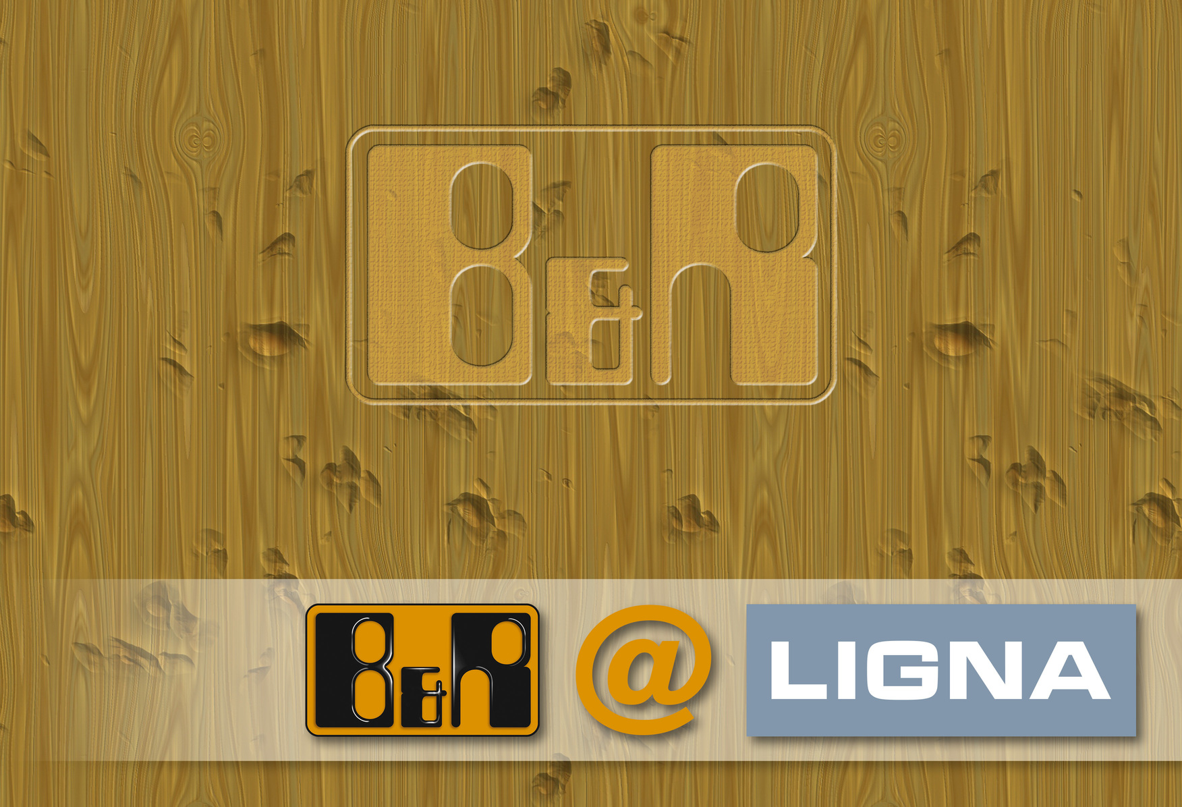
At Ligna 2013, B&R (Hall 25, Booth D34) will be presenting innovative automation solutions for the woodworking industry.

关于贝加莱
贝加莱是一家总部位于奥地利并在全球拥有分公司的创新型自动化企业。2017年7月，贝加莱成为ABB集团的机械自动化事业部。作为工业自动化领域的全球领导者，贝加莱将前沿技术与领先工程相结合，为几乎每个行业的客户提供面向机器与工厂自动化、运动控制、HMI和集成安全技术的完整解决方案。借助于OPC UA、POWERLINK、openSAFETY等工业物联网通信标准，以及强大的Automation Studio软件开发平台，贝加莱不断重新定义自动化工程的未来。受简化流程和超出客户预期的承诺驱动，贝加莱始终保持创新精神并处于工业自动化领域的前沿。
获取更多信息，请访问www.br-automation.com。

