B&R at BLECH India 2013 in Mumbai
Innovative solutions for the metal industry
From April 17th to the 20th, BLECH India, the Technology Exhibition for Sheet Metal Working, is taking place in Mumbai at Bombay Exhibition Centre for the third time.
At BLECH India, B&R will be found at Hall 1, Stall D110 presenting its full range of products and services, as well as custom solutions tailored specifically to the metal industry.
Experience the Technology trusted by the Global market leaders in sheet metal processing
B&R have on display most powerful PLC in the market, Intelligent IO system, HMIs with built in controllers, Rugged Industrial PCs and flexible software for CNC and robotics paired with integrated safety technology. This makes B&R’s solutions perfectly equipped to handle the needs of Metal industry.
Cutting, bending and stamping with integrated robotics
Worldwide B&R solutions can be found in both hydraulic and fully electric bending machines. They are also used in cutting machines that operate with laser, plasma, oxy-fuel and water jet cutting technology. Manufacturers of specialty bending machines for pipes, profiles and wires have experienced the advantage of B&R automation, as have suppliers of all types of stamping machinery. B&R technology melds perfectly into fully integrated cells that perform robotic bending or a combination of processing steps such as laser cutting and bending.
Energy savings, integrated safety technology and condition monitoring ensure reliability and efficiency
With its integrated safety technology and its economic and easy-to-implement condition monitoring solution, B&R is setting trends that will bring sustained benefits for machine manufacturers. B&R has also answered the call for energy-efficient solutions loud and clear – with innovations that can bring up to 80% energy savings. Prominent features of these solutions are the ACOPOSmulti servo system and innovative variable speed hydraulic drives.
Integrated Safety Technology and Ethernet POWERLINK
Integrated Safety Technology, a trend-setting solution for machine manufacturing that integrates safety seamlessly into the standard control system and eliminates the need for extra wiring. All control components are seamlessly integrated using POWERLINK. It is the world's most widely used Industrial Ethernet protocol in applications where plant productivity depends on motion control technology.
  - About B&R
B&R has its head-office at Pune, Maharashtra and four other offices in India. B&R is fully equipped to cater to your application, supply and support requirements right in India. A global leader in industrial automation, B&R provides complete solutions for machine and process automation, motion control, HMI and integrated safety technology for every industry. With industrial fieldbus communication standards like POWERLINK and openSAFETY as well as the powerful Automation Studio software development environment, B&R is constantly redefining the future of automation engineering. The global headquarters of B&R as well as the manufacturing center is at Eggelsberg, Austria.

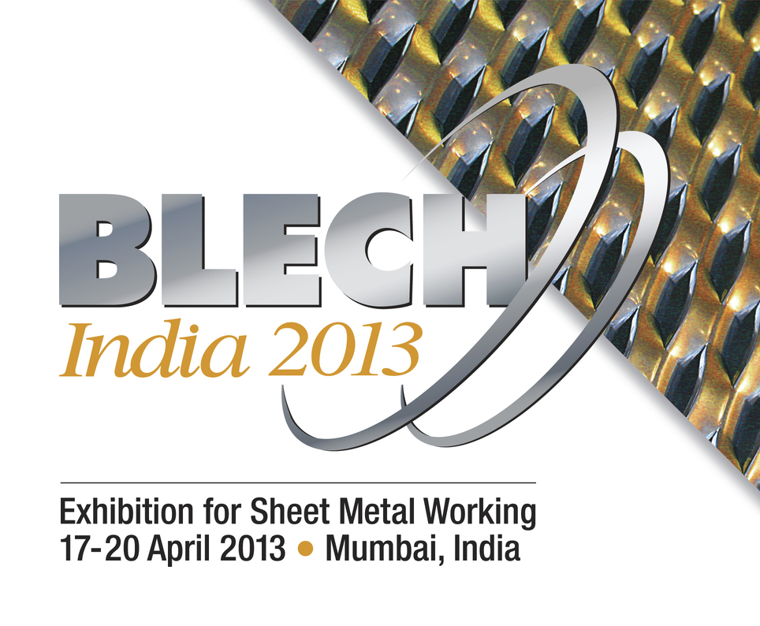

About B&R
B&R, a division of ABB Group, is a global leader in industrial automation headquartered in Austria. B&R combines state-of-the-art technology with advanced engineering to provide customers in virtually every industry with complete solutions for machine and factory automation, motion control, HMI and integrated safety technology. With Industrial IoT communication standards including OPC UA, POWERLINK and openSAFETY as well as its Automation Studio software, B&R is constantly redefining the future of automation engineering. The innovative spirit that keeps B&R at the forefront of industrial automation is driven by a commitment to simplifying processes and exceeding customer expectations.
For more information, visit www.br-automation.com.

