B&R at BLECH India 2013 in Mumbai
Innovative solutions for the metal industry
From April 17th to the 20th, BLECH India, the Technology Exhibition for Sheet Metal Working, is taking place in Mumbai at Bombay Exhibition Centre for the third time.
At BLECH India, B&R will be found at Hall 1, Stall D110 presenting its full range of products and services, as well as custom solutions tailored specifically to the metal industry.
Experience the Technology trusted by the Global market leaders in sheet metal processing
B&R have on display most powerful PLC in the market, Intelligent IO system, HMIs with built in controllers, Rugged Industrial PCs and flexible software for CNC and robotics paired with integrated safety technology. This makes B&R’s solutions perfectly equipped to handle the needs of Metal industry.
Cutting, bending and stamping with integrated robotics
Worldwide B&R solutions can be found in both hydraulic and fully electric bending machines. They are also used in cutting machines that operate with laser, plasma, oxy-fuel and water jet cutting technology. Manufacturers of specialty bending machines for pipes, profiles and wires have experienced the advantage of B&R automation, as have suppliers of all types of stamping machinery. B&R technology melds perfectly into fully integrated cells that perform robotic bending or a combination of processing steps such as laser cutting and bending.
Energy savings, integrated safety technology and condition monitoring ensure reliability and efficiency
With its integrated safety technology and its economic and easy-to-implement condition monitoring solution, B&R is setting trends that will bring sustained benefits for machine manufacturers. B&R has also answered the call for energy-efficient solutions loud and clear – with innovations that can bring up to 80% energy savings. Prominent features of these solutions are the ACOPOSmulti servo system and innovative variable speed hydraulic drives.
Integrated Safety Technology and Ethernet POWERLINK
Integrated Safety Technology, a trend-setting solution for machine manufacturing that integrates safety seamlessly into the standard control system and eliminates the need for extra wiring. All control components are seamlessly integrated using POWERLINK. It is the world's most widely used Industrial Ethernet protocol in applications where plant productivity depends on motion control technology.
  - 关于贝加莱
B&R has its head-office at Pune, Maharashtra and four other offices in India. B&R is fully equipped to cater to your application, supply and support requirements right in India. A global leader in industrial automation, B&R provides complete solutions for machine and process automation, motion control, HMI and integrated safety technology for every industry. 凭借工业现场总线通信标准POWERLINK和openSAFETY以及强大的Automation Studio软件开发环境，贝加莱正在不断地重新定义未来的自动化工程。The global headquarters of B&R as well as the manufacturing center is at Eggelsberg, Austria.

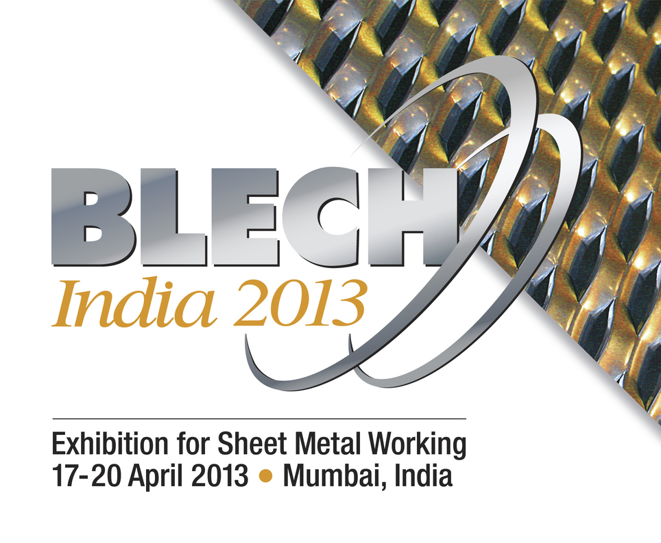

关于贝加莱
贝加莱是一家总部位于奥地利并在全球拥有分公司的创新型自动化企业。2017年7月，贝加莱成为ABB集团的机械自动化事业部。作为工业自动化领域的全球领导者，贝加莱将前沿技术与领先工程相结合，为几乎每个行业的客户提供面向机器与工厂自动化、运动控制、HMI和集成安全技术的完整解决方案。借助于OPC UA、POWERLINK、openSAFETY等工业物联网通信标准，以及强大的Automation Studio软件开发平台，贝加莱不断重新定义自动化工程的未来。受简化流程和超出客户预期的承诺驱动，贝加莱始终保持创新精神并处于工业自动化领域的前沿。
获取更多信息，请访问www.br-automation.com。

