Full protection for your engineering expertise
Advantages for both machine manufacturers and end users
In 2012, B&R teamed up with Wibu-Systems AG, one of the world's foremost software security and anti-piracy technology companies. "The security functions we have gained through this partnership are extremely beneficial to machine manufacturers and end users alike", explains Hans Wimmer, managing director of B&R. Put simply, these functions will allow customers to protect the source code of their software in B&R Automation Studio while still being able to generate proprietary program code for use on control systems and industrial PCs.
Protection against copying, analysis and manipulation
These new security functions provide protection against a wide range of attacks, including the copying of source code to different systems. Code analysis is also not possible, thus stopping any type of reverse engineering in its tracks. Finally, source code is fully protected against unauthorized changes – a form of attack recently made famous by the Stuxnet computer worm. All of these advantages add up to complete protection of software and system integrity.
Developing new business models
B&R customers also have the opportunity to implement new business models that take advantage of pay-per-use or feature-on-demand options for functions to be enabled and sold at a later time. These types of models, already being used by B&R customers, are the same models used by B&R for technology functions. As such, they offer a way for customers to benefit by only licensing the components they need.
"We are very pleased to be working together with B&R," says Oliver Winzenried, CEO of Wibu-Systems. "This partnership is the result of many years of experience in addition to our extensive investment in the area of industrial applications, as demonstrated by our software-based CmActLicense solution as well as our CmDongle hardware, which is available in the form of USB flash drives as well as microSD, SD and CF cards."

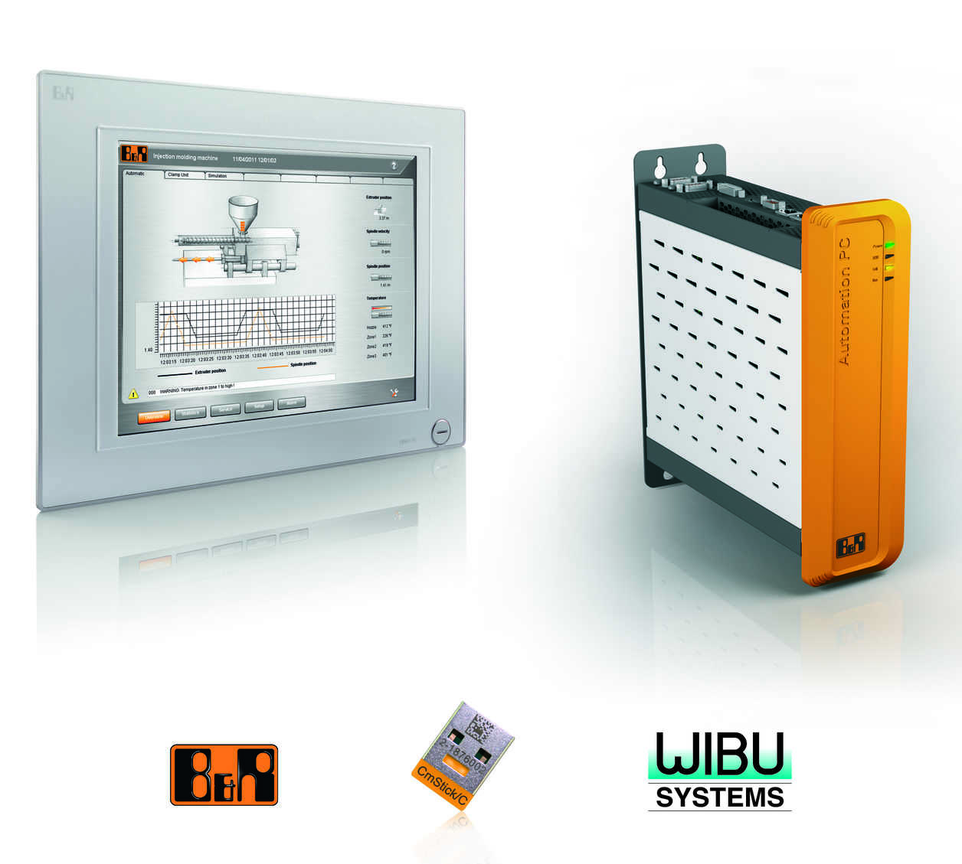
New security functions for protecting program code is just one more way that B&R safeguards the intellectual property of their customers.

关于贝加莱
贝加莱是一家总部位于奥地利并在全球拥有分公司的创新型自动化企业。2017年7月，贝加莱成为ABB集团的机械自动化事业部。作为工业自动化领域的全球领导者，贝加莱将前沿技术与领先工程相结合，为几乎每个行业的客户提供面向机器与工厂自动化、运动控制、HMI和集成安全技术的完整解决方案。借助于OPC UA、POWERLINK、openSAFETY等工业物联网通信标准，以及强大的Automation Studio软件开发平台，贝加莱不断重新定义自动化工程的未来。受简化流程和超出客户预期的承诺驱动，贝加莱始终保持创新精神并处于工业自动化领域的前沿。
获取更多信息，请访问www.br-automation.com。

