Close cooperation between Intel® and B&R
Top computing and graphics performance for automation
Until now, new processor generations have generally been limited to office and home computers. It often took time for industrial PCs to play catch up in terms of performance and multimedia capabilities. This isn't the case with the new Automation PC 910 from B&R. This system was developed in close cooperation with the US semiconductor manufacturer Intel®, who were busy planning the third generation of their Core™ i-series processors at the time. As the Intel® Core™ i3, Core™ i5 and Core™ i7 CPUs with up to four cores appeared on the market, they were immediately put to use in B&R's Automation PC series.
Intel and B&R: Superior performance for next generation technology
"Together with B&R's industrial PC design, the 3rd generation Intel® Core™ i7 processors offer performance and I/O technologies that are second to none," says Matt Langman, head of marketing for the Intelligent Systems Group at Intel. "These systems provide the power needed to meet the intensive processing requirements of future automation and control applications."Together with the new QM77 Express chipset, these processors currently represent the maximum performance available for industrial computers.
Integrated hardware increases graphics performance
Integrated graphics directly on the processor chip increases graphics performance and allows the DirectX 11 API programming interface to be used to display complex 2D and 3D graphics. It also provides support for audio output, pointing and input devices as well as network communication. USB 3.0 interfaces, 2 gigabit Ethernet ports, a serial interface and additional modular interfaces for communication networks such as RS-485 and CAN round off the extensive options available on the Automation PC 910.
Users can find out more about the Automation PC 910, the first system to use Intel's new Core™ i processors in an industrial environment, in a jointly published white paper available on the following Intel and B&R web pages: http://www.intel.com/content/www/us/en/industrial-automation/industrial-computer-performance-brief.html and http://www.br-automation.com/en/company/press-room/close-cooperation-between-intel-and-br/.
- White Paper

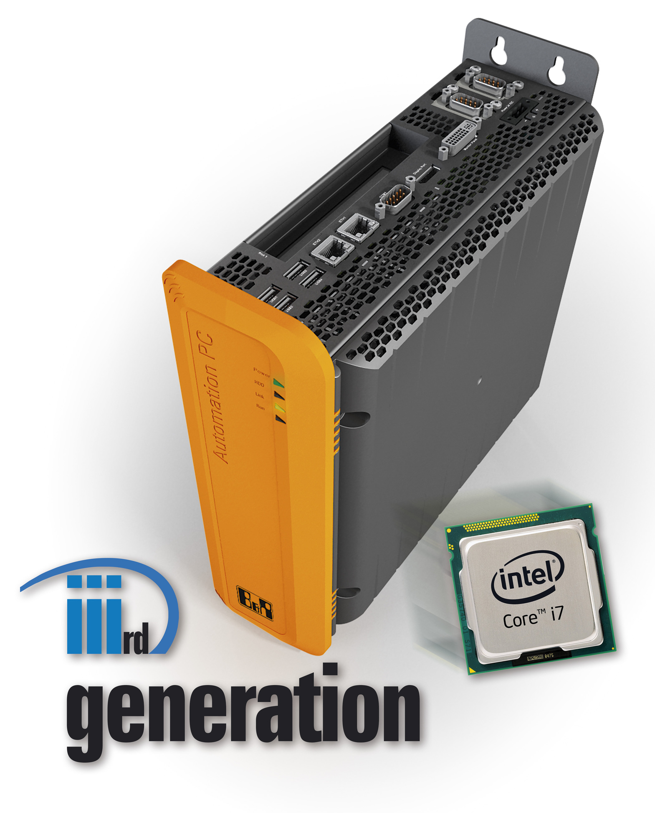

关于贝加莱
贝加莱是一家总部位于奥地利并在全球拥有分公司的创新型自动化企业。2017年7月，贝加莱成为ABB集团的机械自动化事业部。作为工业自动化领域的全球领导者，贝加莱将前沿技术与领先工程相结合，为几乎每个行业的客户提供面向机器与工厂自动化、运动控制、HMI和集成安全技术的完整解决方案。借助于OPC UA、POWERLINK、openSAFETY等工业物联网通信标准，以及强大的Automation Studio软件开发平台，贝加莱不断重新定义自动化工程的未来。受简化流程和超出客户预期的承诺驱动，贝加莱始终保持创新精神并处于工业自动化领域的前沿。
获取更多信息，请访问www.br-automation.com。

