B&R opens Automation Academy in Italy
Extensive training opportunities at the international level
B&R has invested in yet another center for training and professional development featuring state-of-the-art facilities and equipment. One of B&R's top priorities has always been to provide our customers, partners and employees with opportunities for targeted training and continuous professional development. The Automation Academy provides the optimal environment to make that possible. "The Automation Academy will make a significant contribution to advancing training in the area of automation technology," said Luca Galluzzi, managing director of B&R Italy, during the opening ceremony. "Top product quality and continuous technical development are essential to maintaining our position as a leader in the field of automation."
Training par excellence
B&R offers its first-rate training services in 68 countries around the world. Automation Academy courses are arranged in a hierarchy of modular seminars and are always held in the respective local language. More than 100 trainers share their high level of expertise in customer seminars. Theoretical material is always reinforced through practical exercises.
The Automation Academy provides over one hundred seminar rooms around the world for training purposes. The seminars provide a basis for implementing state-of-the-art solutions efficiently. The field of automation demands sophisticated and innovative solutions based on state-of-the-art technology, which makes well-trained employees an essential factor in building and maintaining a company's competitive edge. This is why B&R provides its customers and partners with an extensive selection of training seminars that covers all B&R products and solutions.
Engineering Camp: An investment in expertise
B&R places the same emphasis on training and professional development for its own employees as it does for its customers and partners. Young engineers participate in four-month "Engineering Camps" to develop an expert understanding of the automation technology used in various industries. This training gives every engineer in B&R's global workforce a uniform skill set and level of training to ensure optimal customer support anywhere in the world.
Participants gain from practical experience
B&R cooperates with schools and universities around the world in addition to supporting numerous continued education projects and application-specific research and development efforts. This focus on both theory and practice stimulates continuous interaction between young automation students, engineers and developers. Students are offered the valuable opportunity to apply their technical knowledge long before graduation, with B&R acting as the gateway between university and the workplace.

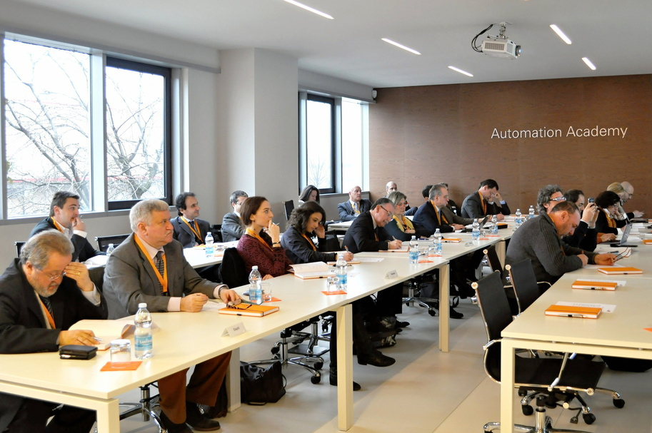
B&R offers its first-rate training services in 68 countries around the world. The newest of these Automation Academies has just been opened in Italy.

B&R Hakkında
ABB Grubunun bir bölümü olan B&R, merkezi Avusturya'da bulunan endüstriyel otomasyon alanında global bir liderdir. B&R, neredeyse her sektördeki müşterilere makine ve fabrika otomasyonu, hareket kontrolü, HMI ve entegre güvenlik teknolojisi için eksiksiz çözümler sunmak üzere en son teknolojiyi ileri mühendislikle birleştiriyor. OPC UA, POWERLINK ve openSAFETY gibi Endüstriyel IoT iletişim standartlarının yanı sıra Automation Studio yazılımıyla B&R, otomasyon mühendisliğinin geleceğini sürekli olarak yeniden tanımlıyor. B&R'ı endüstriyel otomasyonun ön saflarında tutan yenilikçi ruh, süreçleri basitleştirme ve müşteri beklentilerini aşma taahhüdünden kaynaklanmaktadır.
Daha fazla bilgi için www.br-automation.com adresini ziyaret edin.

