B&R testing laboratory accredited by Austrian federal ministry
Testing during development increases product quality
B&R products comply with all relevant standards as documented by the respective certifications. In order to bring products to market as quickly as possible, B&R maintains an in-house environmental testing laboratory at company headquarters in Eggelsberg, Austria. Here, B&R is able to officially produce the necessary certifications stating that environmental factors have no negative influence on the operation of its systems and, conversely, that its systems do not negatively impact the environment. In early February, the responsible Austrian federal ministry granted the laboratory accreditation in accordance with EN ISO/IEC 17025:2007.
Products from B&R easily withstand all environmental influences
Manufacturers use B&R products in machines and systems all over the world, including in mobile machines and offshore systems. As a result, these products are subjected to extreme temperatures, shock, vibration, salty ocean air and radiation emitted from radio and radar equipment. Even under these adverse conditions, B&R products perform with utmost reliability for many years.
B&R lab tests the effects of the environment on devices...
In the environmental testing laboratory, technicians are able to simulate the various environmental conditions that devices will later be confronted with in the field. Multiple climate-controlled chambers establish temperatures ranging from -40°C to +85°C and relative humidity ranging from 10 to 98 percent. Tests are designed to ensure that products are able to handle all types of climate-related strain during operation and that frequent temperature fluctuations do not cause them to age prematurely. In addition, devices are subjected to intense mechanical stress during shock and vibration testing.
A salt spray test exposes products to a saline fog with 5% salt content to test resistance to corrosion. A high voltage test applies a voltage of 6.5 kV to products to ensure that no arcing occurs between circuit board tracks, with bleeder resistance tested at 1,500 V. In a shielded enclosure, immunity testing is performed with discharges of up to 30 kV, bursts of up to 5.5 kV and surges up to 5 kV to determine the electromagnetic compatibility of devices.
...and the effects of devices on their environment
Conversely, there are also very strict regulations regarding the effects that devices are permitted to have on the environment in which they operate. For purely electrical equipment, as is the case with B&R, these effects include sonic, thermal and radio emissions as well as the introduction of voltage spikes and harmonics back into the electricity grid. These factors are also tested in the shielded enclosure. In a semi-anechoic chamber more than nine meters long, five meters wide and five and a half meters high, electromagnetic emissions are measured in the gigahertz range over a distance of three meters.
B&R's in-house laboratory increases product quality
Since receiving accreditation from the Austrian Federal Ministry of Economy, Family and Youth in February 2013, B&R's environmental testing laboratory has now achieved the status of a fully accredited testing facility. "Having our own accredited environmental testing laboratory gives us a great deal of autonomy," says Franz Stadler, director of B&R's environmental testing laboratory. "It allows us to perform testing more frequently during development and thus continuously improve the quality of our products."

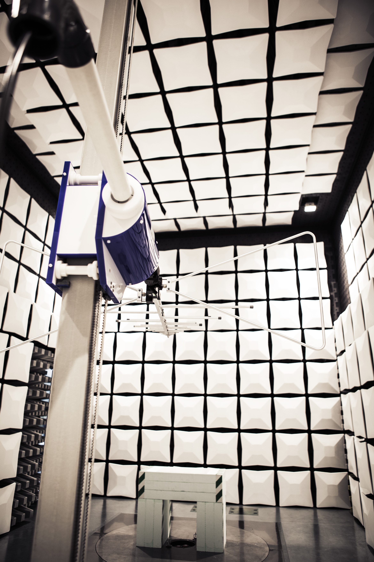
With its own certified in-house testing laboratory, B&R once again proves its dedication to developing automation technology that meets the highest quality and safety standards.
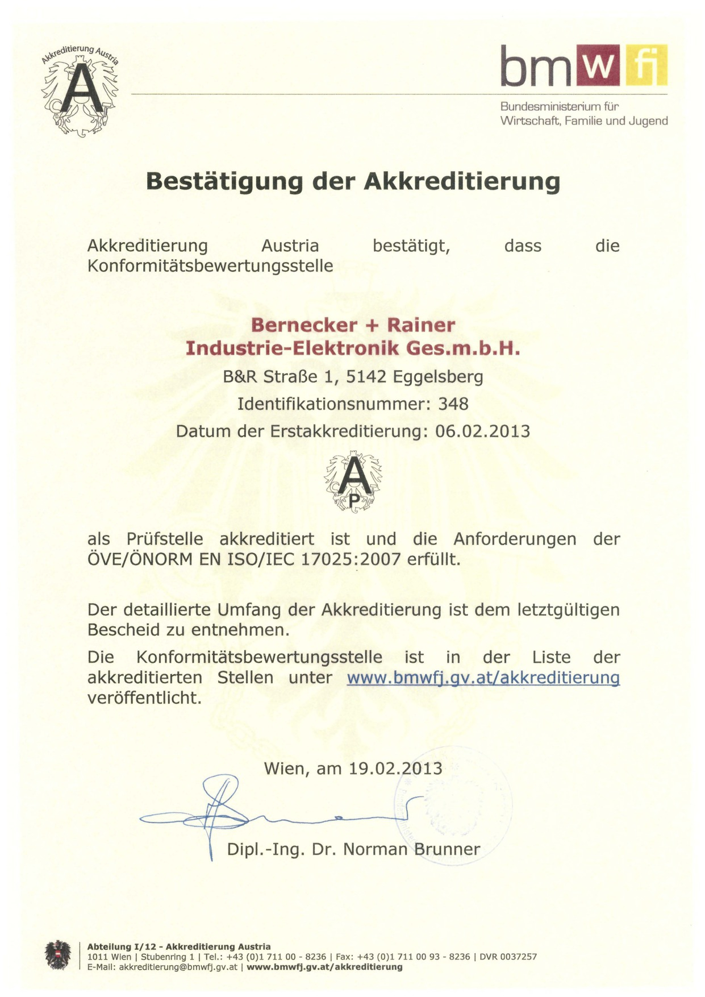
B&R's environmental testing laboratory has been fully accredited as a testing center in accordance with EN ISO/IEC 17025 since February, 2013.

B&R Hakkında
ABB Grubunun bir bölümü olan B&R, merkezi Avusturya'da bulunan endüstriyel otomasyon alanında global bir liderdir. B&R, neredeyse her sektördeki müşterilere makine ve fabrika otomasyonu, hareket kontrolü, HMI ve entegre güvenlik teknolojisi için eksiksiz çözümler sunmak üzere en son teknolojiyi ileri mühendislikle birleştiriyor. OPC UA, POWERLINK ve openSAFETY gibi Endüstriyel IoT iletişim standartlarının yanı sıra Automation Studio yazılımıyla B&R, otomasyon mühendisliğinin geleceğini sürekli olarak yeniden tanımlıyor. B&R'ı endüstriyel otomasyonun ön saflarında tutan yenilikçi ruh, süreçleri basitleştirme ve müşteri beklentilerini aşma taahhüdünden kaynaklanmaktadır.
Daha fazla bilgi için www.br-automation.com adresini ziyaret edin.

