A new seal of quality for B&R drive technology
ControlEng singles out service-oriented companies
B&R customers are now even more perfectly equipped than ever before to design and dimension their drive systems within the framework of their automation solution. This is made possible by the free version of the SERVOsoft drive design tool from the Canadian company ControlEng, which comes integrated in B&R's Automation Studio development software. This software tool allows developers to efficiently and effortlessly select the B&R servo drives, motors and gearboxes that best meet their specific needs. The result is a drive system perfectly coordinated with the masses it needs to move, which also has the effect of reducing energy consumption to an absolute minimum.
Outstanding customer support
The "Qualified SERVOsoft Partner" (QSP) distinction is awarded by the ControlEng Corporation to companies who go above and beyond the recommended level of support for the SERVOsoft tool. Requirements include the integration and maintenance of product data in the SERVOsoft database, a dedicated email address for customer support and drive experts trained by ControlEng.
"We are honored to have received this distinction from a manufacturer-independent software company like ControlEng," says Alois Holzleitner, manager of B&R's Motion business unit. "It highlights the goal shared by both B&R and ControlEng: to provide engineers the support they need to develop better machines."

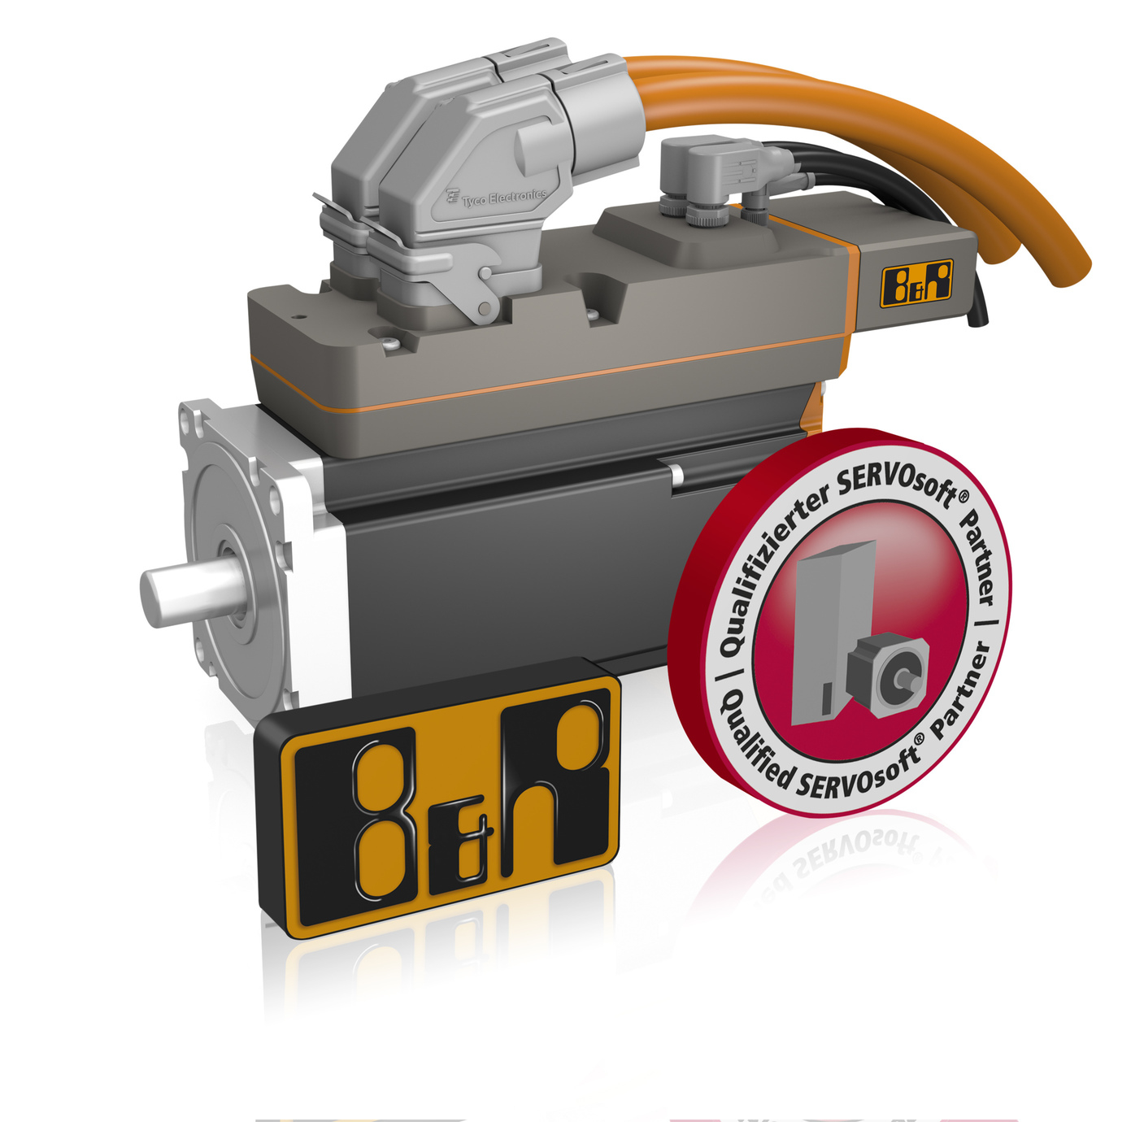
In recognition of the support B&R provides developers who design drive systems using SERVOsoft, the Canadian software company ControlEng has authorized B&R to display the QSP seal of quality.

About B&R
B&R, a division of ABB Group, is a global leader in industrial automation headquartered in Austria. B&R combines state-of-the-art technology with advanced engineering to provide customers in virtually every industry with complete solutions for machine and factory automation, motion control, HMI and integrated safety technology. With Industrial IoT communication standards including OPC UA, POWERLINK and openSAFETY as well as its Automation Studio software, B&R is constantly redefining the future of automation engineering. The innovative spirit that keeps B&R at the forefront of industrial automation is driven by a commitment to simplifying processes and exceeding customer expectations.
For more information, visit www.br-automation.com.

