A new seal of quality for B&R drive technology
ControlEng singles out service-oriented companies
B&R customers are now even more perfectly equipped than ever before to design and dimension their drive systems within the framework of their automation solution. This is made possible by the free version of the SERVOsoft drive design tool from the Canadian company ControlEng, which comes integrated in B&R's Automation Studio development software. This software tool allows developers to efficiently and effortlessly select the B&R servo drives, motors and gearboxes that best meet their specific needs. The result is a drive system perfectly coordinated with the masses it needs to move, which also has the effect of reducing energy consumption to an absolute minimum.
Outstanding customer support
The "Qualified SERVOsoft Partner" (QSP) distinction is awarded by the ControlEng Corporation to companies who go above and beyond the recommended level of support for the SERVOsoft tool. Requirements include the integration and maintenance of product data in the SERVOsoft database, a dedicated email address for customer support and drive experts trained by ControlEng.
"We are honored to have received this distinction from a manufacturer-independent software company like ControlEng," says Alois Holzleitner, manager of B&R's Motion business unit. "It highlights the goal shared by both B&R and ControlEng: to provide engineers the support they need to develop better machines."

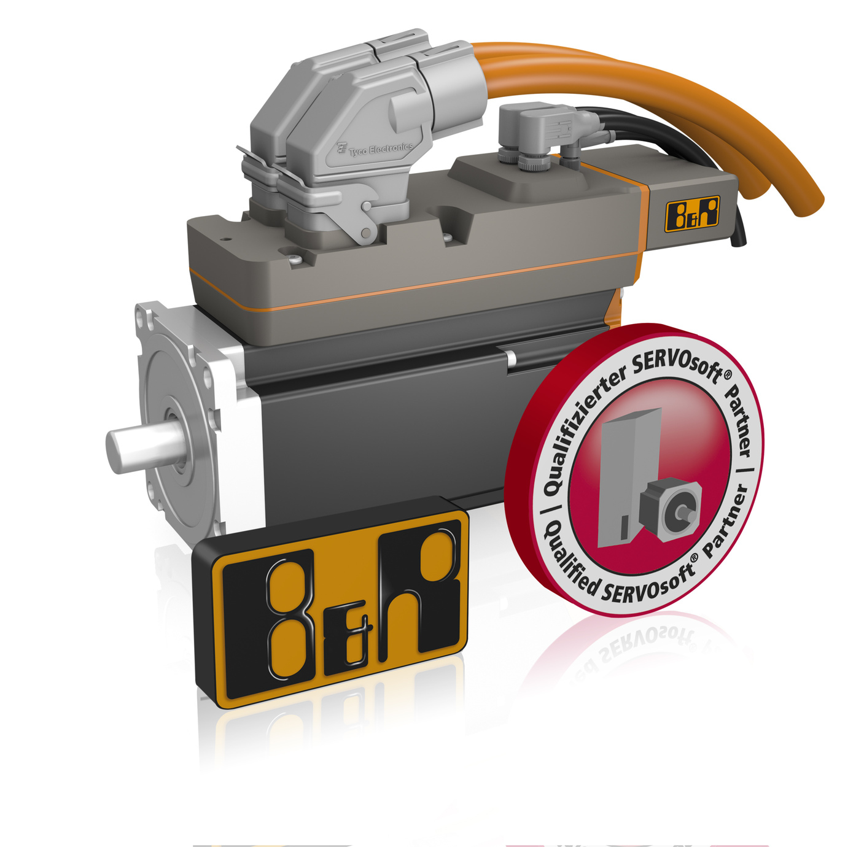
In recognition of the support B&R provides developers who design drive systems using SERVOsoft, the Canadian software company ControlEng has authorized B&R to display the QSP seal of quality.

B&R Hakkında
ABB Grubunun bir bölümü olan B&R, merkezi Avusturya'da bulunan endüstriyel otomasyon alanında global bir liderdir. B&R, neredeyse her sektördeki müşterilere makine ve fabrika otomasyonu, hareket kontrolü, HMI ve entegre güvenlik teknolojisi için eksiksiz çözümler sunmak üzere en son teknolojiyi ileri mühendislikle birleştiriyor. OPC UA, POWERLINK ve openSAFETY gibi Endüstriyel IoT iletişim standartlarının yanı sıra Automation Studio yazılımıyla B&R, otomasyon mühendisliğinin geleceğini sürekli olarak yeniden tanımlıyor. B&R'ı endüstriyel otomasyonun ön saflarında tutan yenilikçi ruh, süreçleri basitleştirme ve müşteri beklentilerini aşma taahhüdünden kaynaklanmaktadır.
Daha fazla bilgi için www.br-automation.com adresini ziyaret edin.

