A new seal of quality for B&R drive technology
ControlEng singles out service-oriented companies
B&R customers are now even more perfectly equipped than ever before to design and dimension their drive systems within the framework of their automation solution. This is made possible by the free version of the SERVOsoft drive design tool from the Canadian company ControlEng, which comes integrated in B&R's Automation Studio development software. This software tool allows developers to efficiently and effortlessly select the B&R servo drives, motors and gearboxes that best meet their specific needs. The result is a drive system perfectly coordinated with the masses it needs to move, which also has the effect of reducing energy consumption to an absolute minimum.
Outstanding customer support
The "Qualified SERVOsoft Partner" (QSP) distinction is awarded by the ControlEng Corporation to companies who go above and beyond the recommended level of support for the SERVOsoft tool. Requirements include the integration and maintenance of product data in the SERVOsoft database, a dedicated email address for customer support and drive experts trained by ControlEng.
"We are honored to have received this distinction from a manufacturer-independent software company like ControlEng," says Alois Holzleitner, manager of B&R's Motion business unit. "It highlights the goal shared by both B&R and ControlEng: to provide engineers the support they need to develop better machines."

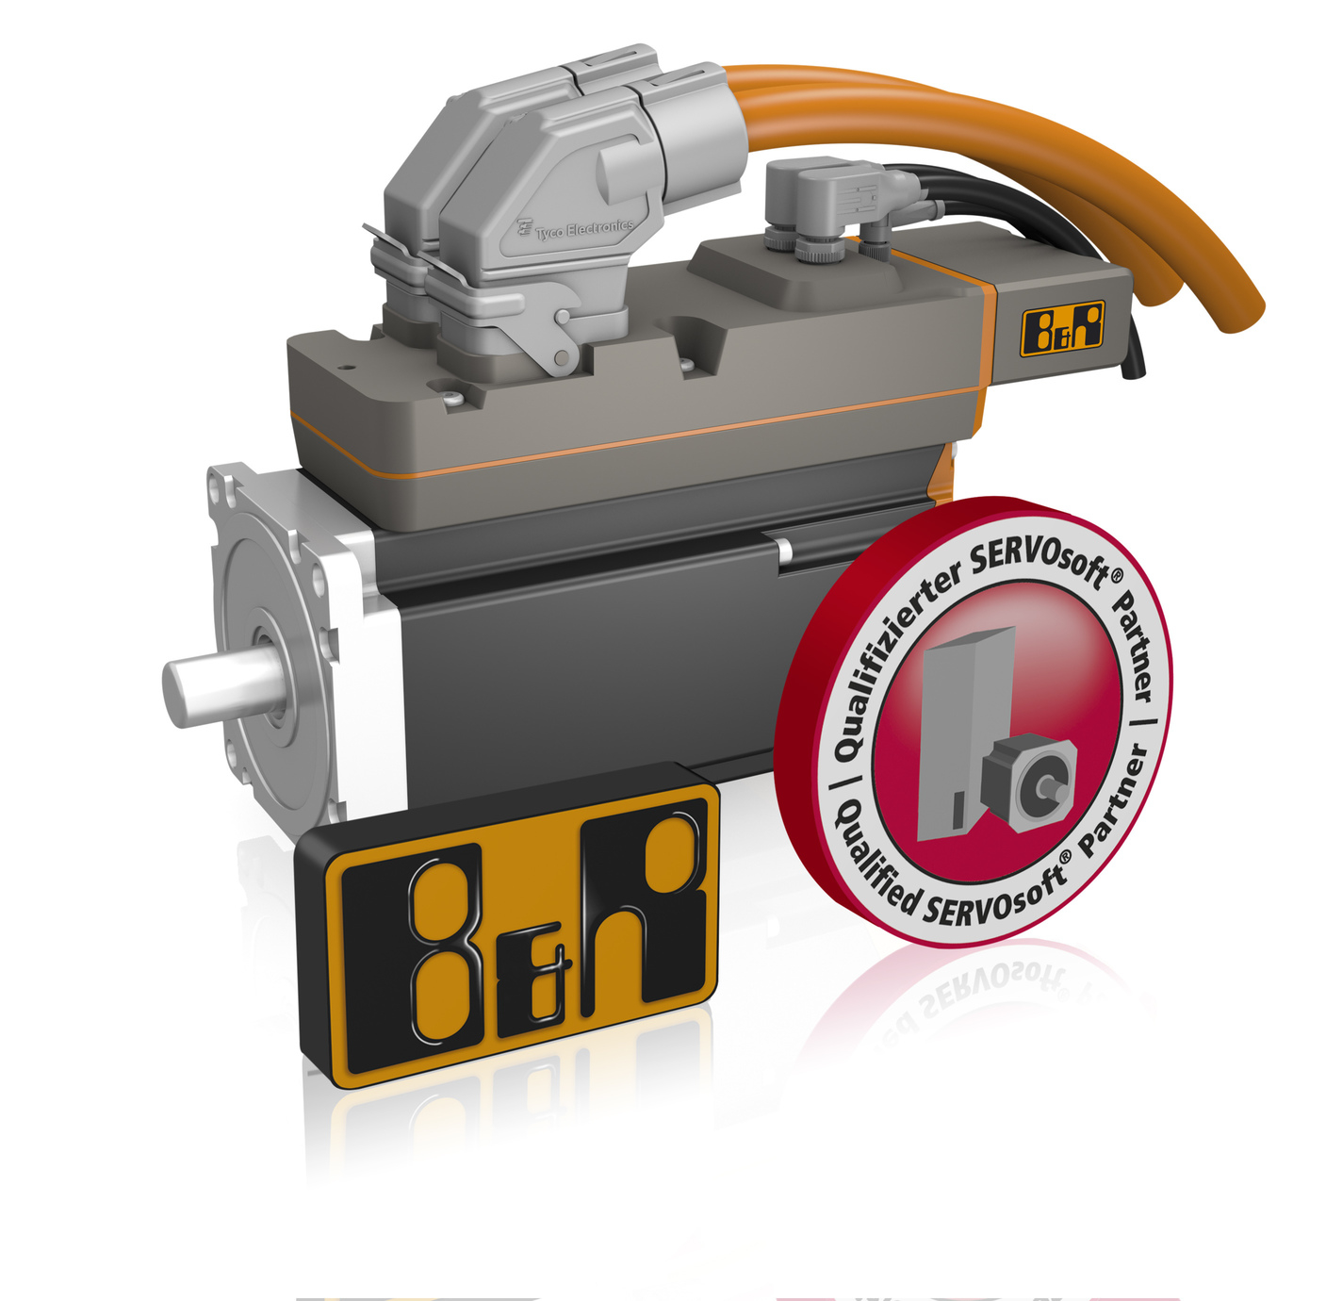
In recognition of the support B&R provides developers who design drive systems using SERVOsoft, the Canadian software company ControlEng has authorized B&R to display the QSP seal of quality.

关于贝加莱
贝加莱是一家总部位于奥地利并在全球拥有分公司的创新型自动化企业。2017年7月，贝加莱成为ABB集团的机械自动化事业部。作为工业自动化领域的全球领导者，贝加莱将前沿技术与领先工程相结合，为几乎每个行业的客户提供面向机器与工厂自动化、运动控制、HMI和集成安全技术的完整解决方案。借助于OPC UA、POWERLINK、openSAFETY等工业物联网通信标准，以及强大的Automation Studio软件开发平台，贝加莱不断重新定义自动化工程的未来。受简化流程和超出客户预期的承诺驱动，贝加莱始终保持创新精神并处于工业自动化领域的前沿。
获取更多信息，请访问www.br-automation.com。

