Record number of participants at the B&R User Meeting in Salzburg
Workshops and a company exhibition stimulate interactive communication
275 participants from machine and plant engineering companies took advantage of the opportunity to learn firsthand about highly innovative automation solutions at this two-day event. With specialized lectures and interactive workshops, B&R was able to provide detailed information covering all areas of industrial automation – from small machine controllers to complex process control systems.
An interactive program with great diversity
In twelve blocks of presentations, 27 B&R speakers, 20 external experts and B&R customers presented participants with a wide range of information. Ten expert workshops also held during the meeting were a big hit as well. Comprehensive product-independent topic areas such as optimizing engineering workflows, increasing efficiency through simulation and the advantages of integrated safety technology were handled with the help of concrete application examples. "Participants really enjoyed the interactive format," says Hermann Obermair, sales manager at B&R Austria, with satisfaction. "Not only did they take advantage of the opportunity to ask questions, but they also provided valuable input from the field."
Informacje o produktach bezpośrednio u źródła
Of course, many new developments were on the agenda, not just from B&R, but also from other manufacturers whose products can be integrated in B&R automation solutions via IO-Link or POWERLINK or used in safety solutions via openSAFETY.
During breaks, many participants also took the opportunity to visit the informative company exhibition directly at the venue in order to see hardware products and B&R software tools live in action as well as to discuss specific topics with industry experts.
Innovative real-world solutions
Many successful applications using B&R technology were on display, but an overview of diverse applications from various areas of the automotive industry was especially impressive. The autobahn tunnel through the Pfänder mountain near Bregenz was presented as an example of an automation solution distributed over a wide area in harsh environmental conditions. This solution has proven to be highly resistant to failure and allows systems from other manufacturers to be connected with ease. A detailed presentation of solutions and applications related to power generation and conversion focused directly on wind power.
Valuable feedback
"Participants at the B&R User Meeting aren't just at the receiving end of information," states Obermaier, "they also help direct the topics by contributing interactively to discussions. This provides valuable feedback that shows us how the market is developing and ensures that we are able to offer solutions that meet everyone's needs."

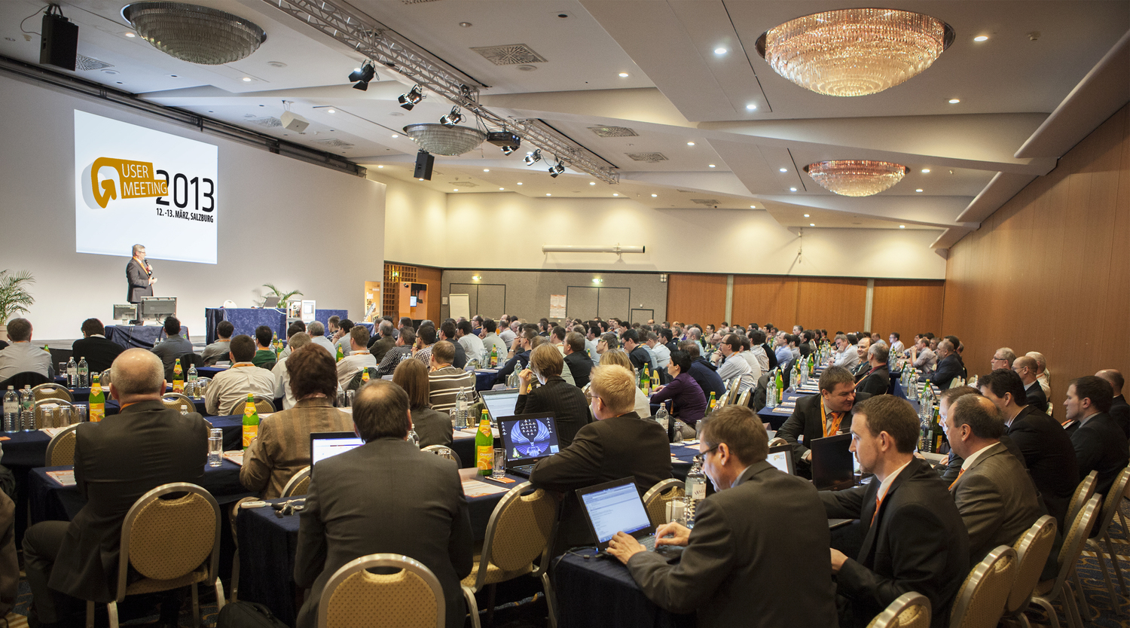
275 participants from machine and plant engineering companies took advantage of the opportunity to find out more about exciting new B&R innovations at the User Meeting in Salzburg.

O firmie B&R
B&R to innowacyjna firma z branży automatyzacji z siedzibą w Austrii i przedstawicielstwami na całym świecie. Od 6 lipca 2017 B&R stała się jednostką biznesową Grupy ABB. Jako globalny lider w automatyce przemysłowej, B&R łączy najnowocześniejsze technologie z kunsztem inżynieryjnym, oferując klientom z praktycznie każdej branży kompleksowe rozwiązania z zakresu automatyki maszyn i automatyki zakładowej, sterowania napędami, interfejsów HMI oraz zintegrowanej technologii bezpieczeństwa. Dzięki standardom komunikacji przemysłowej IoT, takim jak OPC UA, POWERLINK i openSAFETY, a także z wydajnym środowiskiem programistycznym Automation Studio, B&R nieustannie przedefiniowuje przyszłość technologii automatyzacji. Duch innowacyjności, który prowadzi B&R na szczyt przemysłowej automatyzacji, jest wzmacniany zamiłowaniem do upraszczania procesów i wyprzedzania oczekiwań klientów.
Aby uzyskać więcej informacji odwiedź stronę www.br-automation.com

