Woojin revolutionizes its machines with B&R
Both companies to present innovations at K 2013
Upgrading to B&R servo technology and POWERLINK communication has allowed Woojin to optimize speed and precision on three different lines of injection molding machines. In October, B&R and Woojin will be presenting these and other innovations at the world’s leading exhibition for plastics and rubber, the K 2013 trade fair in Dusseldorf, Germany.
"The key to injection molding is to maximize both speed and precision without sacrificing either," says Injun Jung, R&D Director at Woojin. "State-of-the-art decentralized servo technology from B&R gives us the control we need to perfectly synchronize multi-axis tasks and achieve a highly responsive injection process, while the POWERLINK network allows individual slave axes to exchange data directly at very high speeds and with excellent precision."
Woojin was able to boost energy efficiency and significantly lower noise from its hydraulic injection molding machines using servo pump technology from B&R. B&R servo pumps can also be found on Woojin’s two-platen machines. These machines range from 450 to 3000 tons of clamping force, with a 3500 ton model to be available by the end of the year. Woojin has also upgraded its fully electric TN250E machine with a new toggle mechanism to optimize pressure and added three servo motors on the injection side to achieve injection speeds of 1000 mm/sec. This new solution has created 10% more space between the platen without increasing the machine’s overall dimensions. The entire injection drive system, including the controller, is sourced on a turn-key basis from global automation leader B&R.
Woojin introduced its new machines based on B&R technology at KOPLAS 2013 with resounding success. Both companies are now looking forward to presenting their latest innovations for the plastics industry at the K 2013 fair in Dusseldorf.

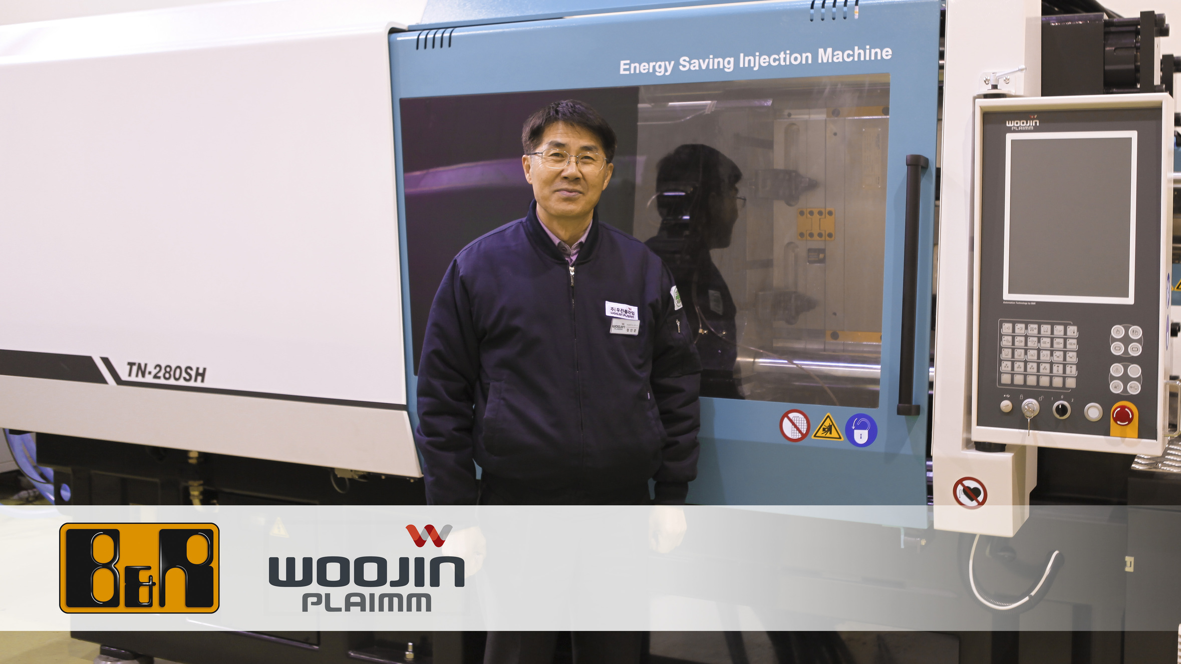
“The key to injection molding is to maximize both speed and precision without sacrificing either,” states Injun Jung, R&D Director at Woojin.

B&R Hakkında
ABB Grubunun bir bölümü olan B&R, merkezi Avusturya'da bulunan endüstriyel otomasyon alanında global bir liderdir. B&R, neredeyse her sektördeki müşterilere makine ve fabrika otomasyonu, hareket kontrolü, HMI ve entegre güvenlik teknolojisi için eksiksiz çözümler sunmak üzere en son teknolojiyi ileri mühendislikle birleştiriyor. OPC UA, POWERLINK ve openSAFETY gibi Endüstriyel IoT iletişim standartlarının yanı sıra Automation Studio yazılımıyla B&R, otomasyon mühendisliğinin geleceğini sürekli olarak yeniden tanımlıyor. B&R'ı endüstriyel otomasyonun ön saflarında tutan yenilikçi ruh, süreçleri basitleştirme ve müşteri beklentilerini aşma taahhüdünden kaynaklanmaktadır.
Daha fazla bilgi için www.br-automation.com adresini ziyaret edin.

