Woojin revolutionizes its machines with B&R
Both to present innovations at K 2013
Upgrading to B&R servo technology and POWERLINK communication has helped Woojin optimize the speed and precision of three different lines of injection molding machines. In October, B&R and Woojin will be presenting these and other innovations at the world’s leading exhibition for plastics and rubber, the K 2013 trade fair in Dusseldorf, Germany.
“The key to injection molding is to maximize both speed and precision without sacrificing either,” states Injun Jung, R&D Director at Woojin. “State-of-the-art decentralized servo technology from B&R gives us the control we need to perfectly synchronize multi-axis tasks and achieve a highly responsive injection process, while the POWERLINK network allows individual slave axes to exchange data directly at very high speeds and with excellent precision.”
Woojin was able to boost energy efficiency and significantly lower noise from its hydraulic injection molding machines using servo pump technology from B&R. B&R servo pumps can also be found on Woojin’s two-platen machine. These machines range from 450 to 3000 tons of clamping force, with a 3500 ton model to be available by the end of the year. Woojin has upgraded its fully electric TN250E machine with a new toggle mechanism to optimize pressure and three servo motors on the injection side to achieve injection speeds of 1000 mm/sec. The new solution also created 10% more space between the platen without increasing the machine’s overall dimensions. The entire injection drive system, including controller, is sourced on a turn-key basis from global automation leader B&R.
Woojin introduced its new machines based on B&R technology at KOPLAS 2013 with resounding success. Both companies will be presenting their latest innovations for the plastics industry at the K 2013 fair in Dusseldorf.

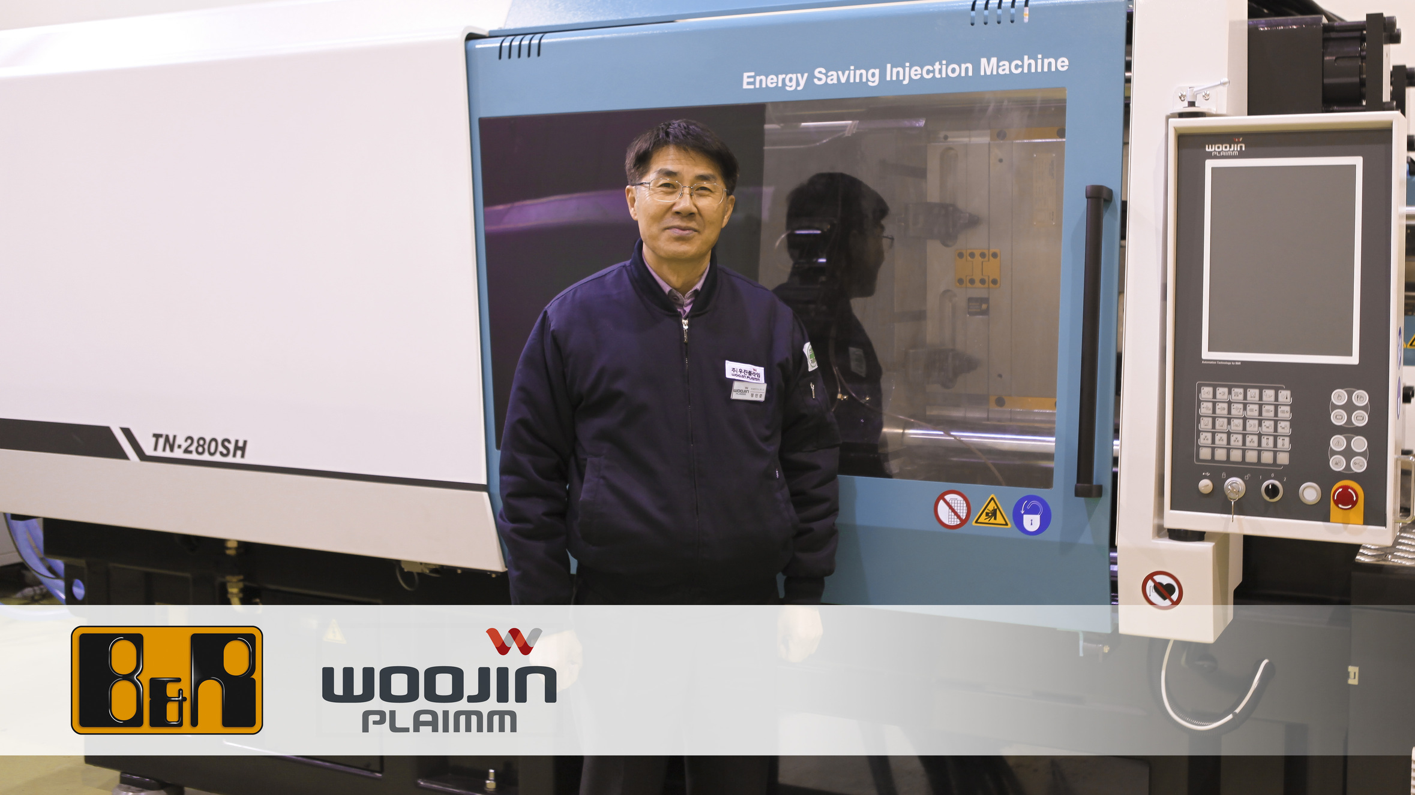
“The key to injection molding is to maximize both speed and precision without sacrificing either,” states Injun Jung, R&D Director at Woojin.

关于贝加莱
贝加莱是一家总部位于奥地利并在全球拥有分公司的创新型自动化企业。2017年7月，贝加莱成为ABB集团的机械自动化事业部。作为工业自动化领域的全球领导者，贝加莱将前沿技术与领先工程相结合，为几乎每个行业的客户提供面向机器与工厂自动化、运动控制、HMI和集成安全技术的完整解决方案。借助于OPC UA、POWERLINK、openSAFETY等工业物联网通信标准，以及强大的Automation Studio软件开发平台，贝加莱不断重新定义自动化工程的未来。受简化流程和超出客户预期的承诺驱动，贝加莱始终保持创新精神并处于工业自动化领域的前沿。
获取更多信息，请访问www.br-automation.com。

