B&R servo drive with BiSS interface
Expanded range of position encoders for the ACOPOSmulti series
Being able to read signals from a large number of different position encoders is nothing new to the B&R ACOPOSmulti drive family. Now, this already extensive range of products is once again being expanded to include a brand new member: an interface card for BiSS encoders. This new addition presents customers with yet another option from a wide range of measuring systems for selecting the position encoder best suited to the application at hand.
Reading sensor data quickly and reliably with BiSS
The fully digital BiSS bidirectional sensor interface is an open and license-free communication standard that allows sensor data to be read synchronously, securely and quickly. The new BiSS interface features high-speed data transfer with excellent error detection properties.
This makes the BiSS encoder interface especially well suited for demanding applications such as integrating fully digital hollow shaft encoders with large internal diameters or implementing robust absolute or linear measurement systems with high-speed movements.
Extended range of ACOPOSmulti plug-in modules
The BiSS interface plug-in card is a logical addition to the wide range of ACOPOS encoder modules and opens up new possibilities for tackling demanding automation projects.

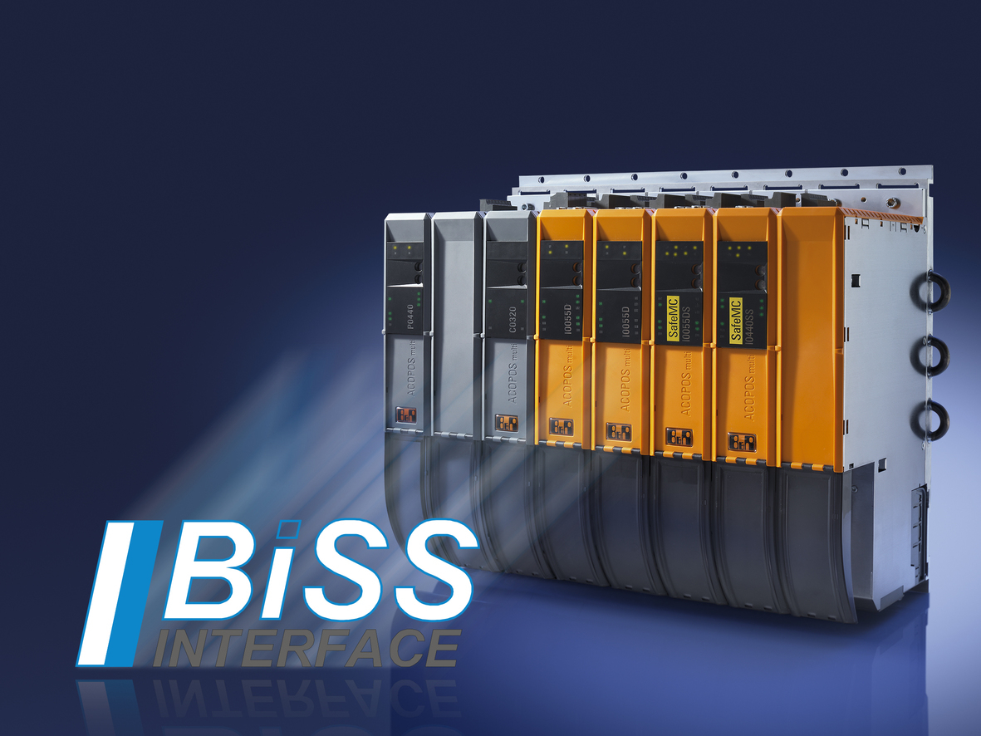
With the addition of the BISS interface, B&R has expanded their range of position encoders for ACOPOSmulti servo drives – another option for helping users to select the encoder best suited to the application at hand.

关于贝加莱
贝加莱是一家总部位于奥地利并在全球拥有分公司的创新型自动化企业。2017年7月，贝加莱成为ABB集团的机械自动化事业部。作为工业自动化领域的全球领导者，贝加莱将前沿技术与领先工程相结合，为几乎每个行业的客户提供面向机器与工厂自动化、运动控制、HMI和集成安全技术的完整解决方案。借助于OPC UA、POWERLINK、openSAFETY等工业物联网通信标准，以及强大的Automation Studio软件开发平台，贝加莱不断重新定义自动化工程的未来。受简化流程和超出客户预期的承诺驱动，贝加莱始终保持创新精神并处于工业自动化领域的前沿。
获取更多信息，请访问www.br-automation.com。

