Controller redundancy with POWERLINK
Implementing high availability systems with standard components
B&R is setting new standards with its redundancy solution for X20 control systems, a breakthrough that now allows the advantages of high availability to be enjoyed by smaller applications at much less cost. B&R's solution is based on standard X20 controllers that can be reconfigured at any time with features that reduce downtime using the Automation Studio software development environment. This eliminates the need for specialized redundancy controllers, which are generally very expensive due the small quantities produced. Engineering effort is reduced to declaring the PLC a redundant unit and configuring communication parameters or failure criteria.
Switching in a matter of milliseconds
With B&R's solution, one controller provides active control, while a second controller runs in the background in standby mode. All network functions are monitored continuously so that when the time comes, the backup controller can quickly take over all of the active PLC's functions. Whichever controller becomes active always uses the same IP address as its predecessor. The switching time of the system is a mere two task cycles – so all of this takes place in a matter of a few milliseconds.
Perfectly synchronized with POWERLINK
This redundancy solution is powered by the high-performance, real-time Ethernet POWERLINK communication protocol. An independent high-speed fiber optic redundancy link is used to continually synchronize all important data – the I/O image, for example – between the active and inactive controllers.

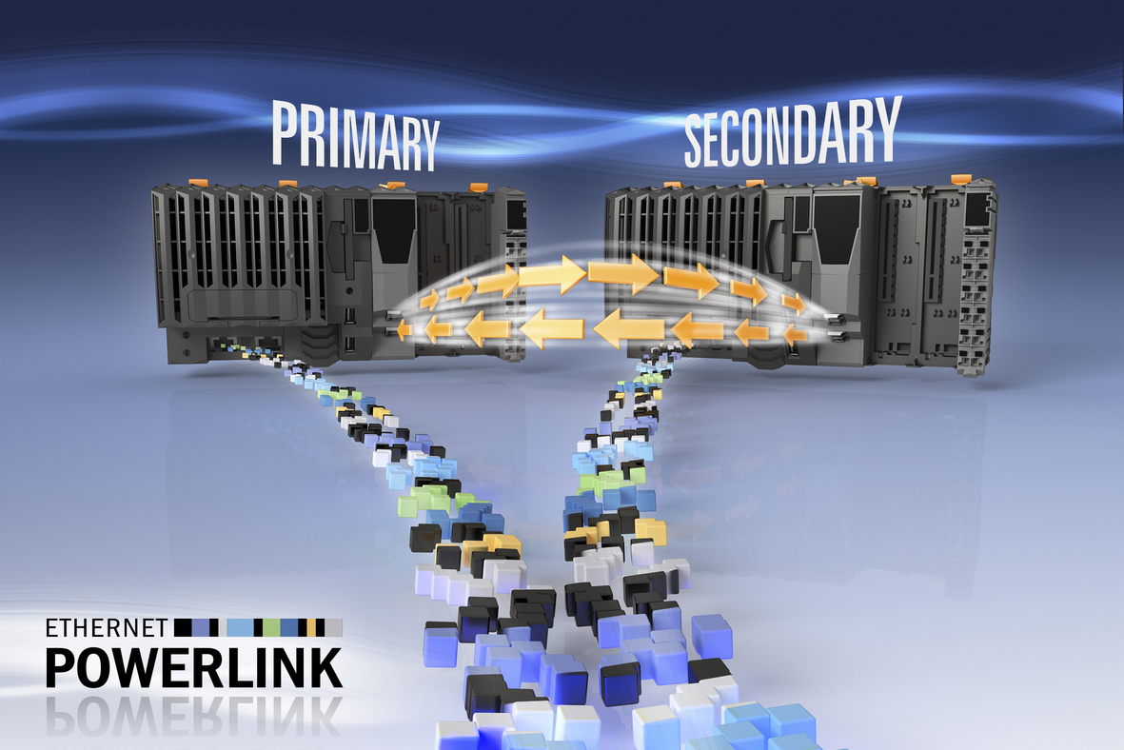
B&R makes it possible to design high-availability systems using standard components, making redundancy affordable for smaller applications with lower downtime costs.

About B&R
B&R, a division of ABB Group, is a global leader in industrial automation headquartered in Austria. B&R combines state-of-the-art technology with advanced engineering to provide customers in virtually every industry with complete solutions for machine and factory automation, motion control, HMI and integrated safety technology. With Industrial IoT communication standards including OPC UA, POWERLINK and openSAFETY as well as its Automation Studio software, B&R is constantly redefining the future of automation engineering. The innovative spirit that keeps B&R at the forefront of industrial automation is driven by a commitment to simplifying processes and exceeding customer expectations.
For more information, visit www.br-automation.com.

