Controller redundancy with POWERLINK
Implementing high availability systems with standard components
B&R is setting new standards with its redundancy solution for X20 control systems, a breakthrough that now allows the advantages of high availability to be enjoyed by smaller applications at much less cost. B&R's solution is based on standard X20 controllers that can be reconfigured at any time with features that reduce downtime using the Automation Studio software development environment. This eliminates the need for specialized redundancy controllers, which are generally very expensive due the small quantities produced. Engineering effort is reduced to declaring the PLC a redundant unit and configuring communication parameters or failure criteria.
Switching in a matter of milliseconds
With B&R's solution, one controller provides active control, while a second controller runs in the background in standby mode. All network functions are monitored continuously so that when the time comes, the backup controller can quickly take over all of the active PLC's functions. Whichever controller becomes active always uses the same IP address as its predecessor. The switching time of the system is a mere two task cycles – so all of this takes place in a matter of a few milliseconds.
Perfectly synchronized with POWERLINK
This redundancy solution is powered by the high-performance, real-time Ethernet POWERLINK communication protocol. An independent high-speed fiber optic redundancy link is used to continually synchronize all important data – the I/O image, for example – between the active and inactive controllers.

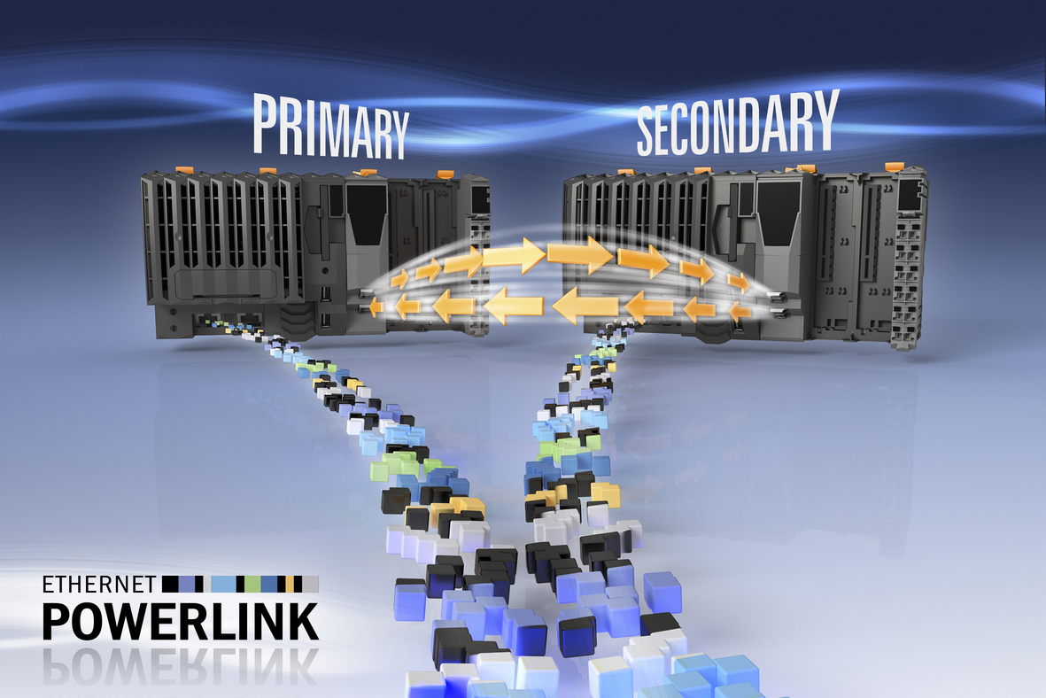
B&R makes it possible to design high-availability systems using standard components, making redundancy affordable for smaller applications with lower downtime costs.

B&R Hakkında
ABB Grubunun bir bölümü olan B&R, merkezi Avusturya'da bulunan endüstriyel otomasyon alanında global bir liderdir. B&R, neredeyse her sektördeki müşterilere makine ve fabrika otomasyonu, hareket kontrolü, HMI ve entegre güvenlik teknolojisi için eksiksiz çözümler sunmak üzere en son teknolojiyi ileri mühendislikle birleştiriyor. OPC UA, POWERLINK ve openSAFETY gibi Endüstriyel IoT iletişim standartlarının yanı sıra Automation Studio yazılımıyla B&R, otomasyon mühendisliğinin geleceğini sürekli olarak yeniden tanımlıyor. B&R'ı endüstriyel otomasyonun ön saflarında tutan yenilikçi ruh, süreçleri basitleştirme ve müşteri beklentilerini aşma taahhüdünden kaynaklanmaktadır.
Daha fazla bilgi için www.br-automation.com adresini ziyaret edin.

