SafeLOGIC-X – The virtual safety solution from B&R
Scalable safety integration for small applications
SafeLOGIC-X from B&R now brings all the advantages of integrated safety technology to small, cost-sensitive applications as well. This solution covers it all – from safe I/O and drive technology to integrated diagnostics, safe line integration and safe machine options.
Unlimited scalability guarantees system continuity
The SafeLOGIC-X solution is programmed using the SafeDESIGNER editor in Automation Studio, just like the hardware-based SafeLOGIC solution. The advantage: When a system outgrows its SafeLOGIC-X solution, it's no problem to switch to a dedicated SafeLOGIC controller. The safety applications can be scaled and configured to meet the requirements of systems of any size. As safe input and output modules are added to a SafeLOGIC safety controller, existing programming code can simply be reused without having to make a single change. Switching over also doesn't require recertification, another benefit that saves both time and money.
This type of unlimited scalability guarantees system continuity right from the start while also ensuring a uniform approach to engineering and diagnostics – two factors vital to increasing the availability of systems and machines.
Safety functions distributed across existing components
SafeLOGIC-X is solely a software-based solution; extra safety controller hardware is not needed. Whereas safety functions are distributed across existing hardware components on the network, the safety application itself runs on a safe input module. All parameter and configuration management is handled on the standard controller. Safe user interface functionality is even handled by the visualization device. And what's the best thing about the SafeLOGIC-X solution? It can be implemented on every single Automation PC, Panel PC, Power Panel and modular control system from B&R.
Data distribution and monitoring with openSAFETY
The architecture used with SafeLOGIC-X is made possible by the openSAFETY standard. This safety protocol provides communication services that comply with SIL 3 requirements and ensures that parameters and configuration data are safely distributed and monitored over the entire network.

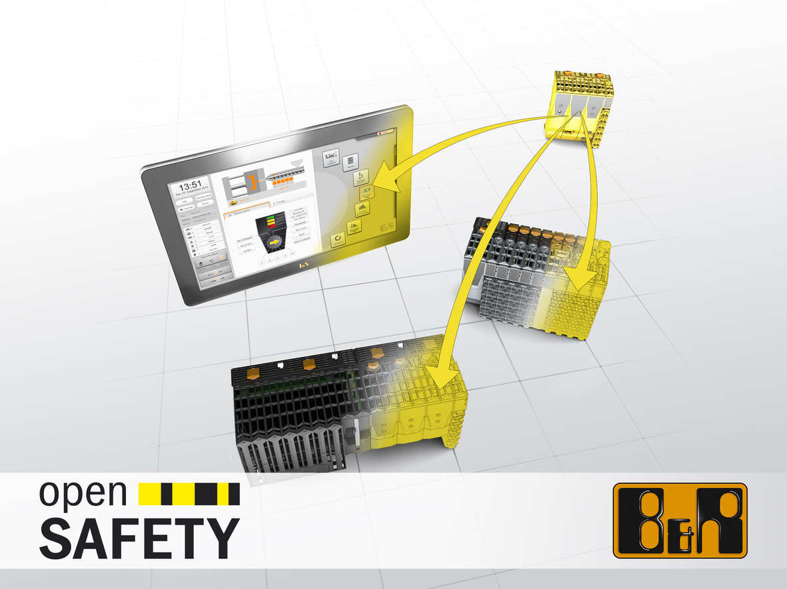
SafeLOGIC-X from B&R eliminates the need for extra safety controller hardware by distributing safety functions across hardware components that already exist on the network.

About B&R
B&R, a division of ABB Group, is a global leader in industrial automation headquartered in Austria. B&R combines state-of-the-art technology with advanced engineering to provide customers in virtually every industry with complete solutions for machine and factory automation, motion control, HMI and integrated safety technology. With Industrial IoT communication standards including OPC UA, POWERLINK and openSAFETY as well as its Automation Studio software, B&R is constantly redefining the future of automation engineering. The innovative spirit that keeps B&R at the forefront of industrial automation is driven by a commitment to simplifying processes and exceeding customer expectations.
For more information, visit www.br-automation.com.

