SafeLOGIC-X – The virtual safety solution from B&R
Scalable safety integration for small applications
SafeLOGIC-X from B&R now brings all the advantages of integrated safety technology to small, cost-sensitive applications as well. This solution covers it all – from safe I/O and drive technology to integrated diagnostics, safe line integration and safe machine options.
Unlimited scalability guarantees system continuity
The SafeLOGIC-X solution is programmed using the SafeDESIGNER editor in Automation Studio, just like the hardware-based SafeLOGIC solution. The advantage: When a system outgrows its SafeLOGIC-X solution, it's no problem to switch to a dedicated SafeLOGIC controller. The safety applications can be scaled and configured to meet the requirements of systems of any size. As safe input and output modules are added to a SafeLOGIC safety controller, existing programming code can simply be reused without having to make a single change. Switching over also doesn't require recertification, another benefit that saves both time and money.
This type of unlimited scalability guarantees system continuity right from the start while also ensuring a uniform approach to engineering and diagnostics – two factors vital to increasing the availability of systems and machines.
Safety functions distributed across existing components
SafeLOGIC-X is solely a software-based solution; extra safety controller hardware is not needed. Whereas safety functions are distributed across existing hardware components on the network, the safety application itself runs on a safe input module. All parameter and configuration management is handled on the standard controller. Safe user interface functionality is even handled by the visualization device. And what's the best thing about the SafeLOGIC-X solution? It can be implemented on every single Automation PC, Panel PC, Power Panel and modular control system from B&R.
Data distribution and monitoring with openSAFETY
The architecture used with SafeLOGIC-X is made possible by the openSAFETY standard. This safety protocol provides communication services that comply with SIL 3 requirements and ensures that parameters and configuration data are safely distributed and monitored over the entire network.

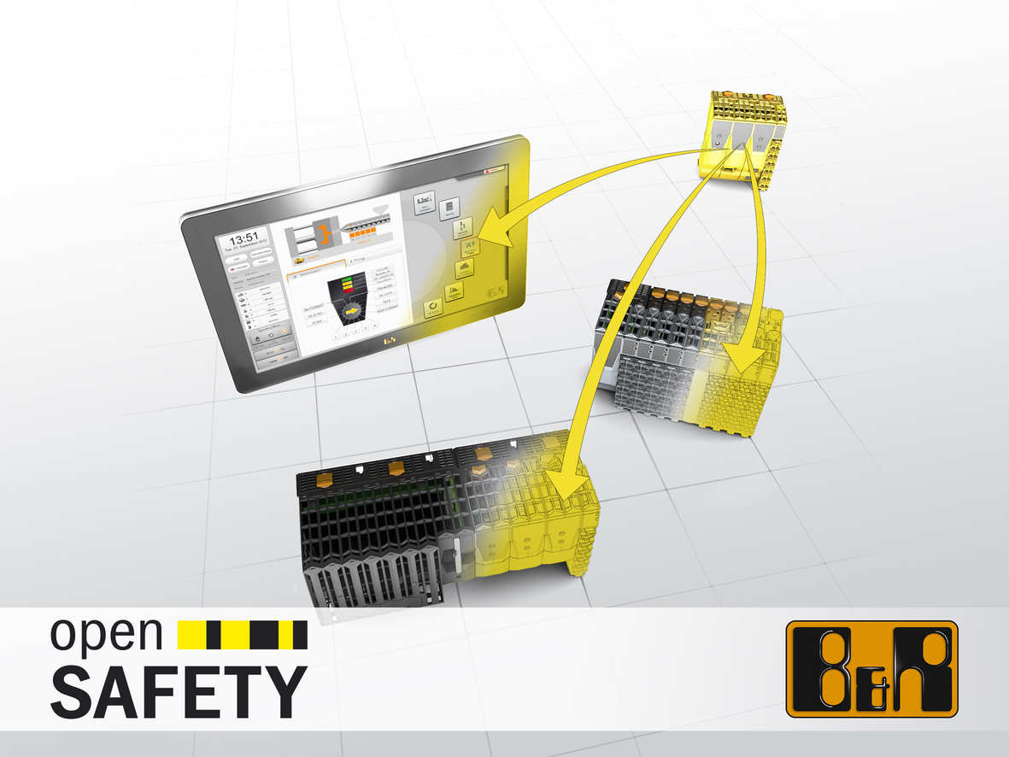
SafeLOGIC-X from B&R eliminates the need for extra safety controller hardware by distributing safety functions across hardware components that already exist on the network.

关于贝加莱
贝加莱是一家总部位于奥地利并在全球拥有分公司的创新型自动化企业。2017年7月，贝加莱成为ABB集团的机械自动化事业部。作为工业自动化领域的全球领导者，贝加莱将前沿技术与领先工程相结合，为几乎每个行业的客户提供面向机器与工厂自动化、运动控制、HMI和集成安全技术的完整解决方案。借助于OPC UA、POWERLINK、openSAFETY等工业物联网通信标准，以及强大的Automation Studio软件开发平台，贝加莱不断重新定义自动化工程的未来。受简化流程和超出客户预期的承诺驱动，贝加莱始终保持创新精神并处于工业自动化领域的前沿。
获取更多信息，请访问www.br-automation.com。

