Entire range of B&R safety products satisfies all EN 50156 requirements
TÜV confirms the safety of B&R I/O modules and controllers
TÜV Süd, one of the world's leading technical service organizations, has recently confirmed that the entire range of B&R X20 safety I/O modules and controllers satisfies all of the requirements of EN 50156 "Electrical equipment for furnaces and ancillary equipment". This standard applies in particular to protective systems used in furnaces and power plants.
Failsafe digital and analog inputs
Safety solutions from B&R allows users to achieve the highest levels of modularity and performance without having to sacrifice a single bit of availability. Safe I/O modules included in the B&R X20 series offer a wide spectrum of failsafe digital and analog inputs. A perfect example is the robust temperature input module for thermocouples, which demonstrates how safety products can be integrated into systems with furnaces or boilers.
openSAFETY – Safe communication for process control systems
Network-integrated safety technology offers huge advantages, especially in the area of process engineering. And with the absolute fastest response times, minimal wiring and safe data transport over any type of fieldbus, no other safety protocol offers production lines the same degree of protection as openSAFETY.

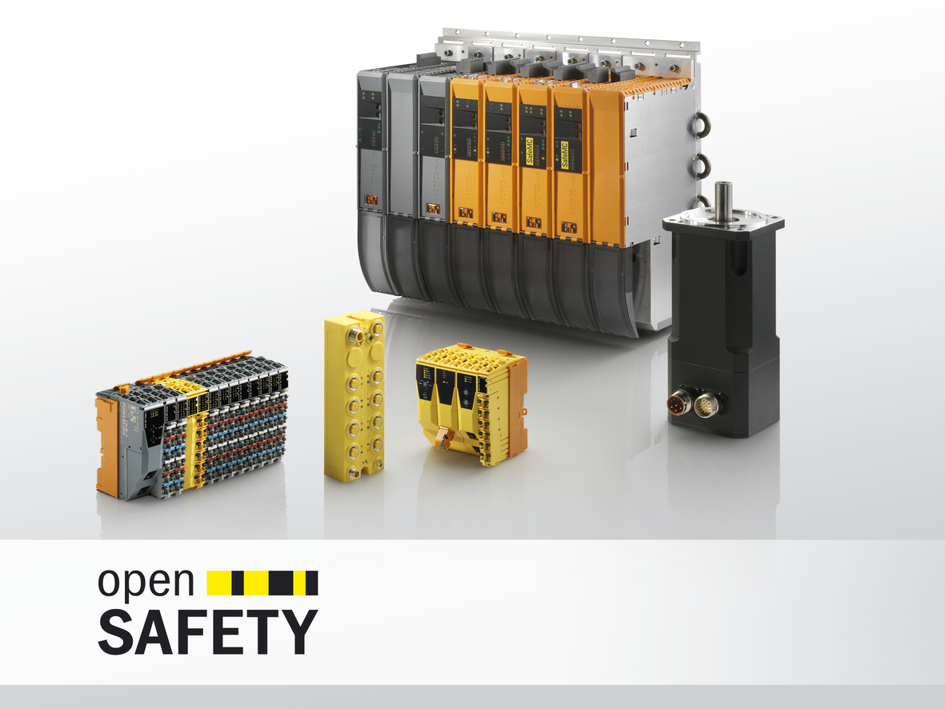
Confirmed by TÜV Süd: Every B&R safety controller and safe I/O module meets all of the requirements of EN 50156.

About B&R
B&R, a division of ABB Group, is a global leader in industrial automation headquartered in Austria. B&R combines state-of-the-art technology with advanced engineering to provide customers in virtually every industry with complete solutions for machine and factory automation, motion control, HMI and integrated safety technology. With Industrial IoT communication standards including OPC UA, POWERLINK and openSAFETY as well as its Automation Studio software, B&R is constantly redefining the future of automation engineering. The innovative spirit that keeps B&R at the forefront of industrial automation is driven by a commitment to simplifying processes and exceeding customer expectations.
For more information, visit www.br-automation.com.

