Advancements in robot safety from B&R
Monitor all serial robot types in a safety application
B&R has extended the safety function "Safely Limited Speed at Tool Center Point" (SLS at TCP): It is now possible to monitor the full spectrum of serial robot types in the safety application. So far it has already enabled safe monitoring of all the joints on a 6-axis articulated arm robot.
Configure custom kinematic chains
With the extended functionality, B&R now offers a parameter block for generalized serial robots. This makes it possible to configure any type of kinematic chain. Users are no longer restricted to specific types of robots, they can define and configure custom kinematic systems. Up to eleven joints can be defined. It is also possible to include up to 20 joint couplings with coupling factors. This allows users to incorporate mechanical couplings between individual axes.
TÜV-certified function blocks
Safely monitoring speed relies on safe axis position data. This data is provided by ACOPOSmulti servo drives with their integrated SafeMC functionality. SafeROBOTICS function blocks in the safety application use these positions to calculate the absolute speeds of the joints, tool mounting flange and tool center point. The blocks are TÜV-certified.
Data is transferred via the fieldbus-independent, safety-oriented openSAFETY protocol. This gives users complete freedom in the selection of their control system. The safety functions themselves are executed directly on the drives.

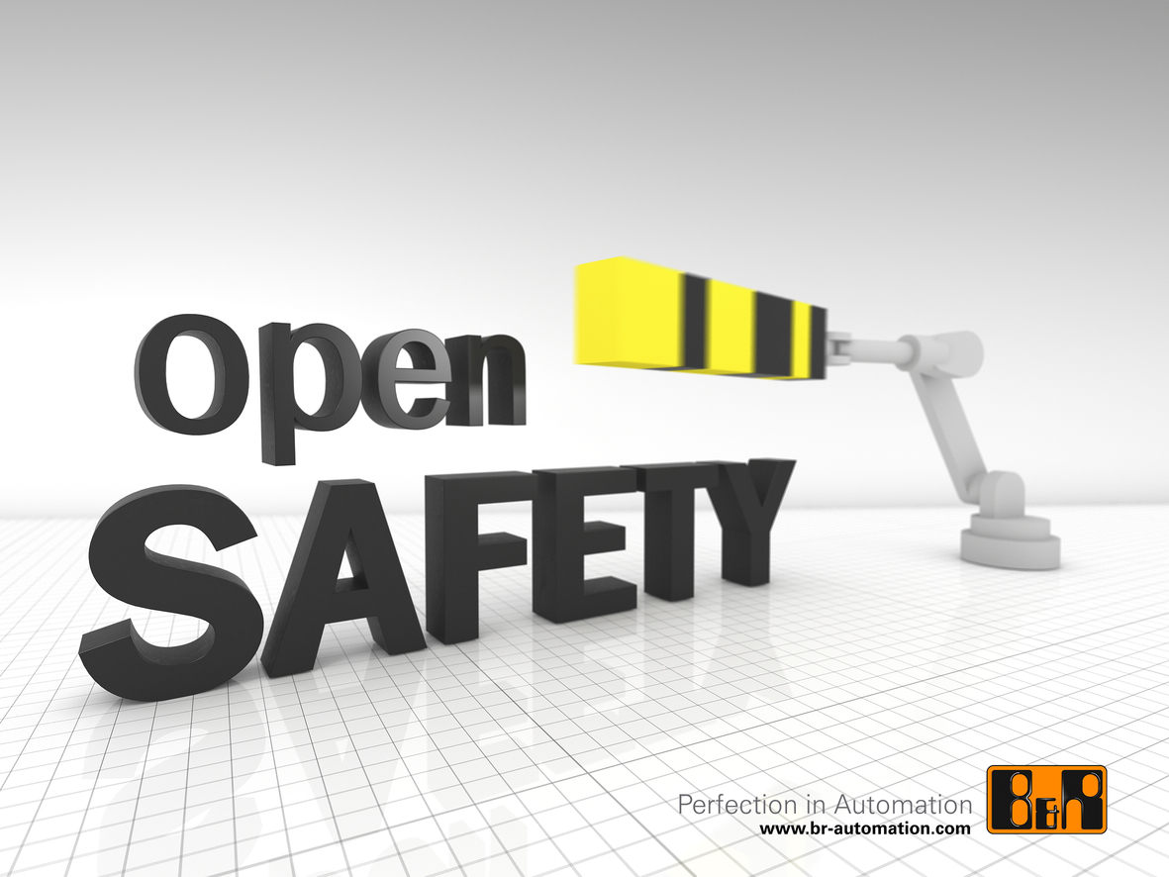
Standardized parameters allow the TÜV-certified function blocks for monitoring the tool center point to be adapted to many different types of kinematic systems without requiring recertification.

About B&R
B&R, a division of ABB Group, is a global leader in industrial automation headquartered in Austria. B&R combines state-of-the-art technology with advanced engineering to provide customers in virtually every industry with complete solutions for machine and factory automation, motion control, HMI and integrated safety technology. With Industrial IoT communication standards including OPC UA, POWERLINK and openSAFETY as well as its Automation Studio software, B&R is constantly redefining the future of automation engineering. The innovative spirit that keeps B&R at the forefront of industrial automation is driven by a commitment to simplifying processes and exceeding customer expectations.
For more information, visit www.br-automation.com.

