B&R Exhibition in Heilbronn
- Agenda - B&R Exhibition in Heilbronn 2013
- Registration
B&R Exhibition 2013 – T.O. Southwest, Heilbronn
Visit us at our B&R Exhibition on July 11, 2013, at the Stettenfels fortress in Untergruppenbach, Germany, and find out about the latest technological trends for future-proof automaton of your machines and systems!

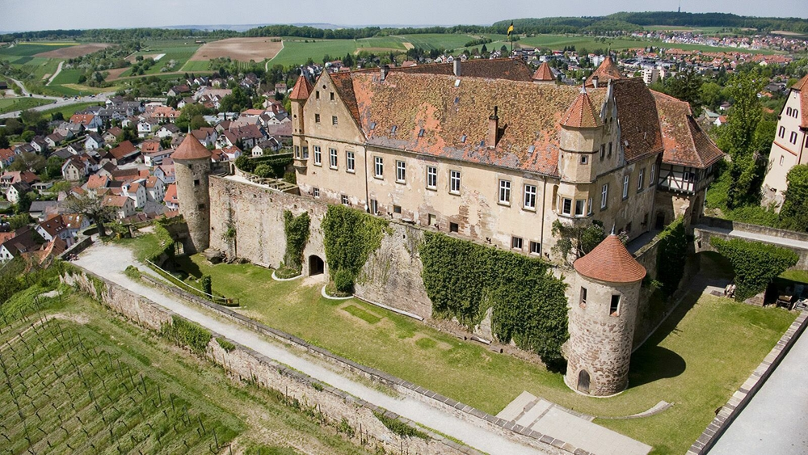

About B&R
B&R, a division of ABB Group, is a global leader in industrial automation headquartered in Austria. B&R combines state-of-the-art technology with advanced engineering to provide customers in virtually every industry with complete solutions for machine and factory automation, motion control, HMI and integrated safety technology. With Industrial IoT communication standards including OPC UA, POWERLINK and openSAFETY as well as its Automation Studio software, B&R is constantly redefining the future of automation engineering. The innovative spirit that keeps B&R at the forefront of industrial automation is driven by a commitment to simplifying processes and exceeding customer expectations.
For more information, visit www.br-automation.com.

