Automation PC 910 from B&R with integrated UPS card
Intelligent safeguard against power outages and fluctuations
For its Automation PC 910, B&R offers a UPS solution that saves both space and costs. Should the external power supply fail, the UPS ensures that data is backed up safely and that programs are closed properly to avoid losing unsaved data. The UPS used by B&R is an online UPS card.
UPS as an insert card saves space and costs
What sets an online UPS apart from a standby UPS is that it runs constantly whenever the PC is on and is therefore able to compensate for power fluctuations in addition to outages. As an insert card, the UPS solution from B&R is especially convenient. Installed directly in the PC, it requires neither housing nor cable connections. This lowers costs and frees up cabinet space, while also reducing power loss.
Two sizes available: 2.2 or 4.5 Ah
The UPS card is available in two sizes. The smaller card, with a capacity of 2.2 Ah, is sufficient for the most common configurations of B&R's extremely customizable industrial PC. For high-performance configurations with extensive options and multiple insert cards, the larger UPS with 4.5 Ah is recommended. The larger card also has a wider temperature range and an exceptionally long service life. Depending on the system configuration, the UPS cards can bridge outages of up to one hour.

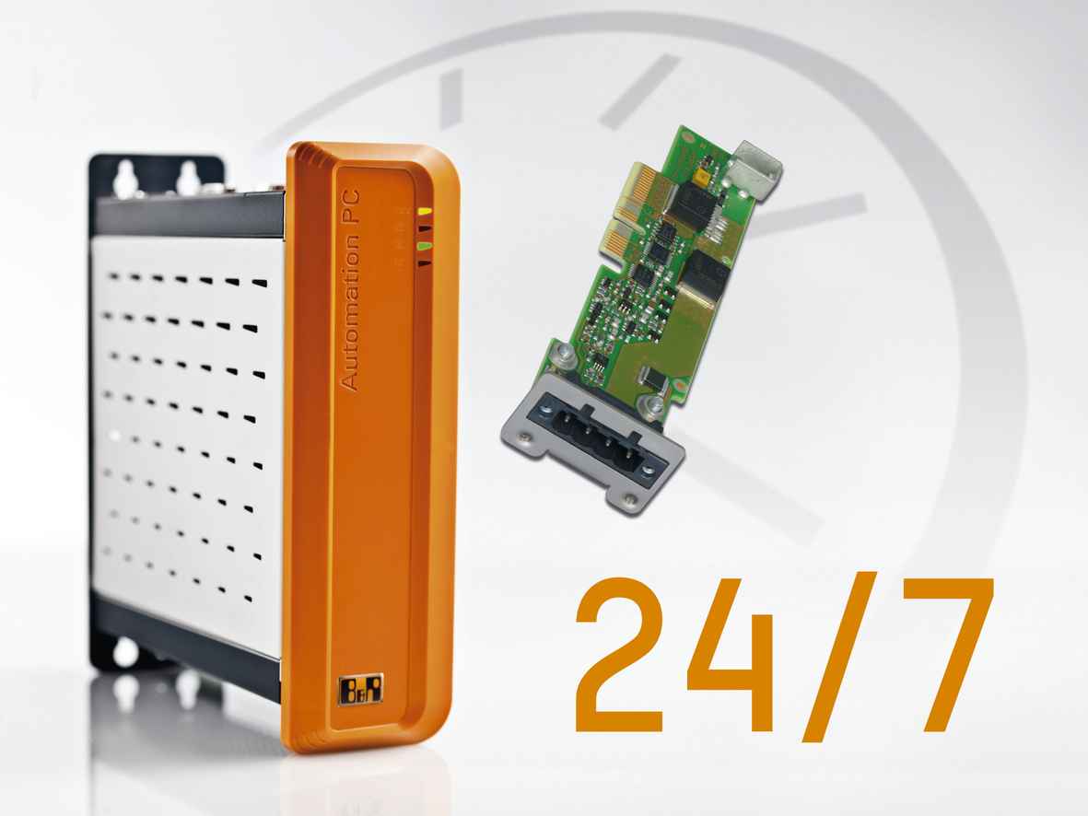
The online UPS card integrated in the Automation PC 910 saves space and costs in the control cabinet. UPS cards are available with either 2.2 or 4.5 Ah charging current.

B&R Hakkında
ABB Grubunun bir bölümü olan B&R, merkezi Avusturya'da bulunan endüstriyel otomasyon alanında global bir liderdir. B&R, neredeyse her sektördeki müşterilere makine ve fabrika otomasyonu, hareket kontrolü, HMI ve entegre güvenlik teknolojisi için eksiksiz çözümler sunmak üzere en son teknolojiyi ileri mühendislikle birleştiriyor. OPC UA, POWERLINK ve openSAFETY gibi Endüstriyel IoT iletişim standartlarının yanı sıra Automation Studio yazılımıyla B&R, otomasyon mühendisliğinin geleceğini sürekli olarak yeniden tanımlıyor. B&R'ı endüstriyel otomasyonun ön saflarında tutan yenilikçi ruh, süreçleri basitleştirme ve müşteri beklentilerini aşma taahhüdünden kaynaklanmaktadır.
Daha fazla bilgi için www.br-automation.com adresini ziyaret edin.

