B&R boosts energy efficiency in plastics processing
APROLEnMon – Easily integrated complete solution
Manufacturers in plastics processing and countless other industries are looking for opportunities to further reduce energy consumption. Generally, the potential for savings is high. Those who find ways to tap into this potential stand to gain a sustained economic benefit along with clear competitive advantages. "Demands on quality continue to rise in the plastics industry, and there is a steady pressure to reduce energy consumption and unit costs in spite of shrinking batch sizes. The goal of an automation solution is therefore to provide the necessary flexibility, added value and efficiency."
Maximum flexibility with minimal engineering
Before you can make your production more efficient, you first have to know where, when and how much energy is actually being consumed. B&R offers a convenient and powerful tool for monitoring energy consumption: APROL EnMon. APROL EnMon is an easily integrated complete solution and comes preinstalled on a B&R box PC. This out-of-the-box solution has only a few parameters to set before it can begin collecting data. Then you can take advantage of the many straightforward and reliable consumption analysis options.
Highly versatile stand-alone solution
A significantly higher level of process optimization can be attained by monitoring not just a single production line, but rather an entire plant along with all of its auxiliary equipment. The key to doing so is to analyze the production system in its entirety. Manufacturers who react accordingly in their production processes can substantially improve the energy balance of their products – and they can do it without generating any additional process costs.
The system grows along with its tasks
"The performance monitoring features enable significant reductions in material usage, energy consumption, production times and unit costs," says Martin Reichinger, manager of B&R's process automation business unit. Well-coordinated machine operation improves capacity utilization, reduces wear and eliminates sources of inefficiency in the production process. "APROL Process Data Acquisition (PDA) provides a central, seamless and long-term archive of all data. This strengthens quality assurance and makes a manufacturing process more competitive."
B&R products are designed with energy in mind
In addition to software products like APROL EnMon and PDA, the entire B&R product lineup is designed to provide optimum energy efficiency. Machine manufacturers can plant the seeds of efficient energy consumption early in the design process by optimizing motion profiles and correctly dimensioning machine components. B&R offers them a development environment that provides all the tools and features they need to design and manage every aspect of an entire automation solution. Drive components from B&R also reuse braking energy distributed throughout the drive network via a DC bus circuit and allow unused power to be fed back into the grid.

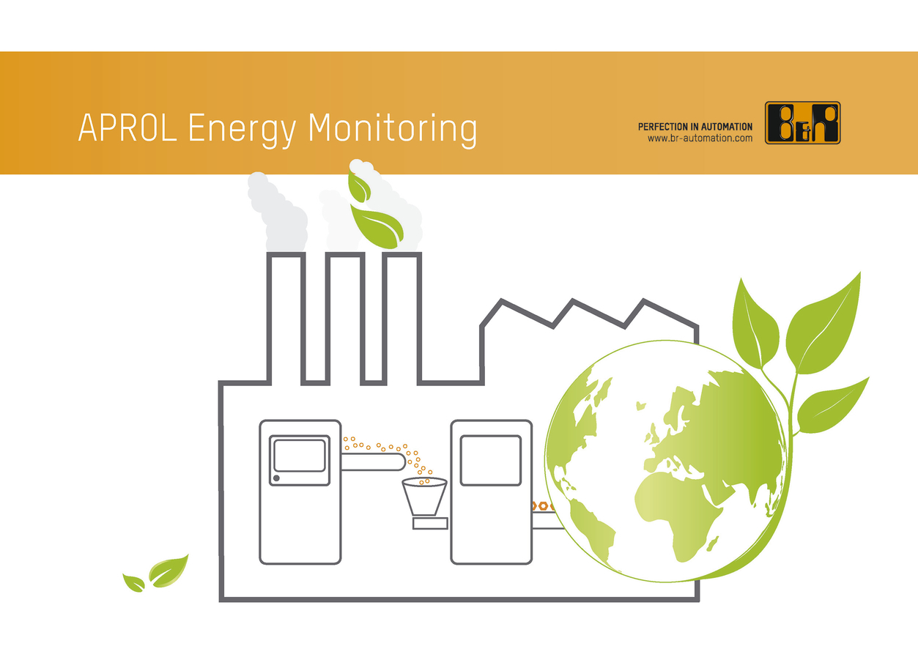
B&R's APROL EnMon energy monitoring solution is the key to tapping into the savings potential of the plastics industry.

B&R Hakkında
ABB Grubunun bir bölümü olan B&R, merkezi Avusturya'da bulunan endüstriyel otomasyon alanında global bir liderdir. B&R, neredeyse her sektördeki müşterilere makine ve fabrika otomasyonu, hareket kontrolü, HMI ve entegre güvenlik teknolojisi için eksiksiz çözümler sunmak üzere en son teknolojiyi ileri mühendislikle birleştiriyor. OPC UA, POWERLINK ve openSAFETY gibi Endüstriyel IoT iletişim standartlarının yanı sıra Automation Studio yazılımıyla B&R, otomasyon mühendisliğinin geleceğini sürekli olarak yeniden tanımlıyor. B&R'ı endüstriyel otomasyonun ön saflarında tutan yenilikçi ruh, süreçleri basitleştirme ve müşteri beklentilerini aşma taahhüdünden kaynaklanmaktadır.
Daha fazla bilgi için www.br-automation.com adresini ziyaret edin.

