New additions to B&R's ACOPOSmicro lineup
Compact drives with option board and heat sink
B&R has made some new additions to its ACOPOSmicro line of compact dual-axis drives. In addition to the drives available with a resolver and EnDat 2.2 and LinMot encoder interfaces, the ACOPOSmicro Servo now also features a convenient option board. In addition to the two trigger inputs and the 24 VDC output, this option board also offers two digital outputs. These can be used to control a holding brake, for example.
Broad selection of cooling options
The ACOPOSmicro Stepper with a heat spreader can be fastened on mounting plates or cold plates. The new model with a heat sink, on the other hand, is designed for wall mounting. This new cooling option allows the stepper to be used in applications with higher performance requirements without taking up any additional cabinet space.

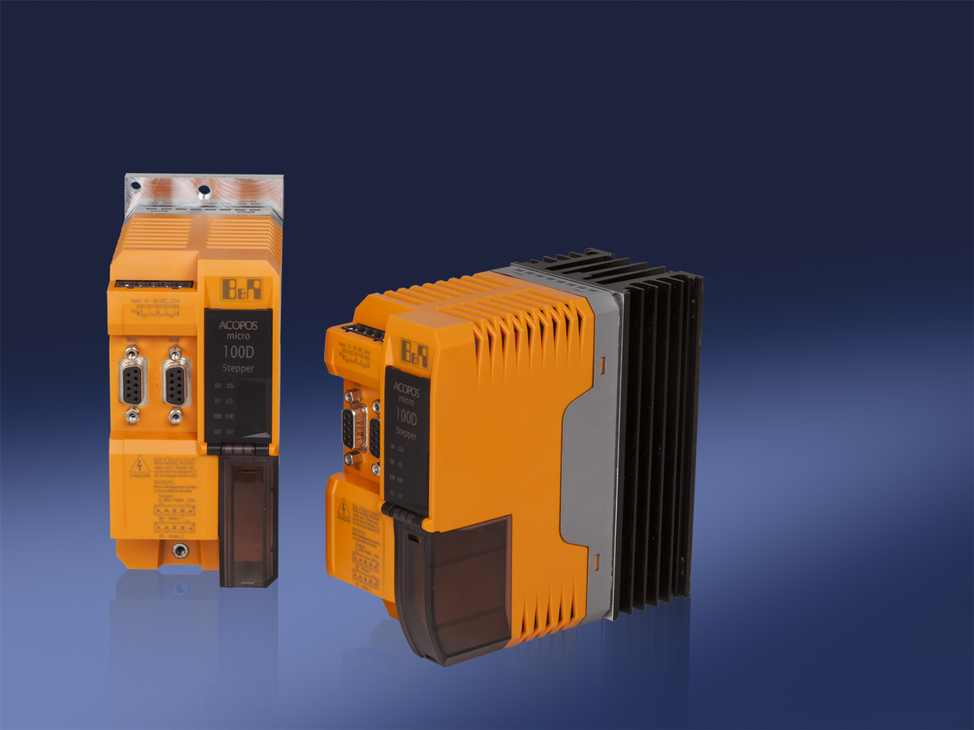
Precise and compact: B&R'S ACOPOSmicro drives, now available with option board and heat sink.

About B&R
B&R, a division of ABB Group, is a global leader in industrial automation headquartered in Austria. B&R combines state-of-the-art technology with advanced engineering to provide customers in virtually every industry with complete solutions for machine and factory automation, motion control, HMI and integrated safety technology. With Industrial IoT communication standards including OPC UA, POWERLINK and openSAFETY as well as its Automation Studio software, B&R is constantly redefining the future of automation engineering. The innovative spirit that keeps B&R at the forefront of industrial automation is driven by a commitment to simplifying processes and exceeding customer expectations.
For more information, visit www.br-automation.com.

