EPSG at the Automotive Engineering Show 2013 in India
Future-proof your plant with POWERLINK and openSAFETY
The EPSG received an overwhelming positive response at the Automotive Engineering Show in Chennai, India, where it hosted visitors from renowned companies from the automotive sector. A highlight of the exhibition was a seminar held by Ninad Deshpande of B&R, in which he addressed the concerns of industrial specialists and automotive plant owners with regard to their communication networks. “These users are looking for fieldbus technology that brings them a maximum balance of productivity and accuracy, and POWERLINK being efficient, reliable and cost effective delivers effectively on both accounts.”
Improvement of manufacturing operations
The second day of the exhibition featured a special seminar entitled “Sustaining Good Performance with Grassroots Innovation”. This interactive session gave practicing professionals from leading automotive plants and global technology providers an opportunity to exchange tips on how to fuel innovation in day-to-day manufacturing operations. Seminar moderator P.V. Sivaram, managing director of B&R India, evaluated innovations submitted from throughout the automotive industry and presented innovation awards to the winners.
POWERLINK has distinct advantages for everyone ranging from device manufacturers to end uses, contributing to a future-proof plant by ensuring freedom of topology, easy maintenance and convenient diagnostics. Open technology provides guaranteed investment security.
An open future is faster and safer
EPSG stole the show with its indisputable advantages. Based on standard Ethernet, POWERLINK stands ready to build on the future evolution of Ethernet technology. As the first real-time Ethernet protocol, POWERLINK delivers an impressive performance – IEEE 802.3 compliance, fast cycle times of 100 µs and a system synchronization of 0.1 µs – that makes it an optimal solution for all aspects of industrial automation. 100% openness means no licensing, no royalties, no copyrights, no vendor lock up, and no single owner of the protocol. These added advantages make POWERLINK the unanimous choice among industrial Ethernet protocols.
openSAFETY – The bus-independent safety standard
openSAFETY is a safety protocol that can be used with all fieldbus or industrial Ethernet systems. This enables the end customer to interconnect several machines on the safety level independently from the bus system being used. This offers advantages over conventional plant safety solutions such as reduced wiring, elimination of setup errors, decreased response times and intelligent safety functions.
Other safety protocols on the market are proprietary, limited to certain fieldbuses and unable to communicate with each other. openSAFETY provides 100% openness and interoperability with all fieldbus network. This openness is not limited to legal details, but is elemental to the technology itself and supported by all of the necessary certifications.
  - About B&R
B&R has its head-office at Pune, Maharashtra and four other offices in India. B&R is fully equipped to cater to your application, supply and support requirements right in India. A global leader in industrial automation, B&R provides complete solutions for machine and process automation, motion control, HMI and integrated safety technology for every industry. With industrial fieldbus communication standards like POWERLINK and openSAFETY as well as the powerful Automation Studio software development environment, B&R is constantly redefining the future of automation engineering. The global headquarters of B&R as well as the manufacturing center is at Eggelsberg, Austria.

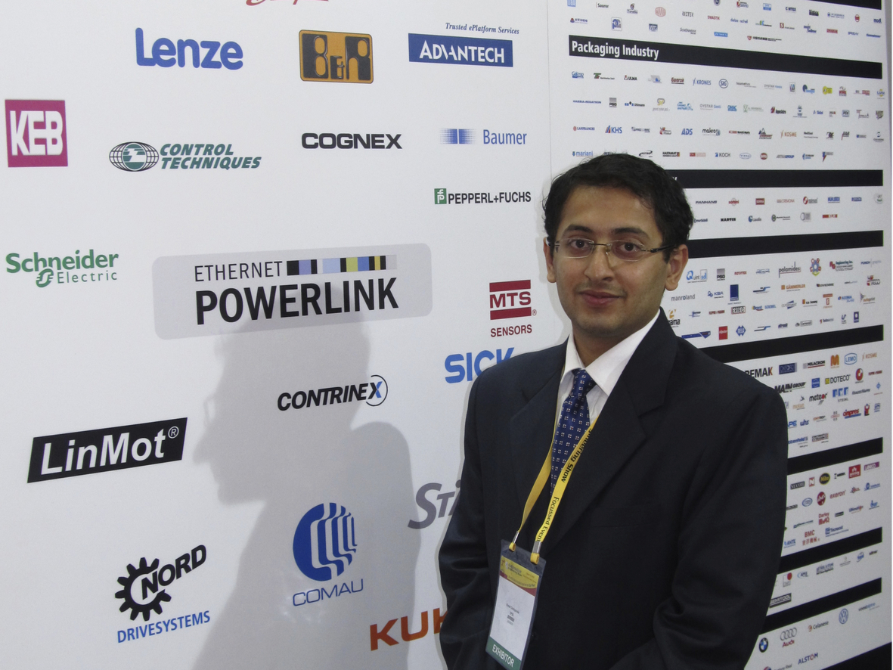
A highlight of the Automotive Engineering Show was a seminar held by Ninad Deshpande of B&R. He addressed the concerns of industrial specialists and automotive plant owners with regard to their communication networks.

About B&R
B&R, a division of ABB Group, is a global leader in industrial automation headquartered in Austria. B&R combines state-of-the-art technology with advanced engineering to provide customers in virtually every industry with complete solutions for machine and factory automation, motion control, HMI and integrated safety technology. With Industrial IoT communication standards including OPC UA, POWERLINK and openSAFETY as well as its Automation Studio software, B&R is constantly redefining the future of automation engineering. The innovative spirit that keeps B&R at the forefront of industrial automation is driven by a commitment to simplifying processes and exceeding customer expectations.
For more information, visit www.br-automation.com.

