APROL – High availability at all levels
B&R process control with redundant servers, fieldbus networks and controllers
Starting with Release 4.0, B&R's APROL process control system provides maximum protection against system failure. APROL allows redundant systems to be set up at four different levels: fieldbus networks, controllers, runtime servers and operator stations. If the active system fails, an identical system running in parallel takes over all of its tasks. This prevents production downtime, improves process reliability and ensures consistent output quality.
Redundancy with standard hardware
For some time, B&R has provided the option of using standard components from the X20 control system to establish controller redundancy. This eliminates the need for costly specialized hardware. Standard control computers from B&R's Automation PC series are also well-suited for constructing redundant server systems. Since the servers hold not only historical archives but also critical applications such as the real-time database and the alarm and trend servers, their failure would have severe consequences.
Changeover within a few milliseconds
The primary and secondary controllers or servers exchange data constantly via a redundancy link. Should the primary unit fail, the powerful real-time Ethernet POWERLINK provides a fast and seamless transition to the secondary controller within a few milliseconds.
APROL allows operator stations, which are typically redundant, to be designed using standard components. With POWERLINK, B&R offers flexible options for redundant fieldbus systems. APROL also makes it possible to implement fieldbus redundancy using third-party systems. Configuration options can be used to enable or disable redundancy.

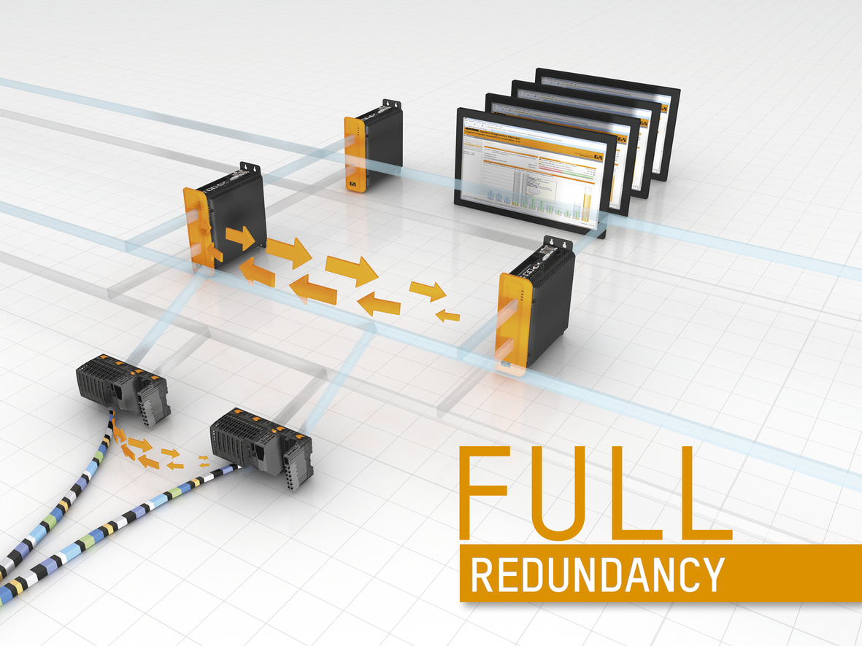
B&R's process control system, APROL, allows standard components to be constructed into high-availability systems at four different levels: Fieldbus networks, controllers, runtime servers and operator stations.

B&R Hakkında
ABB Grubunun bir bölümü olan B&R, merkezi Avusturya'da bulunan endüstriyel otomasyon alanında global bir liderdir. B&R, neredeyse her sektördeki müşterilere makine ve fabrika otomasyonu, hareket kontrolü, HMI ve entegre güvenlik teknolojisi için eksiksiz çözümler sunmak üzere en son teknolojiyi ileri mühendislikle birleştiriyor. OPC UA, POWERLINK ve openSAFETY gibi Endüstriyel IoT iletişim standartlarının yanı sıra Automation Studio yazılımıyla B&R, otomasyon mühendisliğinin geleceğini sürekli olarak yeniden tanımlıyor. B&R'ı endüstriyel otomasyonun ön saflarında tutan yenilikçi ruh, süreçleri basitleştirme ve müşteri beklentilerini aşma taahhüdünden kaynaklanmaktadır.
Daha fazla bilgi için www.br-automation.com adresini ziyaret edin.

