APROL reporting with electronic signatures
B&R's process control system offers manipulation-proof logging
With B&R's APROL process control system, all configurations, operations and modifications performed throughout the system can be seamlessly traced. Secure reporting with electronic signatures reliably prevents manipulation of signed logs and process documents. The workflow remains as intuitive and convenient as B&R customers have come to expect.
Protect signed reports against manipulation
Authorized personnel sign documents using a personalized certificate, derived from a system certificate integrated in APROL. The integrated Adobe Reader verifies the signatures' authenticity, making it impossible to use editing software to manipulate PDF files such as those frequently generated for batch logs.
Maximum convenience for the user
Since the digital signature functionality is fully integrated in APROL, there is no need for externally generated certificates or third party software. Users enjoy seamless security against reporting manipulation with no additional costs.

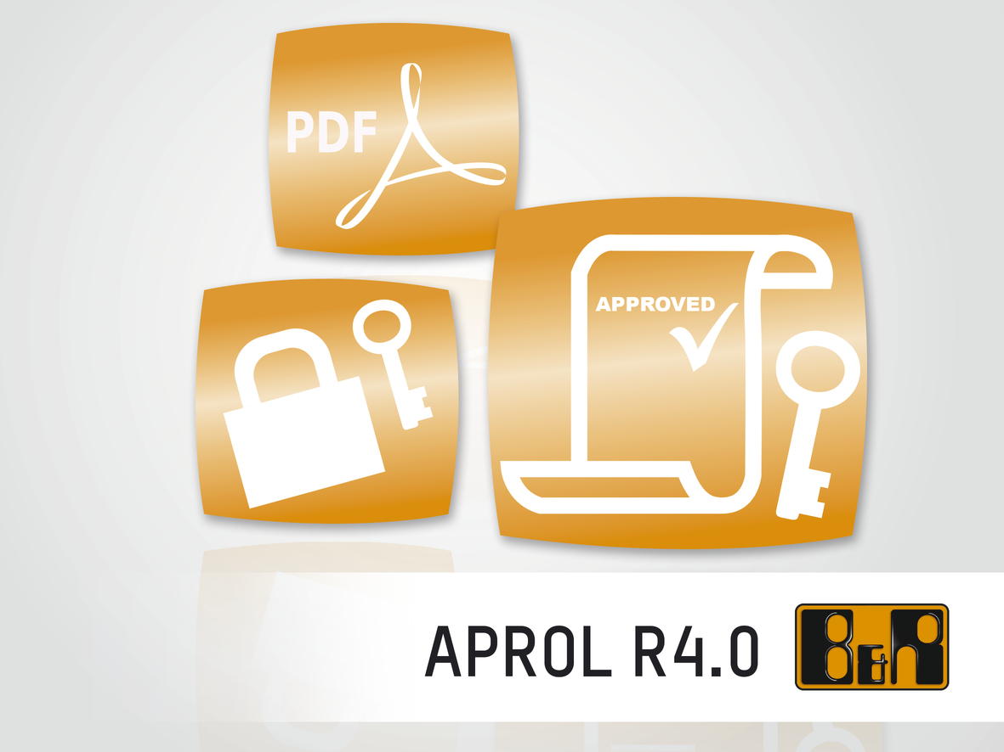
Digital signatures in APROL provide seamless security against manipulation of reporting documents.

About B&R
B&R, a division of ABB Group, is a global leader in industrial automation headquartered in Austria. B&R combines state-of-the-art technology with advanced engineering to provide customers in virtually every industry with complete solutions for machine and factory automation, motion control, HMI and integrated safety technology. With Industrial IoT communication standards including OPC UA, POWERLINK and openSAFETY as well as its Automation Studio software, B&R is constantly redefining the future of automation engineering. The innovative spirit that keeps B&R at the forefront of industrial automation is driven by a commitment to simplifying processes and exceeding customer expectations.
For more information, visit www.br-automation.com.

