High-power servo motors up to 140 kW from B&R
New areas of application in the upper power range
B&R has expanded their product line to include servo motors with high torque and an extended range of speeds. The highly efficient motors in the 8KS series provide up to 140 kW of power and stall torque up to 555 Nm. Available in two sizes with speeds up to 3,000 rpm, 8KS motors open up new possibilities for applications in a wide range of industries that require high power. In addition, these servo motors are available with either axial or centrifugal fans, water cooling and optional mounting feet.
For high-powered servo drive solutions
This motor series is also the perfect complement for implementing high-powered yet energy-efficient servo hydraulic drive solutions together with B&R's servo pump control. The variant with reinforced bearings, for example, makes it possible to set up high-torque belt feed axes for electric injection molding machines.
Simple integration and easy commissioning – just as expected
The servo motors in this series come equipped with a resolver interface, an optical encoder with EnDat interface and an embedded parameter chip, ensuring seamless compatibility with ACOPOSmulti drives and easy integration into B&R's entire system landscape. As a result, 8KS motors can be installed and operated with the same comfort and ease that has come to be expected from all B&R motors.

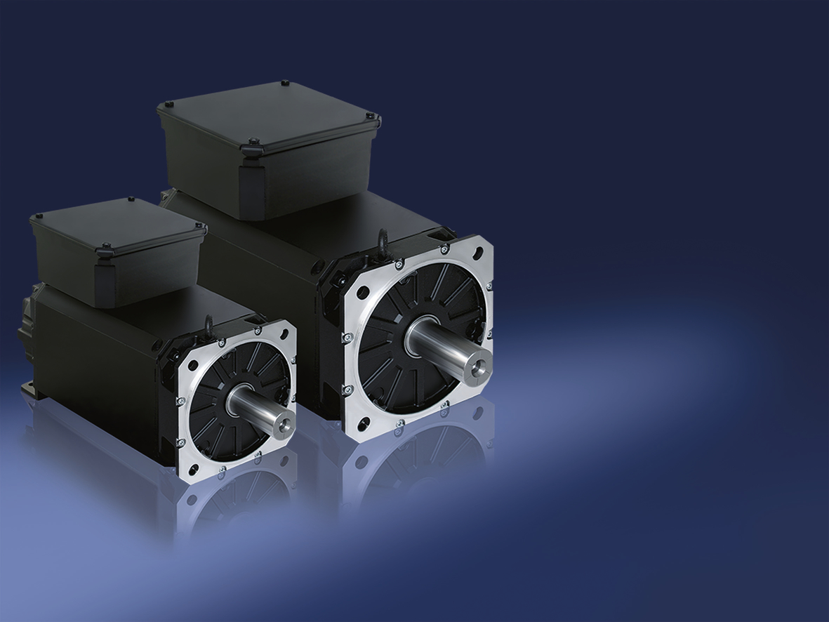
B&R's new 8KS motor series offers all the benefits of servo motor technology in a power range higher than the 8LS and 8JS series.

About B&R
B&R, a division of ABB Group, is a global leader in industrial automation headquartered in Austria. B&R combines state-of-the-art technology with advanced engineering to provide customers in virtually every industry with complete solutions for machine and factory automation, motion control, HMI and integrated safety technology. With Industrial IoT communication standards including OPC UA, POWERLINK and openSAFETY as well as its Automation Studio software, B&R is constantly redefining the future of automation engineering. The innovative spirit that keeps B&R at the forefront of industrial automation is driven by a commitment to simplifying processes and exceeding customer expectations.
For more information, visit www.br-automation.com.

