B&R at the 2013 SMART – Automation Austria
Innovations for industrial automation in Austria
The 2013 SMART – Automation Austria will take place from Oct 1st to the 10th in Linz. In hall DC, booth 231, B&R will be presenting their entire range of products and services. The exhibit will focus on four current topics: Energy monitoring, condition monitoring, a virtual safety solution and high-speed real-time communication via POWERLINK.
Optimized energy management
As a solution for energy data management, APROL EnMon helps users improve their energy efficiency. This ready-to-use solution, which runs on B&R's Automation PC 910, is a simple way to implement the requirements specified in ISO 50001. The solution helps considerably reduce energy consumption, with the resulting financial savings strengthening users' competitive edge.
Predictive maintenance based on constant condition monitoring
The ability to predict machine and system failures reduces costs and increases availability. Condition monitoring modules from B&R precisely detect cases when service work may be needed and are also extremely easy to configure. All of these modules are part of the X20 control system series and can therefore be used in any control topology with no limitations. A special feature of these modules is that they perform vibration analysis locally, right on the module. Prepared results also provide detailed insight into the system mechanics, allowing existing processes to be optimized with maximum efficiency.
POWERLINK – 728 axes in 400 µs
POWERLINK is the perfect choice for Ethernet-based industrial applications with hard real-time requirements. The Ethernet standard has communication cycles in the range of only a few hundred microseconds. Utilizing cross-traffic makes it possible to synchronize multiple axes with exceptional precision. That is why POWERLINK is now the fastest network in the world. This two-dimensional film stretching machine from Brückner Maschinenbau GmbH & Co. KG features 728 axes synchronized with a cycle time of 400 µs.
Virtual safety controller – SafeLOGIC-X
For safe automation applications, B&R presents a software-based safety controller whose safety functionality is distributed across safe I/O modules, a standard controller and the HMI application. This solution, called SafeLOGIC-X, allows even smaller, cost-sensitive safety applications to enjoy the benefits of an integrated safety solution with full-fledged support for all safe motion functions. SafeLOGIC-X uses the openSAFETY communication protocol, the first open – and only 100% bus-independent – safety standard for all Industrial Ethernet solutions.

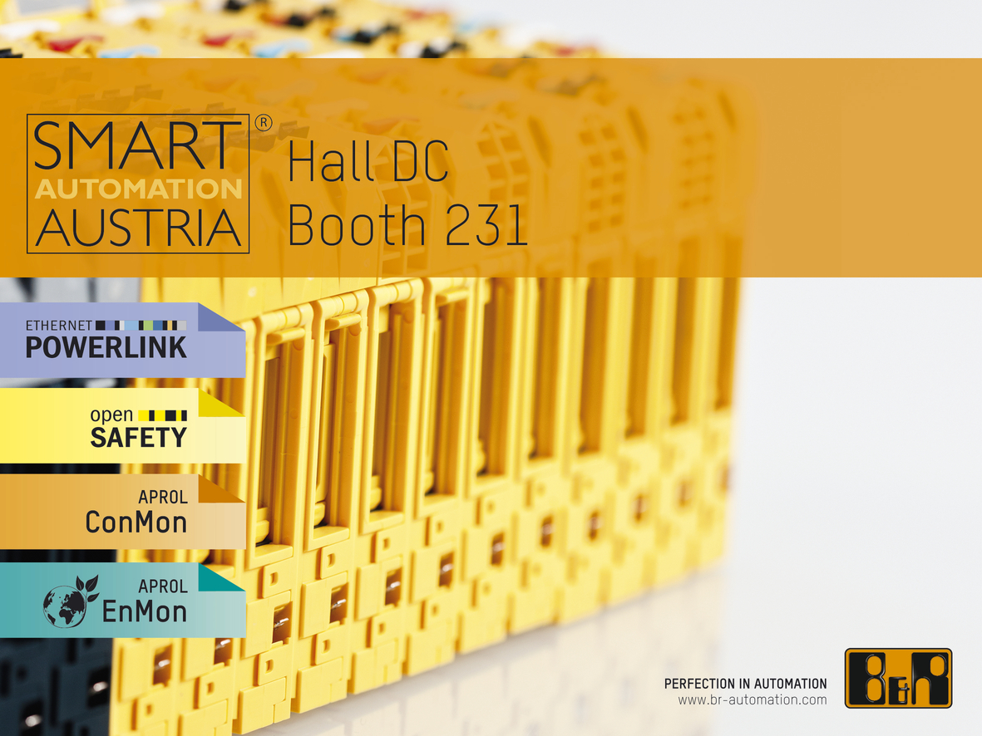
At the trade fair for industrial automation (hall DC, booth 231), B&R will be presenting current automation topics.

B&R Hakkında
ABB Grubunun bir bölümü olan B&R, merkezi Avusturya'da bulunan endüstriyel otomasyon alanında global bir liderdir. B&R, neredeyse her sektördeki müşterilere makine ve fabrika otomasyonu, hareket kontrolü, HMI ve entegre güvenlik teknolojisi için eksiksiz çözümler sunmak üzere en son teknolojiyi ileri mühendislikle birleştiriyor. OPC UA, POWERLINK ve openSAFETY gibi Endüstriyel IoT iletişim standartlarının yanı sıra Automation Studio yazılımıyla B&R, otomasyon mühendisliğinin geleceğini sürekli olarak yeniden tanımlıyor. B&R'ı endüstriyel otomasyonun ön saflarında tutan yenilikçi ruh, süreçleri basitleştirme ve müşteri beklentilerini aşma taahhüdünden kaynaklanmaktadır.
Daha fazla bilgi için www.br-automation.com adresini ziyaret edin.

