B&R at drinktec 2013 in Munich
Perfect solutions for the beverage and liquid food industry
drinktec in Munich is the world’s leading trade show for the beverage and liquid food Industry. Held in four year intervals, this year’s show will run from September 16-20, 2013. Cultivating its close ties to the market, B&R will be presenting its full range of industry solutions – particularly for production and packaging machinery – in Hall A6 / Booth 540.
B&R is a leading supplier of motion, HMI and machine control for the beverage industry, with a comprehensive portfolio of solutions for every requirement at all stages of production and packaging. Whatever the liquid or the packaging technology, B&R has the solution to meet the market’s real demands. This includes hygienic design that reduces the time and effort spent on cleaning. B&R offers universal, scalable solutions built with robust, stainless steel industrial PCs, operator panels, keyboards and servo motors with IP protection levels up to 69K.
Check out our YouTube channel.
- B&R automation solutions for the packaging industry
Mechatronic expertise
Blower, filler, capper and labeler machines demand maximum yield and extreme flexibility. Both can be achieved through a modular design with control and drive components installed directly on the frame or even on rotating parts. B&R combines maximum performance, high flexibility and real openness with ACOPOSremote IP65 servo drives and motor-mounted ACOPOSmotor servo drives, as well as the X67 series of frame-mounted I/O and safe I/O modules.
Real-time high-speed data transfer via slip rings
The fast Ethernet-based communication standards POWERLINK and openSAFETY enable high-speed, certified and safe data transfer, even via slip rings and with line and master node redundancy.
Energy efficiency
Part of the B&R exhibit will focus on the capability of B&R systems with to cover both process control and machine automation with APROL PROCESS CONTROL SYSTEM. This provides added process stability, availability and efficiency, particularly in combination with B&R condition and energy monitoring solutions. Energy efficiency can be further improved by using ACOPOSmicro servo controllers and LinMot® linear motors, the perfect tubular linear actuator combination to replace pneumatics in capping and filling applications.
Shorter time-to-market
Another focal point of B&R’s drinktec exhibit is Automation Studio 4, the latest generation of B&R’s software development environment. It simplifies and accelerates every aspect of machine design, providing convenient simulation to verify the results prior to prototyping and to optimize production efficiency. Automation Studio offers a uniform environment for developing every aspect of an automation solution: from control, motion and safety technology to HMI and process visualization. Helpful modules such as the B&R robotics library ensure perfect integration of pick & place and palletizer units into machines and production lines with open and flexible configuration of kinematic systems.

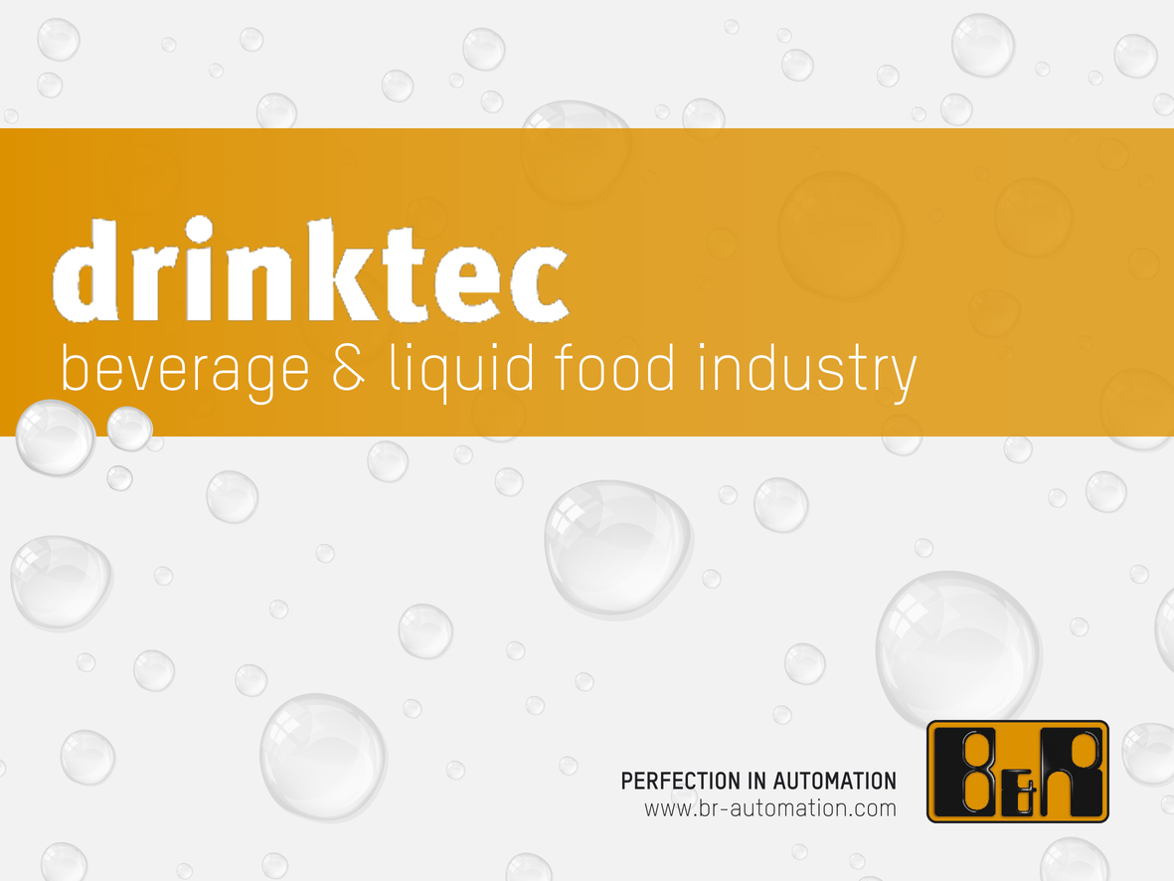
At drinktec 2013 in Munich, B&R will present its comprehensive range of products and solutions for automating machines and systems for the beverage and liquid food industry.

About B&R
B&R, a division of ABB Group, is a global leader in industrial automation headquartered in Austria. B&R combines state-of-the-art technology with advanced engineering to provide customers in virtually every industry with complete solutions for machine and factory automation, motion control, HMI and integrated safety technology. With Industrial IoT communication standards including OPC UA, POWERLINK and openSAFETY as well as its Automation Studio software, B&R is constantly redefining the future of automation engineering. The innovative spirit that keeps B&R at the forefront of industrial automation is driven by a commitment to simplifying processes and exceeding customer expectations.
For more information, visit www.br-automation.com.

