B&R is on the lookout for young professionals
Approximately 150 employees gain practical experience in all areas of the company
In 2013, Bernecker + Rainer Industrie-Elektronik Ges.m.b.H (B&R) again provided numerous summer interns insight into various departments at the company. Approximately 150 trade school and collage students took advantage of the opportunity. The interns worked in production, logistics, research and development, and in sales. "As in past years, there was enormous interest in the intern jobs available," says Nicole Rainer, manager of the personnel department at B&R. "In the district of Braunau, B&R is one of the most popular employers. Those who want to work as an inter here should therefore apply for the position well in advance."
Interns provided intensive training and support
The fact that B&R is so popular with interns is also because of the excellent training they receive. "At B&R, interns are provided assistance and trained to handle their new responsibilities by supervisors," notes Nicole Rainer. An introductory presentation and a company tour on the first day provide a good overview of the company. "I was able to gain insight in various areas and was allowed to complete tasks on my own," explains Isabella Innerebner, intern in the Human Machine Interface (HMI) department. "All of my questions were answered right away, and the other employees tried to explain everything clearly. In general, there is a comfortable working atmosphere, and the colleagues are all very friendly and considerate."
Career orientation made easier
"At B&R, we want to support young people with career orientation and work closely together with the technical college in Braunau," says the personnel manager. Each year, two interns can each use their theoretical knowledge in practical situations at the "summer school". "I liked the internship very much. I had fun doing my work and it was a great experience," says Noel Reis, intern in the Quality Assurance department.

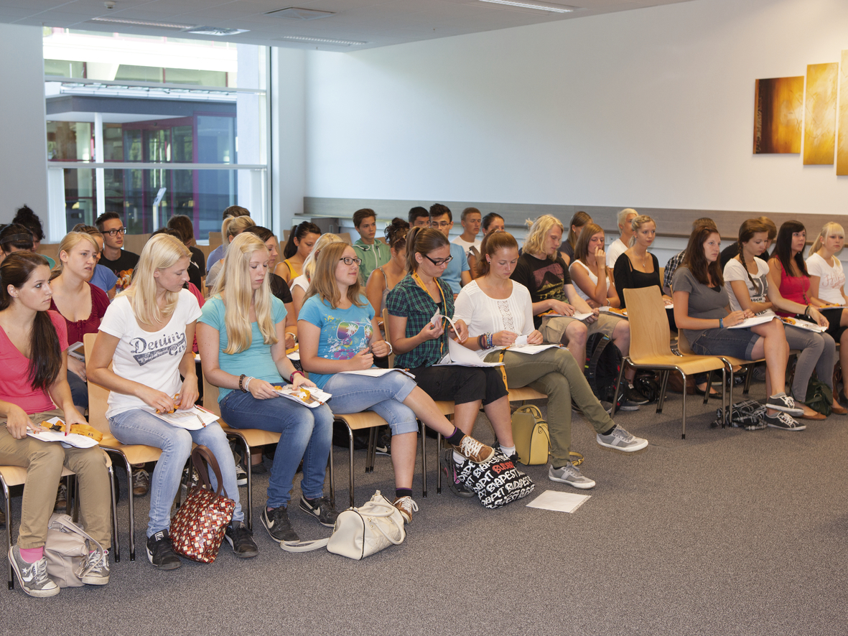
As in past years, there was also enormous interest this year in the intern jobs available at Bernecker + Rainer (B&R). More than 150 interns were able to gain practical experience over the summer in many areas of the company.

B&R Hakkında
ABB Grubunun bir bölümü olan B&R, merkezi Avusturya'da bulunan endüstriyel otomasyon alanında global bir liderdir. B&R, neredeyse her sektördeki müşterilere makine ve fabrika otomasyonu, hareket kontrolü, HMI ve entegre güvenlik teknolojisi için eksiksiz çözümler sunmak üzere en son teknolojiyi ileri mühendislikle birleştiriyor. OPC UA, POWERLINK ve openSAFETY gibi Endüstriyel IoT iletişim standartlarının yanı sıra Automation Studio yazılımıyla B&R, otomasyon mühendisliğinin geleceğini sürekli olarak yeniden tanımlıyor. B&R'ı endüstriyel otomasyonun ön saflarında tutan yenilikçi ruh, süreçleri basitleştirme ve müşteri beklentilerini aşma taahhüdünden kaynaklanmaktadır.
Daha fazla bilgi için www.br-automation.com adresini ziyaret edin.

